AWS Personal notes Udemy course

AWS Fundamentals – Part 1 5

Security groups – 5

EC2 user data 5

EC2 instance Launch types 6

EC2 instance types 6

AMI – image for EC2 instance 7

Placement Groups 8

Elastic Network Interfaces (ENI) 9

EC2 Hibernate 9

AWS Fundamentals – High availability and scalability: ELB and ASB 10

Load Balancer 10

Auto Scaling Group (ASG) 12

EC2 Storage – EBS & EFS 14

EBS Volume - 14

EBS vs Instance Store: 15

EFS (Elastic File system) – 15

EBS vs EFS 16

Decoupling applications: SQS, SNS, Kinesis, Active MQ 16

Amazon SQS – Standard Queue 16

SNS (pub-sub / sending one message to multiple receivers/ similar to topic) 18

Kinesis (similar to Kafka) 19

SQS vs SNS vs Kinesis 21

Amazon MQ (managed ActiveMQ) 21

AWS CLI, SDK, IAM roles & Policies 22

AWS CLI S3 practice 22

AWS create custom IAM Roles and policies 23

AWS Instance Metadata 23

AWS SDK overview 24

AWS RDS Overview 25

RDS read replica vs Multi AZ 25

RDS Security – Encryption 27

Amazon Aurora 28

ElastiCache Overview 31

AWS Route 53 34

Route 53 CNAME vs Alias 35

Routing Policy 36

Route53 Health Checks 37

Advanced Routing Policy 38

3rd party domain and Route 53 40

Classic Solution Architecture 41

WhatTimeItIs.com Stateless App 41

MyClothes.com Stateful Web App 41

MyWordPress.com – Stateful App 45

Instantiating Applications quickly 46

AWS ElasticBeanstalk overview 46

Serverless Overviews from a Solution Architecture perspective 49

Lambda@Edge 52

DynamoDB 53

Lambda API Gateway 55

Lambda API Security – 55

API Gateway hands on 57

AWS Serverless Application Model 60

Databases in AWS 61

RDS 61

Aurora 61

ElastiCache 62

DynamoDB 62

S3 as Database 63

Athena DB 63

Redshift DB Overview 63

Neptune DB 64

Amazon S3 65

Advanced Amazon S3 & Athena 67

S3 Access Logs 68

S3 Replication 69

S3 Storage Classes 71

Athena overview for S3 82

AWS CloudFront 83

CloudFront S3 hands on 85

CloudFront Signed URL / Signed Cookies 86

AWS Global Accelerator 88

# AWS Fundamentals – Part 1

## Security groups –

They act as firewall on EC2 instances.

They regulate –

* Access to Ports
* Authorize IP ranges – Ipv4 to IPv6
* Control of inbound and outbound rules
* Can be attached to multiple instances
* Locked down to a region/VPC combination
* If your application is timed out, then there is a security group issue. If your application has connection refused error, then your application has not started yet.
* All inbound traffic is blocked by default and all outbound traffic is authorized by default

SSH command –

chmod 0400 EC2Tutorial.pem

ssh -i ECRTutorial.pem ec2-user@35.180.100.144

Elastic IPs – IPs that does not change their IP even after restart of EC2 instance. It is a bad architecture, instead use DNS domain name.

AWS EC2 instance comes with a private and public IP address. You SSH with public IP address.

## EC2 user data

It is used to bootstrap your EC2 instance when the machine starts. It runs only once the EC2 instance starts.

**EC2 user data script**

#!/bin/bash

sudo su

yum update -y

yum install -y httpd.x86_64

systemctl start httpd.service

systemctl enable httpd.service

echo "Hello World from $(hostname -f) " > /var/www/html/index.html

curl localhost:80

then open port 80 by ensuring the security group allows http port 80

hit ip address on browser

echo "Hello World" > /var/www/html/index.html

## EC2 instance Launch types

**On Demand Instances**

Short workload, predictable pricing

**EC2 Reserved -**

Pay upfront for what you can use for long term (think database) (75% lesser price than on demand EC2)

Reservation period can be 1 to 3 years

Convertible Reserved Instance - can change EC2 instance type

Scheduled Reserved instances – launch within time window

**EC2 Dedicated hosts -**

Physical dedicated EC2 server for your use with full control of EC2 instance placement.

More expensive and used for Bring your own license or for companies for strong compliance need.

**EC2 dedicated instances -**

Instances running on hardware dedicated to you but can be shared by other instances in same account .No control over instance placement

**EC2 spot instances -**

* Instances that you can lose any time if your max price is less than current spot price. 90% lesser cost than on demand.
* Useful for workloads that are resilient to failure.
* Great combo – reserved Instances for baseline + On – demand & spot for peaks

**Explanation through Hotel Analogy example --**

**On demand** - coming and stating in resort whenever we like, we pay full price

**Reserved** - like planning ahead if we plan to stay for a long time, we may get good discount

**Spot instances** - hotels allows people to bid for empty rooms and the highest bidder keeps the rooms .You get kicked out at any time

**Dedicated Hosts** - We book the entire building of the resort.

**Spot Fleet**

Spot Fleets = set of Spot Instances + (optional) On-Demand Instances

• The Spot Fleet will try to meet the target capacity with price constraints

• Define possible launch pools: instance type (m5.large), OS, Availability Zone

• Can have multiple launch pools, so that the fleet can choose

• Spot Fleet stops launching instances when reaching capacity or max cost

## EC2 instance types

R: applications that needs a lot of RAM – in-memory caches

• C: applications that needs good CPU – compute / databases

• M: applications that are balanced (think “medium”) – general / web app

• I: applications that need good local I/O (instance storage) – databases

• G: applications that need a GPU – video rendering / machine learning

• T2 / T3: burstable instances (up to a capacity)

• T2 / T3 - unlimited: unlimited burst

**Burstable instances (instance type) -**

When the machine needs to process something that cases unexpected spike, it can burst and CPU can be very good.

## AMI – image for EC2 instance

AMI are built for specific AWS region only.

**How to create AMI?**

Right click on instance and click "image" --> "create image"

Create image and then go to "AMI" and see your image

Right click on image and click "Launch" to start an EC2 instance using this image

Right click on image and click "deregister" to delete the image

Your AMI is stored in S3 and by default are private and locked to your region/account. However you have to pay for using S3.

You can make your AMI public and sell it on Amazon market place.

**Cross Account AMI Copy (FAQ + Exam Tip)**

• You can share an AMI with another AWS account.

• Sharing an AMI does not affect the ownership of the AMI.

• If you copy an AMI that has been shared with your account, you are the owner of the target AMI in

your account.

• To copy an AMI that was shared with you from another account, the owner of the source AMI must

grant you read permissions for the storage that backs the AMI, either the associated EBS snapshot

(for an Amazon EBS-backed AMI) or an associated S3 bucket (for an instance store-backed AMI).

• Limits:

• You can't copy an encrypted AMI that was shared with you from another account. Instead, if the

underlying snapshot and encryption key were shared with you, you can copy the snapshot while reencrypting

it with a key of your own. You own the copied snapshot, and can register it as a new AMI.

• You can't copy an AMI with an associated billingProduct code that was shared with you from another

account. This includes Windows AMIs and AMIs from the AWS Marketplace. To copy a shared AMI

with a billingProduct code, launch an EC2 instance in your account using the shared AMI and then

create an AMI from the instance.

## Placement Groups

Sometimes you want to control the way your EC2 instances should be placed .You can achieve this using placement group .Following are the types of placement groups –

**Cluster – Same Rack. Same AZ.**

Pros – Very fast (low latency)

Cons – If rack fails everything fails.

Use case – Big data job that needs to be completed in quick time. Applications that need low latency and high throughput.

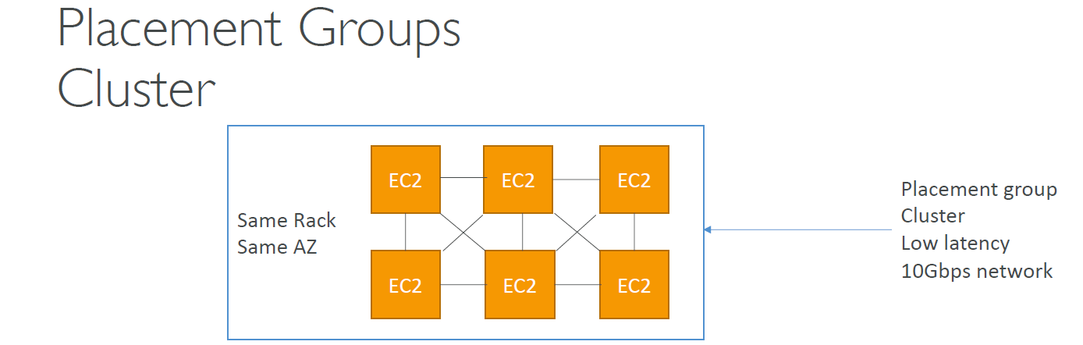

**Spread – Different AZ.**

Pros – Reduced risk in simultaneous failure and can spread across multiple AZ

Cons – only 7 EC2 instance per AZ per placement group

Use case – Applications that require high availability where each instance is isolated from failure from each other

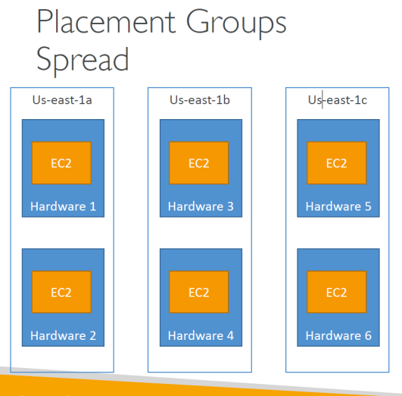

**Partition – one AZ but different racks**

Upto 7 partitions per AZ

Upto 100 EC2 instances

Pros – A partition failure wont affect the other partition

Use case – HDFS, HBase, Cassandra, Kafka

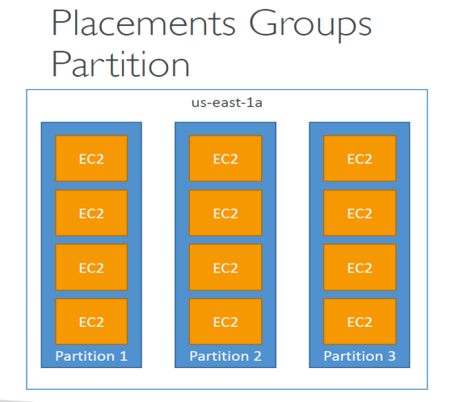

## Elastic Network Interfaces (ENI)

ENI has one of the below attributes –

Primary private IPv4, one or more secondary IPv4

One Elastic IP (IPv4) per private IPv4

One or more security groups

A MAC address

## EC2 Hibernate

The in-memory (RAM) state is preserved

• The instance boot is much faster! (The OS is not stopped / restarted)

• Under the hood: the RAM state is written to a file in the root EBS volume

• The root EBS volume must be encrypted

An instance cannot be hibernated more than 60 days

Use cases:

• long-running processing

• saving the RAM state

• Services that take time to initialize

# AWS Fundamentals – High availability and scalability: ELB and ASB

**High Availability vs Scalability –**

HA means having instances in differ AZ for supporting failure scenarios

Scalability means increasing either the configuration of one instance or having multiple instances to support the incoming traffic.

## Load Balancer

**Types of load balancers on AWS**

Classic LB (v1 old gen 2009) - supports http, https, TCP

Application LB (v2 gen 2016) - supports http, https, websocket

Network LB (v2 gen 2017) - supports TCP, TLS (secure TLC) & UDP

You can set LB as internal(private) or external (public) ELBs

**Setup -**

you set up a load balancer that should allow restricted traffic from Outside users .

Your EC2 would allow traffic from above load balancer

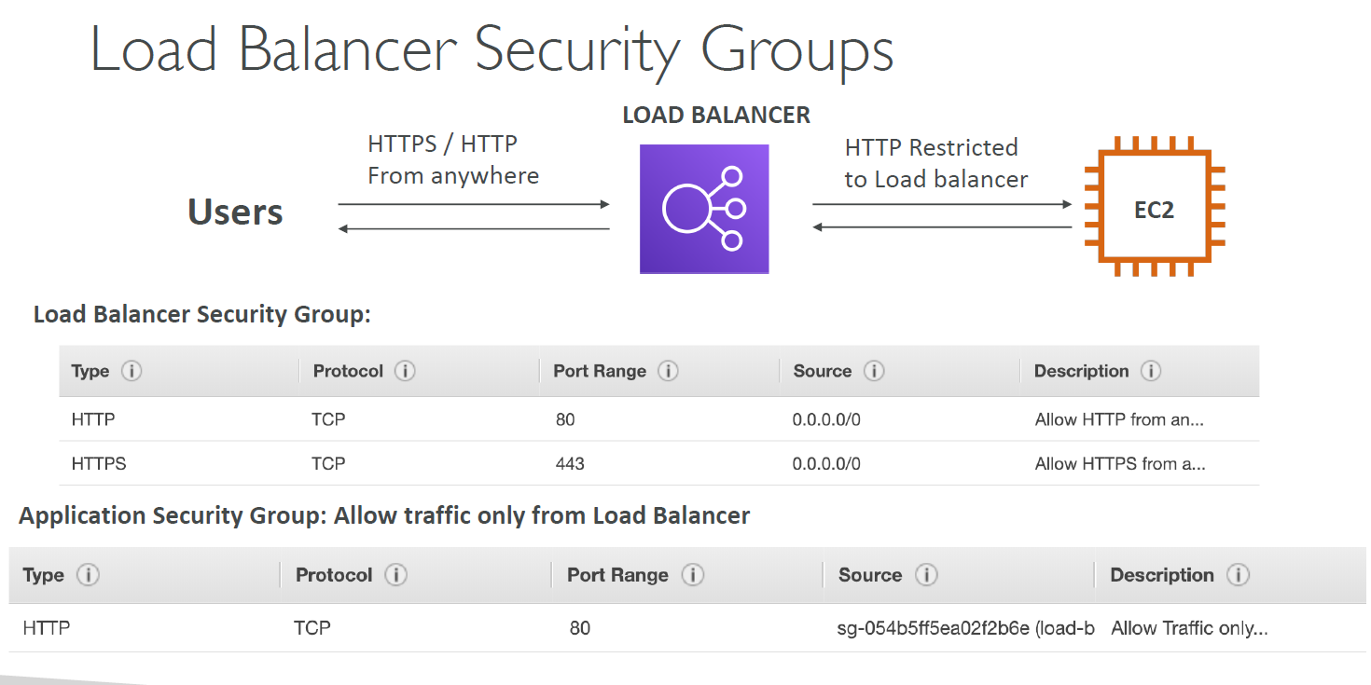

**Classic LB (v1)**

Can be used for fixed hostname - example XXX.region.elb.amazon.com

Supports TCP, HTTP and HTTPS

Health check are TCP and HTTP based

**Application LB (v2)**

Load balancing to multiple HTTP applications across machines-

* Routing based on hostname in URL (one.example.com and other.example.com)
* Routing based on path in URL (one.example.com/users and one.example.com/posts)
* Routing based on path variable (example.com/users?id-123&order=false)

In comparison, we'd need multiple classic Load Balancer per application

ALB are great fit for micro services and container based application (example Docker and Amazon ECS)

**Network LB (v2)**

Forward TCP and UDP traffic to your instances (not for Http and https)

Handle millions of requests per seconds (Latency lower than ALB)

They are used for extreme performance TCP or UDP traffic

NLB has one static IP per AZ (ALB has one static hostname)

It is not free at all

**Load Balancer Stickiness**

It uses cookie with expiration date to control. Use case : make sure the user doesn’t lose his session data

Click on stickness to enable it in Target group. IT asks you for how long you want the stickness to be enabled.

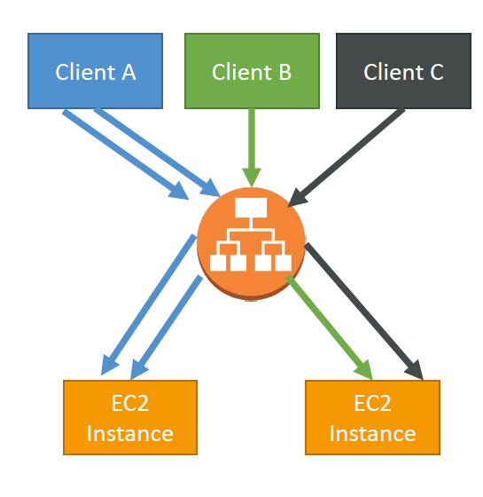

**Cross Load Balancing**

This feature is available in all LB - Classical, Application and Network. No charges to turn it on in CLB and ALB however you need to pay for this feature in NLB.

For ALB it is on by default.

The LB evenly distributes the traffic across all registered instances in AZ

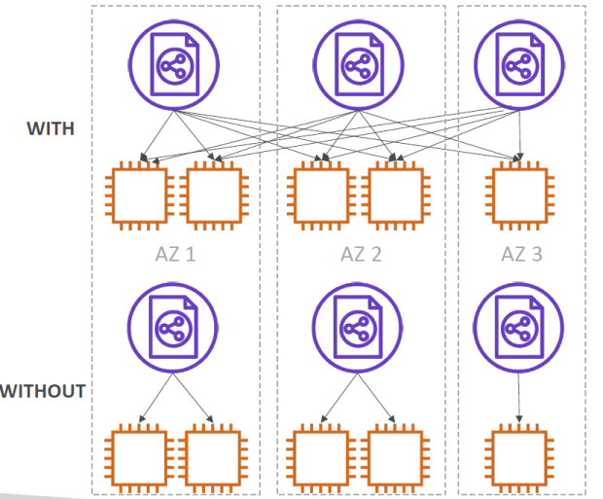

**SSL Certificates-**

TLS is newer version of SSL .

Using SSL/SNI (Server Name Indication) ,you can have multiple SSL certificates to server multiple websites .

For SSL to work you indicate the hostname in the initial SSL handshake , the LB server will then find the correct certificate or return default one .

SSL only works for ALB and NLB (it does not work for CLB)

Summary -

CLB supports only one SSL certificate (for multiple certificates you need to have multiple CLB)

ALB & NLB -supports multiple listeners with multiple SSL certificates. That means using SNI concept once load balancer can have more than one certificate to route to different SSL enabled instances.

**ELB - Connection Draining**

Time to complete "in flight requests" while the instance is de-registering or unhealthy.

Stops sending new requests to the instance which is de-registering

You can set it to any value between 1 to 3600 seconds

Can be disabled by setting the value to 0

## Auto Scaling Group (ASG)

The goal of an Auto Scaling Group (ASG) is to:

• Scale out (add EC2 instances) to match an increased load

• Scale in (remove EC2 instances) to match a decreased load

• Ensure we have a minimum and a maximum number of machines running

• Automatically register new instances to a load balancer

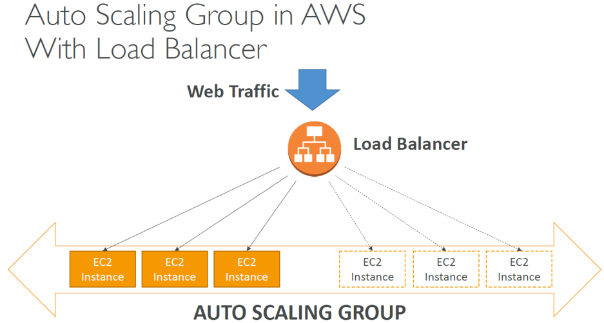

**Auto Scaling New Rules**

• It is now possible to define “better” auto scaling rules that are directly managed by EC2

• Target Average CPU Usage

• Number of requests on the ELB per instance

• Average Network In / Average Network Out

We can also autoscale based on a custom metrics or based on schedule using cloud watch

**ASG Brain Dump**

• Scaling policies can be on CPU, Network… and can even be on custom metrics or based on a schedule (if you know your visitors patterns)

• ASGs use Launch configurations or Launch Templates (newer)

• To update an ASG, you must provide a new launch configuration / launch template

• IAM roles attached to an ASG will get assigned to EC2 instances

• ASG are free. You pay for the underlying resources being launched

• Having instances under an ASG means that if they get terminated for whatever reason, the ASG will automatically create new ones as a replacement. Extra safety!

• ASG can terminate instances marked as unhealthy by an LB (and hence replace them

**Auto Scaling Groups - Scaling policies**

1. **Target Tracking Scaling** – e.g. I want the average ASG CPU to stay at 40%
2. **Simple/Step Scaling** – e.g. cloudWatch alarm triggered at CPU > 70% to scale up by 2 units
3. **Scheduled Actions** - Anticipate a scaling based on known usage patterns

**Scaling Cooldowns -**

The cooldown period helps to ensure that your Auto scaling group doesn't launch or terminate additional instances before the previous scaling activity takes effect.

You can also mention your own default cooldown for specific scaling policy.

During the cooldown period, termination or launch of instance is kept on hold.

**AZ Default Termination Policy -**

1. Find the AZ which has the most number of instances.

2. If there are multiple instances to choose from, delete the one with the oldest launch configuration.

3. ASG tries to balance the no of instances across AZ by default

**Lifecycle Hooks -**

Hooks present on "Pending "and "Terminating" state

**Launch template vs launch configuration -**

Launch template is newer whereas launch configuration is older.

Launch template has multiple versions and can provide mix of both spot instances and On-demand (or a mix)

LT can use T2 unlimited burst feature.

LT is recommended by AWS going forward

# EC2 Storage – EBS & EFS

## EBS Volume -

It is a network drive (and not physical drive), this means it might have some latency

It can be detached from an EC2 instance.

It is locked to an AZ. (to use it in another AZ, you would have to create a snapshot first)

Types of EBS-

GP2 , IOI ,STI ,SDD

**EBS Volume Types -**

• EBS Volumes come in 4 types

• GP2 (SSD): General purpose SSD volume that balances price and performance for a wide variety of workloads

• IO1 (SSD): Highest-performance SSD volume for mission-critical low-latency or high throughput workloads

• ST1 (HDD): Low cost HDD volume designed for frequently accessed, throughput intensive

workloads

• SC1 (HDD): Lowest cost HDD volume designed for less frequently accessed workloads

• EBS Volumes are characterized in Size | Throughput | IOPS (I/O Ops Per Sec)

• When in doubt always consult the AWS documentation – it’s good!

• Only GP2 and IO1 can be used as boot volumes

**EBS Snapshots**

• Incremental – only backup changed blocks

• EBS backups use IO and you shouldn’t run them while your application is handling a lot of traffic

• Snapshots will be stored in S3 (but you won’t directly see them)

• Not necessary to detach volume to do snapshot, but recommended

• Max 100,000 snapshots

• Can copy snapshots across AZ or Region

• Can make Image (AMI) from Snapshot

• EBS volumes restored by snapshots need to be pre-warmed (using fio or dd command to read the entire volume)

• Snapshots can be automated using Amazon Data Lifecycle Manager

**EBS Migration**

• EBS Volumes are only locked to a specific AZ

• To migrate it to a different AZ (or region):

• Snapshot the volume

• (optional) Copy the volume to a different region

• Create a volume from the snapshot in the AZ of your choice

**EBS Encryption**

Data at rest, all data in flight moving between the instances, snapshots are encrypted

Encryption has minimal latency (uses KMS (AES0256) keys for encryption).

## EBS vs Instance Store:

* Some instance do not come with Root EBS volume, instead they come with instance store.
* Instance store is physically attached to the machine (EBS is network drive)
* Offers upto 7GiB
* Instance store would give - Better I/O ,high IOPS ,good buffer ,cache and data survives reboots
* cons - On termination or stop, the instance store is lost .You cannot resize the instance store. Backups must be operated by the user.
* For high IOPS (like millions) use Instance store

**EBS RAID Options**

• EBS is already redundant storage (replicated within an AZ)

• But what if you want to increase IOPS to say 100 000 IOPS?

• What if you want to mirror your EBS volumes?

• You would mount volumes in parallel in RAID settings!

• RAID is possible as long as your OS supports it

• Some RAID options are:

• RAID 0

• RAID 1

• RAID 5 (not recommended for EBS – see documentation)

• RAID 6 (not recommended for EBS – see documentation)

• We’ll explore RAID 0 and RAID 1

**RAID 0 (increase performance) -** distribute data across two EBS Volume which increase the performance, however this would increase the risk of data loss if one of the EBS goes down .

**RAID 1 (increase fault tolerance) -** we still have two EBS volume, however data is written to both EBS every time which achieves fault tolerance but performance is slightly less than RAID1

## EFS (Elastic File system) –

Managed NFS (network file system) that can be mounted on EC2 instances.

EFS works with EC2 instances in multi-AZ (EBS is only linked to one AZ at a time).

It is highly available, scalable and expensive compared to EBS

Use case- content management, web serving, data sharing, wordpress.

EFS only applicable for Linux system

1000s of concurrent NFS client, 10 GB+ /s throughput

Storage Tiers (life cycle management feature - move file after N days)

Two types –

1) Standard (for frequently accessed files) and

2) Infrequent access (EFS-IA): cost to relative files lower

## EBS vs EFS

**EBS volumes…**

• can be attached to only one instance at a time

• are locked at the Availability Zone (AZ) level

• gp2: IO increases if the disk size increases

• io1: can increase IO independently

To migrate an EBS volume across AZ

• Take a snapshot

• Restore the snapshot to another AZ

• EBS backups use IO and you shouldn’t run them while your application is handling a lot of traffic

• Root EBS Volumes of instances get terminated by default if the EC2 instance gets terminated. (you can disable that)

**Elastic file system…**

Mounting 100s of instances across AZ

• EFS share website files (WordPress)

• Only for Linux Instances (POSIX)

• EFS has a higher price point than EBS

• Can leverage EFS-IA for cost savings

# Decoupling applications: SQS, SNS, Kinesis, Active MQ

## Amazon SQS – Standard Queue

(Multiple producers, multiple consumers but one msg read by only consumer, so many-to-one configuration )

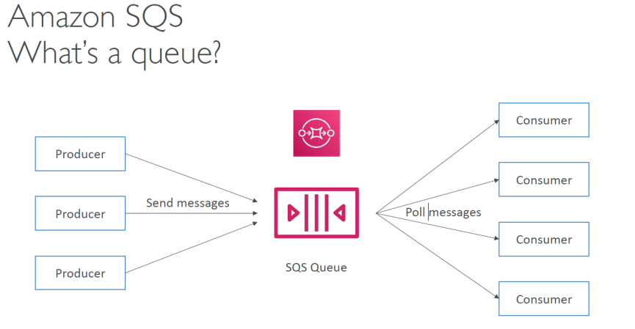

**Attributes -**

* Unlimited throughput, unlimited no of messages in queue.
* Default retention of message is 4 days, maximum of 14 days
* Low Latency (<10ms)
* Limitation of 256kb per message sent
* Can be duplicate messages (at least once delivery)
* Can be out of order messages (best offer ordering)
* Poll messages from SQS (receive up to 10 messages at a time)

**Scaling -**

* Can have multiple EC2 consumers
* At least once delivery
* Consumers have to delete the messages after processing them.
* We can scale the consumers horizontally to improve throughput of processing
* Can scale using Auto scaling group using Queue length as the metric (approx no of messages)
* Encryption - https API or KMS keys or client side

**AccessControls**: IAM policies available

**SQS Access Policies**: (similar to S3 bucket policies)

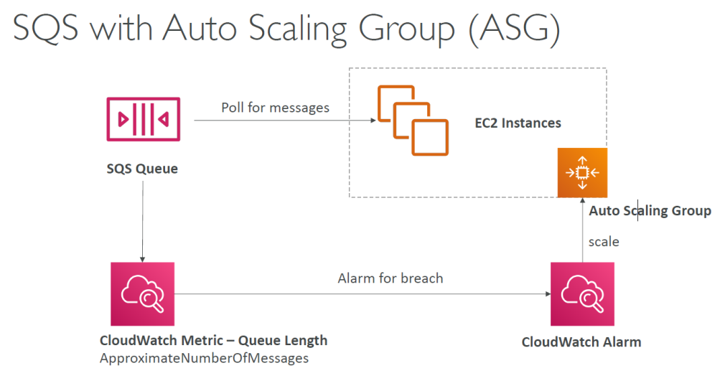

**SQS - Message Visibility Timeout**

* After a message is polled by a consumer, it becomes invisible to other consumers
* By default, message visibility timeout is 30 seconds
* After the visibility timeout, if the message is not processed ,then it gets returned to queue
* If the visibility time is too high and if the consumer crashes ,re-processing of msg will take time
* If the visibility time is too low ,we may get duplicates

**Dead Letter queue**

If a consumer fails to process a message within the visibility timeout, the message gets back to queue. We can set how many times the message should get back to queue, after which the message goes back to DLQ

**Delay Queue**

Delay a message (consumer don’t see it immediately) up to 15 minutes

**FIFO Queue**

Exactly once send capability.

Messages are processed in order by the consumer

Limited throughput : 300 msg/s

## SNS (pub-sub / sending one message to multiple receivers/ similar to topic)

* What if you want to send one message to many receivers ? (pub/sub)
* Use SNS topic to achieve this
* Producer sends msg to one SNS topic and we can as many listeners to the topic.
* Each subscriber to the topi will get all the messages.(option to filter messages as well)
* 100,00 topic limit , 10,000,000 subcriptions per topic

**Subscription can be -**

SQS Http, https, Lambda, SMS, Mobile application

**SNS integrates with -**

Cloud watch m auto scaling , amazon S3 , Cloud Formation

**SNS security (same as SQS)-**

in flight encrytpion , KMS Keys , client side encryption, Access control via IAM

**SNS Access policies**

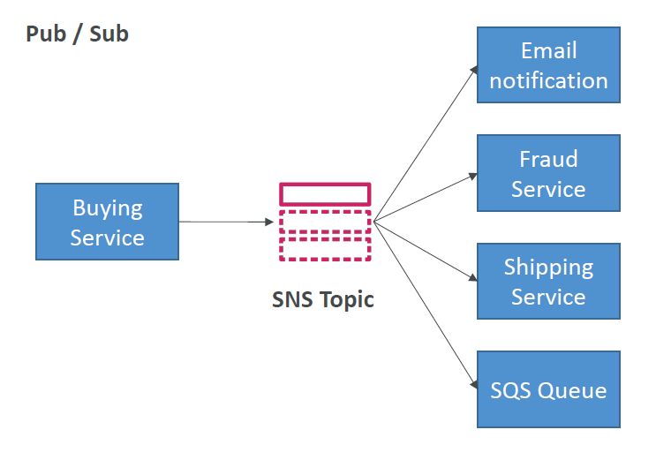

**SNS + SQS: Fan out**

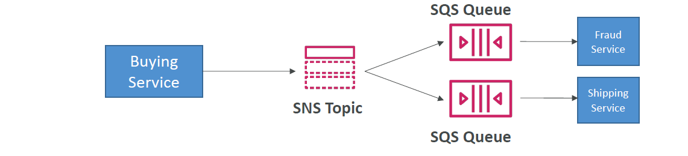

Push once in SNS, receive in all SQS queues that are subscribers

• Fully decoupled, no data loss

• SQS allows for: data persistence, delayed processing and retries of work

• Ability to add more SQS subscribers over time

• SNS cannot send messages to SQS FIFO queues (AWS limitation)

## Kinesis (similar to Kafka)

* Alternative to Apache Kafka
* Great for application logs, metrics, IoT, clickstreams
* Great for "real-time" big data
* Great for streaming processing frameworks (Spark,NiFi,etc )
* Data is automatically replicated to 3 AZ

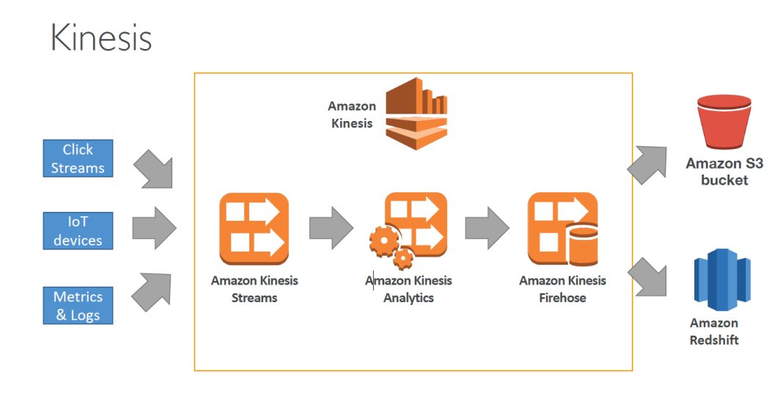

**Kinesis Streams:** low latency streaming ingest at scale

**Kinesis Analytics:** perform real-time analytics on streams using SQL

**Kinesis Firehose:** load streams into S3, Redshift, ElasticSearch

Streams are divided in ordered shards / Partitions

Data retention is 1 day by default, can go up to 7 days

Ability to reprocess / replay data

Multiple applications can consume the same stream

Once data is in inserted in Kinesis, it can’t be deleted

**Shards**

* 1MB/s or 1000 msgs at write per shard
* 2MB/s at read per shard
* Billing is per shard provisioned
* Records are ordered per shard
* You can reshard or merge shards

**Kinesis Commands -**

* aws kinesis help
* aws kinesis list-streams //to get stream name
* aws kinesis describe-stream --stream-name <name of stream>
* aws kinesis put-record --stream-name <name of stream> --data "user sign up" --partition-key user123 // to send data
* aws kinesis get-shard-iterator --stream-name <stream name> --shard-iterator-type TRIM_HORIZON --shard-id <shard id from describe command>
* aws kinesis get -records --shard-iterator <iterator value from above command>

**AWS Kinesis API – Exceptions**

ProvisionedThroughputExceeded Exceptions

• Happens when sending more data (exceeding MB/s or TPS for any shard)

• Make sure you don’t have a hot shard (such as your partition key is bad and too much data goes to that partition)

Solution:

• Retries with backoff

• Increase shards (scaling)

• Ensure your partition key is a good one

**Kinesis Data Firehose**

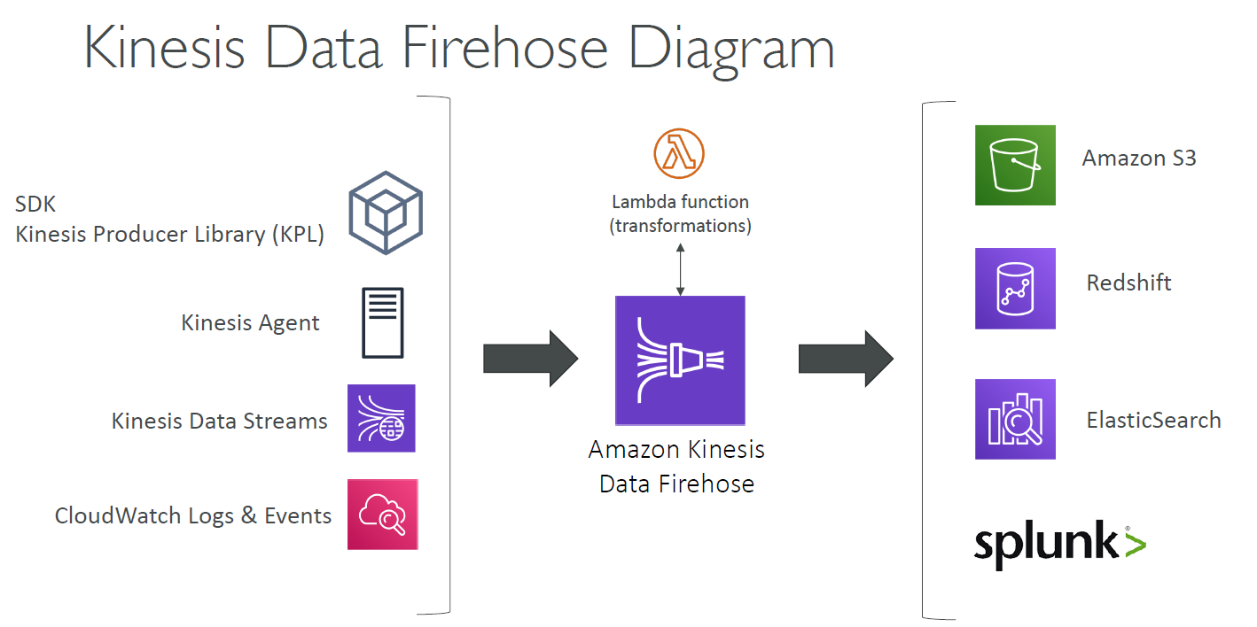

**Kinesis Data Streams vs Firehose**

Streams

• Going to write custom code (producer / consumer)

• Real time (~200 ms)

• Must manage scaling (shard splitting / merging)

• Data Storage for 1 to 7 days, replay capability, multi consumers

Firehose

• Fully managed, send to S3, Splunk, Redshift, ElasticSearch

• Serverless data transformations with Lambda

• Near real time (lowest buffer time is 1 minute)

• Automated Scaling

• No data storage

**Kinesis Analytics**

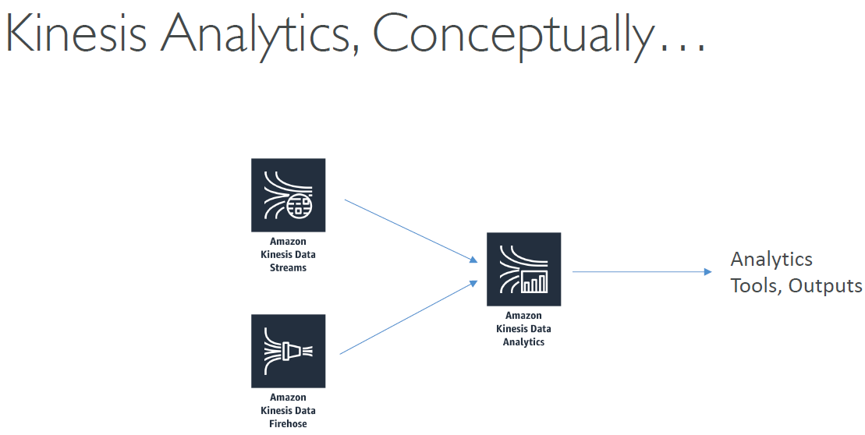

Performs real-time analytics on Kinesis Streams using SQL

## SQS vs SNS vs Kinesis

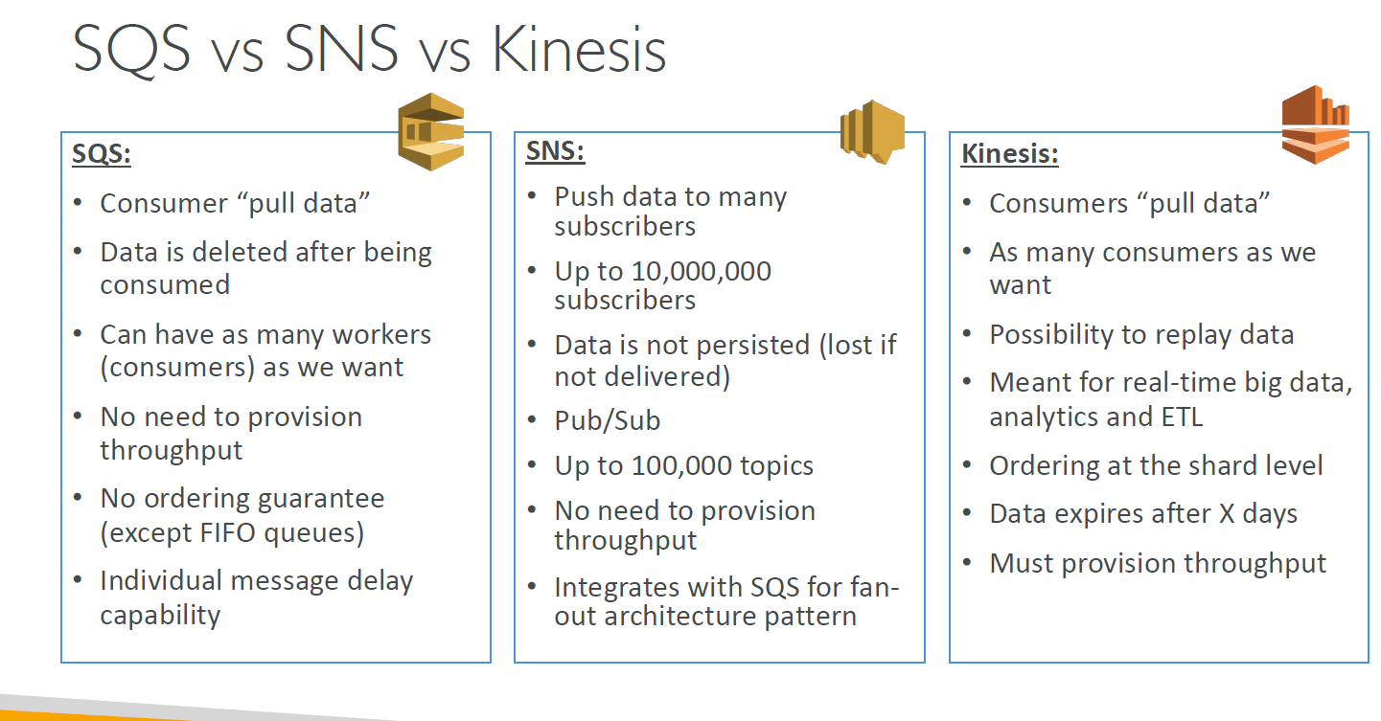

## Amazon MQ (managed ActiveMQ)

Amazon MQ = managed Apache ActiveMQ

Amazon MQ has both queue feature (~SQS) and topic feature (~SNS)

However they don't scale as much as SQS/SNS

Amazon MQ runs on a dedicated machine, can run in HA with failover

# AWS CLI, SDK, IAM roles & Policies

**Steps to install and configure AWS CLI on windows –**

1. Download AWS SDK MSI from internet (version 2)
2. Install and verify if “aws –version” works fine
3. Configure AWS for your account –
4. First type IAM and create an account ( anupmehta702 Athempuna$1988)
5. Type “aws –configure” It would ask you for access Id and secret key , provide it from the account that you created .

**AWS on EC2 – The BAD way**

We could run AWS configure on any EC2 machine as well. But this is a BAD way of doing it as your EC2 can be compromised and the personal credentials that you put to configure AWS CLI might be compromised.

NEVER put you’re your personal credentials on EC2

**AWS on EC2 – The RIGHT way**

**IAM** roles can be attached to EC2 instances

IAM roles come with policy attached authorizing exactly what the EC2 instance is allowed to do.

EC2 instance can have only one IAM role at a time

**How to assign IAM roles for EC2?**

1. Create an EC2 instance
2. Ssh into it using “ssh -i EC2Tutorial.pem [ec2-user@35.180.46.120](mailto:ec2-user@35.180.46.120)”
3. Type aws –version. It would show you the version of the AWS CLI it already has.
4. Now type “aws s3 ls” it would throw an error and ask you to configure your AWS CLI. However it is a bad idea to use “aws configure” command and provide your access Id and secret key.
5. Attach an IAM role to the EC2 instance
6. Go to IAM 🡪 create role 🡪 “AWS service” ( since we want the role to be created for EC2)
7. Choose “EC2” as the service.
8. Attach policy to IAM role. For time being attach “AmazonS3ReadOnlyAccess”
9. Add name to the role “MyFirstEC2Role”
10. Go to EC2 management console 🡪 Right click 🡪 “Instance settings” 🡪 “Attach/Replace IAM Role”🡪 “MyFirstEC2Role”
11. Update the policy of IAM role to “AmazonS3FullAccess” .Then hit below command to create a new S3 bucket “aws s3 mb s3://newCustomBucket”
12. Remove the new created bucket using “aws s3 rb s3://newCustomBucket”

## AWS CLI S3 practice

aws s3 s3://name-of-the-bucket

aws s3 mb s3://name-of-bucket-you-want-to-create

aws s3 rb s3://name-of-bucket-you-want-to remove

aws s3 cp local-file.txt s3://name-of-the-bucket/file-to-be-saved-as.txt //copy local file to s3

aws s3 cp s3://name-of-bucket/coffee.jpg coffee.jpg //copy file from s3 to local

## AWS create custom IAM Roles and policies

Go to IAM 🡪 create policy, then select below (OR type search policy generator on browser)

Select service – s3

Select Actions – All S3 actions

Select Resources – Specific (specify ARN for the object) OR All resources

Request conditions – Optional

The json representation of the above policy

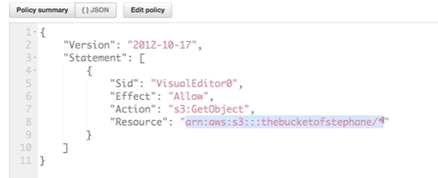

You can test your policy using “IAM Policy simulator” (search on net)

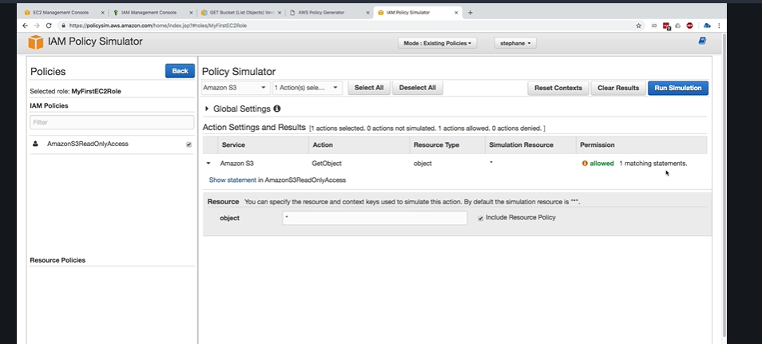

## AWS Instance Metadata

AWS EC2 Instance Metadata is powerful but one of the least known features to developers

• It allows AWS EC2 instances to “learn about themselves” without using an IAM Role for that purpose.

• The URL is http://169.254.169.254/latest/meta-data

• You can retrieve the IAM Role name from the metadata, but you CANNOT retrieve the IAM Policy.

• Metadata = Info about the EC2 instance

• Userdata = launch script of the EC2 instance

Ssh into the EC2 instance and enter the below command

curl <http://169.254.169.254/latest/>

o/p 🡪 dynamic

meta-data

user-data

curl <http://169.254.169.254/latest/meta-data/>

o/p 🡪 ami-id

instance-id

local-ipv4

iam/

public-keys/

….

curl <http://169.254.169.254/latest/meta-data/instance-id>

o/p 🡪 asdsa-asdsa-sdss //instance-id

## AWS SDK overview

What if you want to perform actions on AWS directly from your applications code? (Without using the CLI).

• You can use an SDK (software development kit)!

• Official SDKs are…

• Java

• .NET

• Node.js

• PHP

• Python (named boto3 / botocore)

• Go

• Ruby

• C++

**AWS SDK Credentials Security**

• It’s recommend to use the default credential provider chain

• The default credential provider chain works seamlessly with:

• AWS credentials at ~/.aws/credentials (only on our computers or on premise)

• Instance Profile Credentials using IAM Roles (for EC2 machines, etc…)

• Environment variables (AWS_ACCESS_KEY_ID, AWS_SECRET_ACCESS_KEY)

• Overall, NEVER EVER STORE AWS CREDENTIALS IN YOUR CODE.

• Best practice is for credentials to be inherited from mechanisms above, and

100% IAM Roles if working from within AWS Services

Exponential Backoff

If the AWS CLI APIs are failing then it might happen that all the clients are trying to hit it without any success, overloading / flooding the AWS service.

To avoid this AWS SDK have backoff strategy where every subsequent call after an unsuccessful API call waits for certain time before making request .This time exponential increases till a successful call is made avoid the flooding of the API calls to AWS service

Any API that fails because of too many calls needs to be retried with Exponential Backoff

• These apply to rate limited API

• Retry mechanism included in SDK API calls

# AWS RDS Overview

RDS stands for relational database service

AWS allows you to create below databases in AWS –

Postgres

• MySQL

• MariaDB

• Oracle

• Microsoft SQL Server

• Aurora (AWS Proprietary database)

**Advantage over using RDS versus deploying DB on EC2**

Why not install the database on EC2 instance instead of using AWS managed database service?

The main advantages that AWS managed database services provide are as below –

• Automated provisioning, OS patching.

Continuous backups and restore to specific timestamp (Point in Time Restore)!

• Monitoring dashboards

• Read replicas for improved read performance

• Multi AZ setup for DR (Disaster Recovery)

• Maintenance windows for upgrades

• Scaling capability (vertical and horizontal)

• Storage backed by EBS (gp2 or io1)

• BUT you can’t SSH into your instances since it is a managed service

## RDS read replica vs Multi AZ

**Read replica for scalability**

* Up to 5 Read replicas
* Within AZ, Cross AZ or Cross region
* Replications are ASYNC and hence eventually consistent
* Replicas can be promoted to their own DB
* Applications must update the connection string to leverage read replicas
* Read replicas in same AZ would cost less (in fact no network cost) than in other AZ (network cost is high)

**Read replica use case**

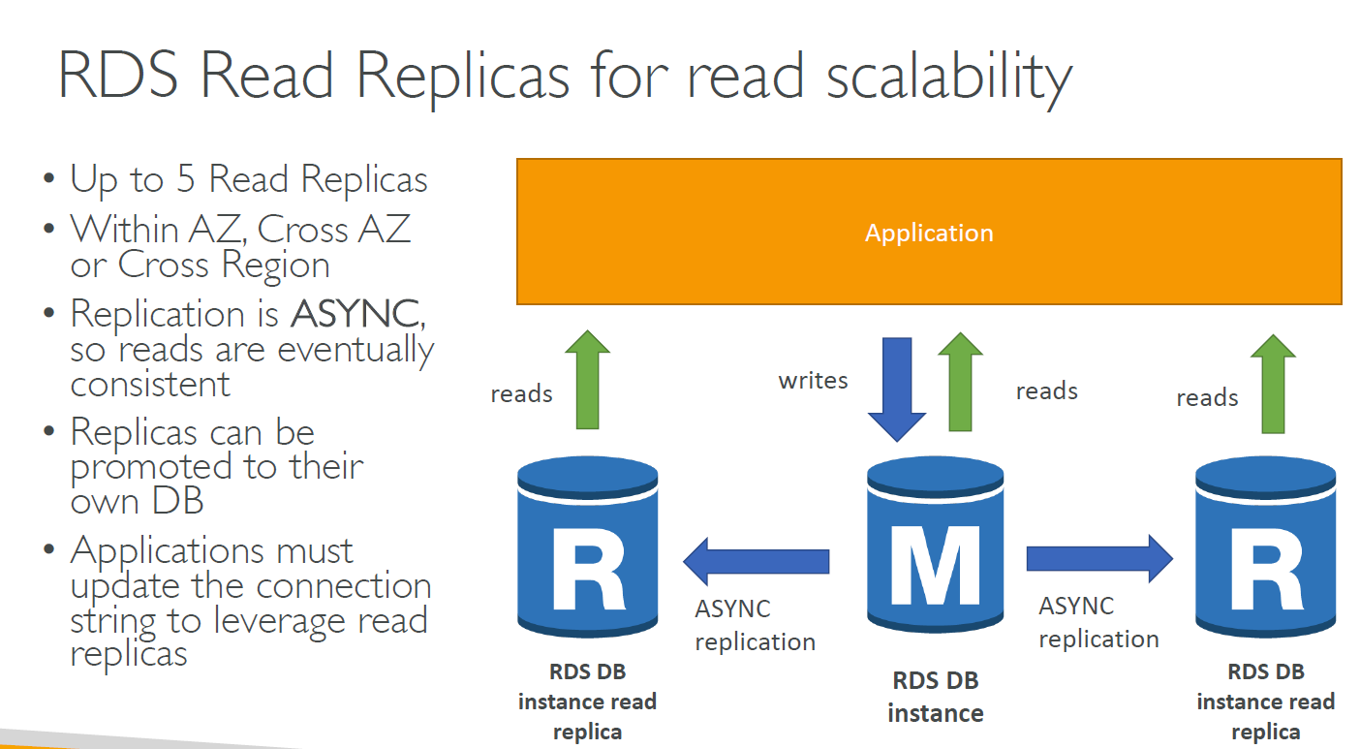

**RDS Multi AZ (Disaster Recovery)**

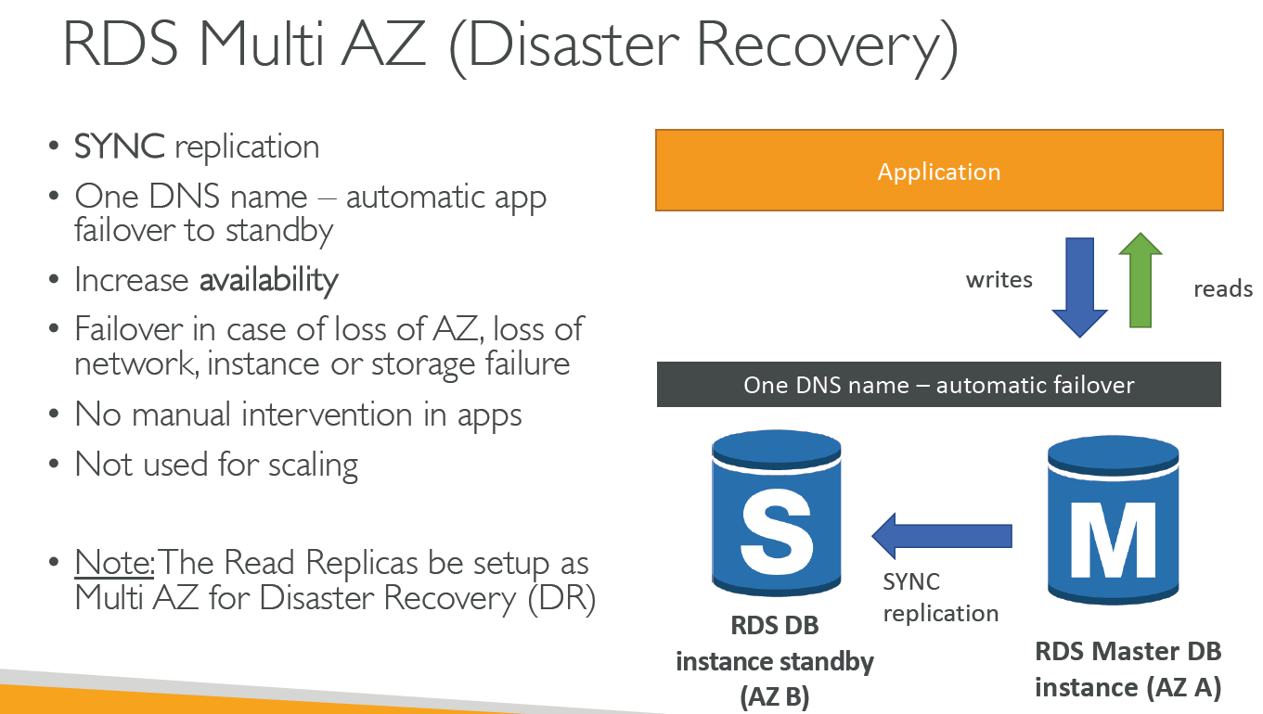

**Create RDS on AWS**

Search RDS

Choose a database creation method - standard Create

Engine options – MySQL (since it free)

Version – 5.7.22

Templates – Free tier

DB instance identifier – my first MySQL

Username & password

DB instance size – db.t2.micro (burstable classes)

Storage – General Purpose (SSD) 20 GB

Multi AZ deployment – Do you need a standby DB instance for failover? Disabled for free tier

Publicly accessible – Yes

VPC security group – Create new for database port 3306

Database option – initial DB name – myDB

Enable backups – 7 days

Hit Create database

Once created we can “Create Read Replica” (in “Instance actions” option)

Use sqlelectron to test DB

## RDS Security – Encryption

• At rest encryption

• Possibility to encrypt the master & read replicas with AWS KMS - AES-256 encryption

• Encryption has to be defined at launch time

• If the master is not encrypted, the read replicas cannot be encrypted

• Transparent Data Encryption (TDE) available for Oracle and SQL Server

• In-flight encryption

• SSL certificates to encrypt data to RDS in flight

• Provide SSL options with trust certificate when connecting to database

• To enforce SSL:

• PostgreSQL: rds.force_ssl=1 in the AWS RDS Console (Parameter Groups)

• MySQL: Within the DB: GRANT USAGE ON *.* TO 'mysqluser'@'%' REQUIRE SSL;

**RDS Encryption Operations**

• Encrypting RDS backups

• Snapshots of un-encrypted RDS databases are un-encrypted

• Snapshots of encrypted RDS databases are encrypted

• Can copy a snapshot into an encrypted one

• To encrypt an un-encrypted RDS database:

• Create a snapshot of the un-encrypted database

• Copy the snapshot and enable encryption for the snapshot

• Restore the database from the encrypted snapshot

• Migrate applications to the new database, and delete the old database

**RDS Security – Network & IAM**

Network Security

• RDS databases are usually deployed within a private subnet, not in a public one

• RDS security works by leveraging security groups (the same concept as for EC2 instances) – it controls which IP / security group can communicate with RDS

Access Management

• IAM policies help control who can manage AWS RDS (through the RDS API)

• Traditional Username and Password can be used to login into the database

• IAM-based authentication can be used to login into RDS MySQL & PostgreSQL

**RDS Security – Summary**

• Encryption at rest:

• Is done only when you first create the DB instance

• or: unencrypted DB => snapshot => copy snapshot as encrypted => create DB from snapshot

• Your responsibility:

• Check the ports / IP / security group inbound rules in DB’s SG

• In-database user creation and permissions or manage through IAM

• Creating a database with or without public access

• Ensure parameter groups or DB is configured to only allow SSL connections

• AWS responsibility:

• No SSH access

• No manual DB patching

• No manual OS patching

• No way to audit the underlying instance

## Amazon Aurora

Aurora is a proprietary technology from AWS (not open sourced)

• Postgres and MySQL are both supported as Aurora DB (that means your drivers will work as if Aurora was a Postgres or MySQL database)

• Aurora is “AWS cloud optimized” and claims 5x performance improvement

over MySQL on RDS, over 3x the performance of Postgres on RDS

• Aurora storage automatically grows in increments of 10GB, up to 64 TB.

• Aurora can have 15 replicas while MySQL has 5, and the replication process is faster (sub 10 ms replica lag)

• Failover in Aurora is instantaneous. It’s HA (High Availability) native.

• Aurora costs more than RDS (20% more) – but is more efficient.

**Aurora High Availability and Scalability**

6 copies of your data across 3 AZ:

• 4 copies out of 6 needed for writes

• 3 copies out of 6 needed for reads

• Self healing with peer-to-peer replication

• Storage is striped across 100s of volumes

• One Aurora Instance takes writes (master)

• Automated failover for master in less than 30 seconds

• Master + up to 15 Aurora Read Replicas serve reads

• Support for Cross Region Replication

**Aurora DB Cluster**

There is one DNS name that always points to writer endpoint

For reader as well, we have a Reader endpoint that has one DNS name which internally acts as connection load balancing.

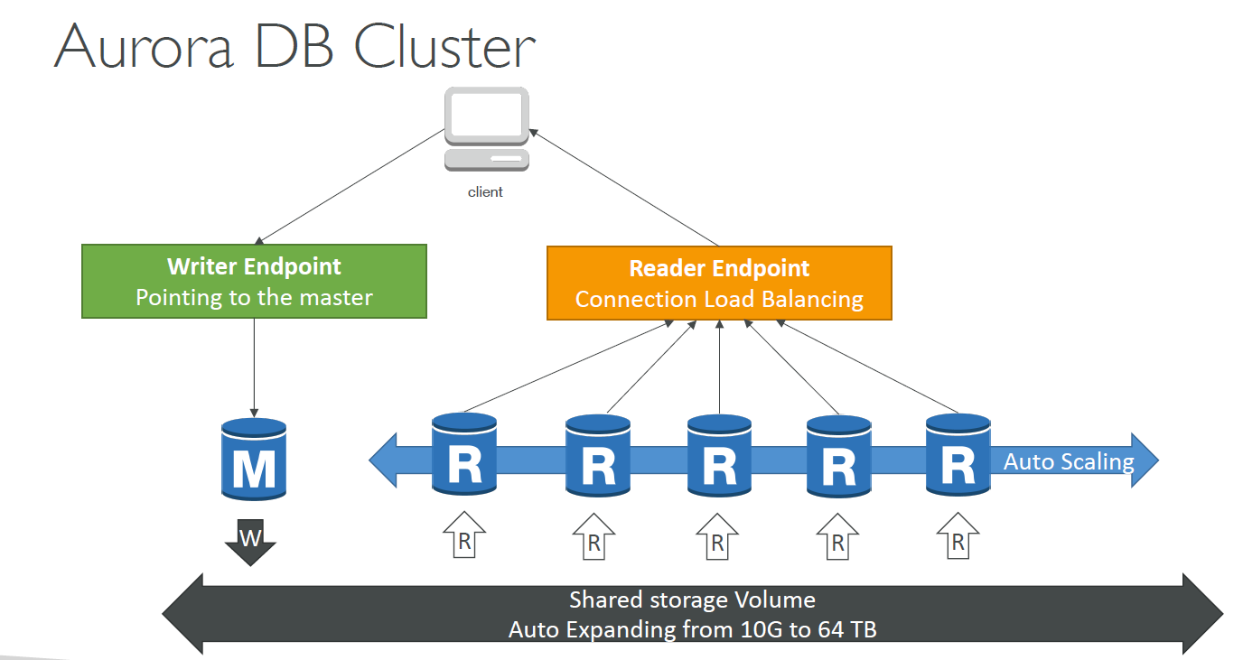

**Features of Aurora**

• Automatic fail-over

• Backup and Recovery

• Isolation and security

• Industry compliance

• Push-button scaling

• Automated Patching with Zero Downtime

• Advanced Monitoring

• Routine Maintenance

• Backtrack: restore data at any point of time without using backups

**Aurora Security**

• Similar to RDS because uses the same engines

• Encryption at rest using KMS

• Automated backups, snapshots and replicas are also encrypted

• Encryption in flight using SSL (same process as MySQL or Postgres)

• Possibility to authenticate using IAM token (same method as RDS)

• You are responsible for protecting the instance with security groups

• You can’t SSH

**Aurora Serverless**

* It is an automated database instantiation and auto scaling based on actual usage.
* It scales in and out automatically giving relational DB a flavor of distributed DB.
* No capacity planning required and pay per second.
* It is good for infrequent, intermittent or unpredictable workloads.(Exam tip)

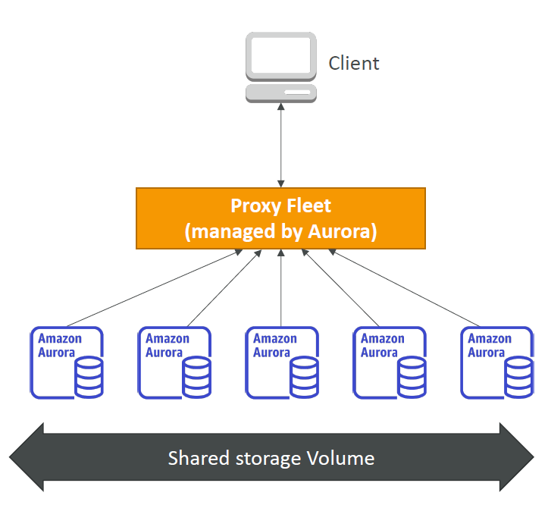

**Global Aurora**

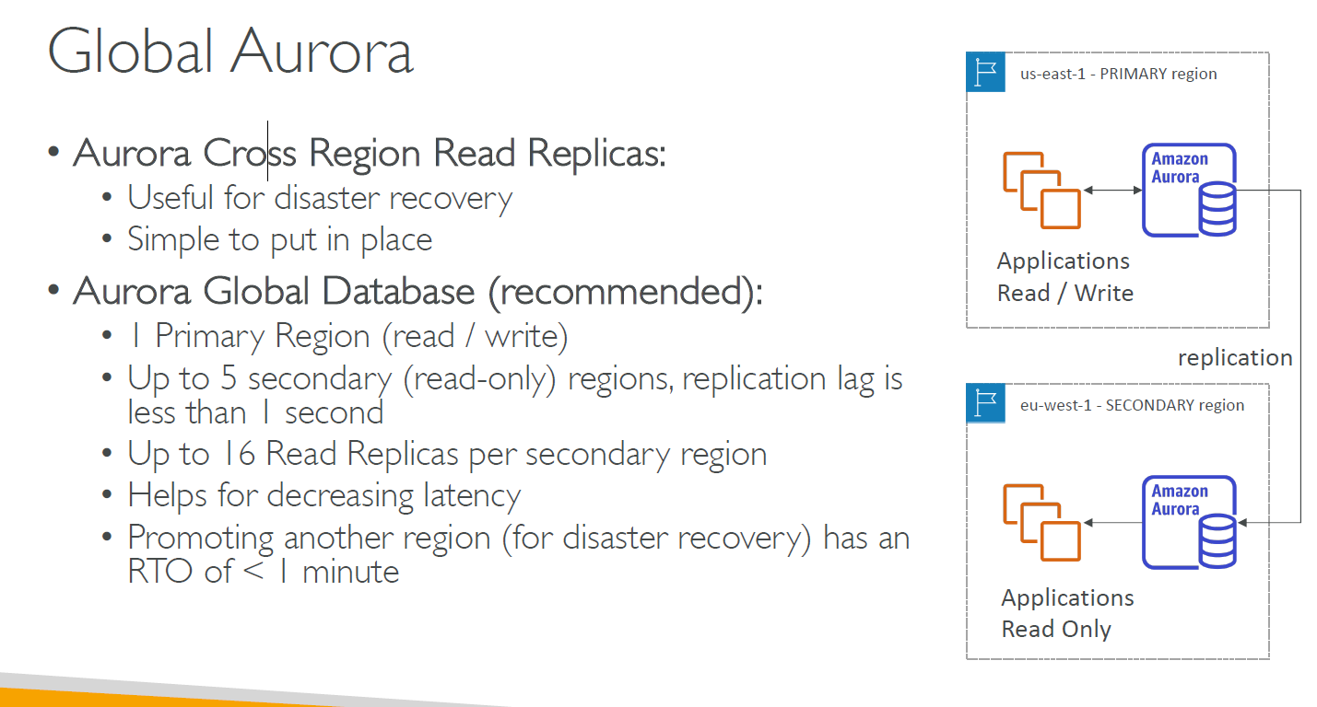

**Steps to create Aurora (Hands on)**

(Not free it is charged)

Search RDS

Choose a database creation method - standard Create

Engine options – Amazon Aurora

Edition – Amazon Aurora with MySQL compatibility. (or can use PostgreSQL as well)

Database location – Regional OR Global

Database features – One writer and multiple readers (select this)

One writer and multiple readers – parallel query

Multiple writers

Serverless

Templates – Free tier

DB instance identifier – my first MySQL

Username & password

DB instance size – db.r5.large (burstable classes)

Availability & durability – Multi AZ deployment - Create an Aurora Replica or Reader node in a different AZ

Publicly accessible – No

VPC security group – Create new for database port 3306

Database option – initial DB name – myDB

Enable backups – 7 days

Enable Encryption -- Yes / No

Backtrack – Yes/no

Deletion Protection

Hit Create database

## ElastiCache Overview

ElastiCache is to get managed Redis or Memcached

• Caches are in-memory databases with really high performance, low latency

• Helps reduce load off of databases for read intensive workloads

• Helps make your application stateless

• AWS takes care of OS maintenance / patching, optimizations, setup, configuration, monitoring, failure recovery and backups

• Using ElastiCache involves heavy application code changes

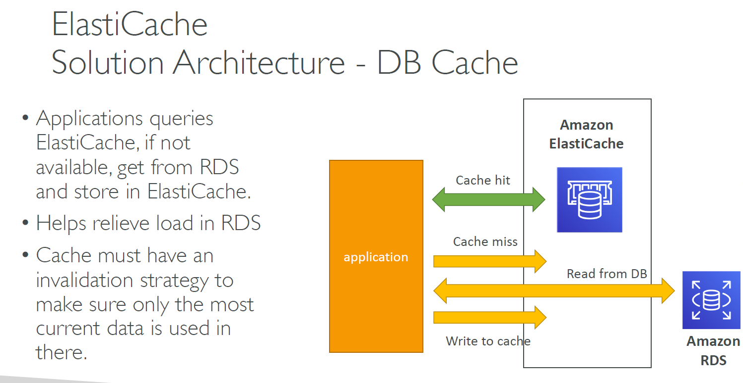

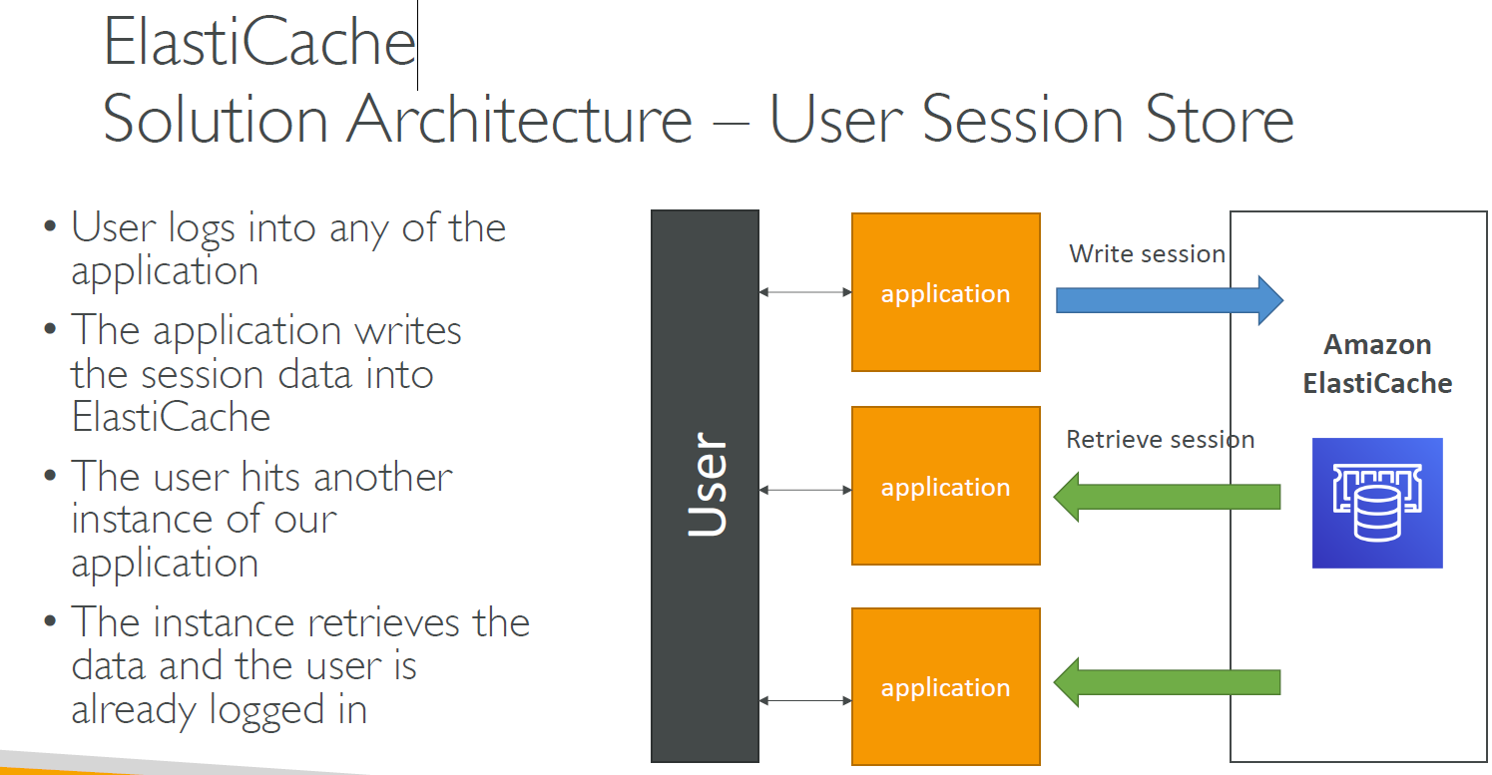

**Elastic Cache –Redis vs Memcache**

Redis is more like RDS whereas memcache is more like Elasticache

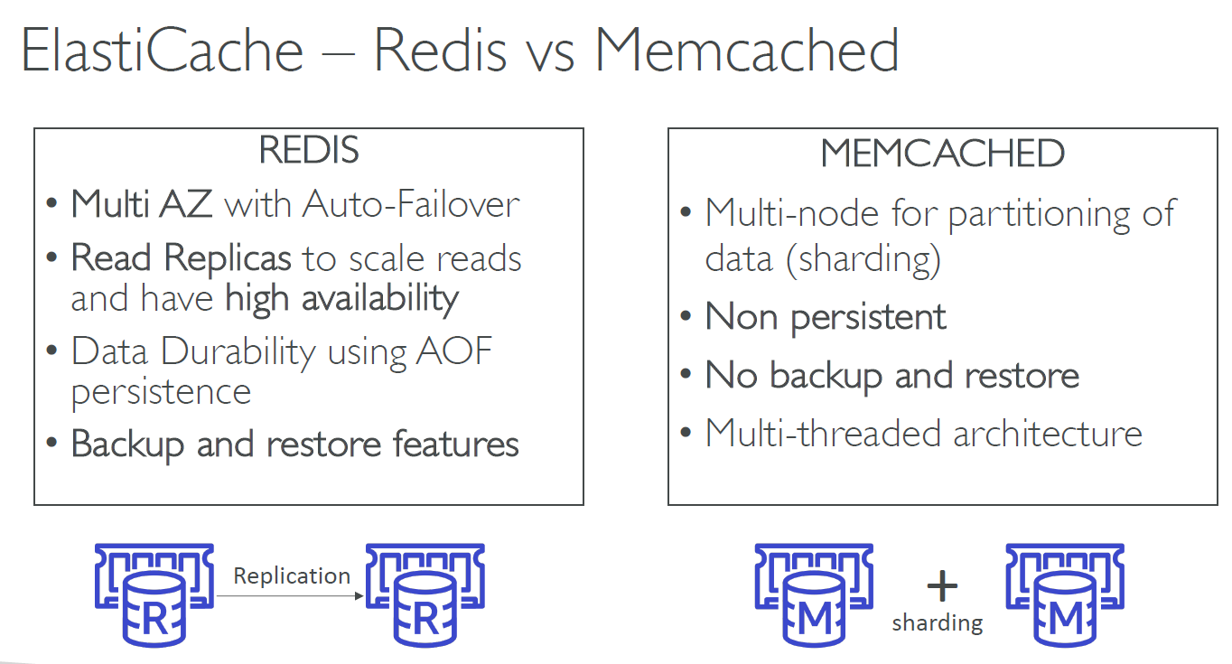

**How to create ElastiCache?**

Search ElastiCache Dashboard

Cluster engine – Redis / Memcache (Select Redis)

Redis Settings – Name, description, Engine version – 5.0.6, Port – 6379, Parameter group – default.redis5.0, Node type – cache.t2.micro, Number of replicas – 2 (but select 0)

Advanced Redis Setting –

Subnet-group – Create new, VPC Id, Subnets

Security group

Encryption-in-transit

Backup

Hit create button

**ElastiCache for solution Architecture**

Note – DO not support IAM authentication

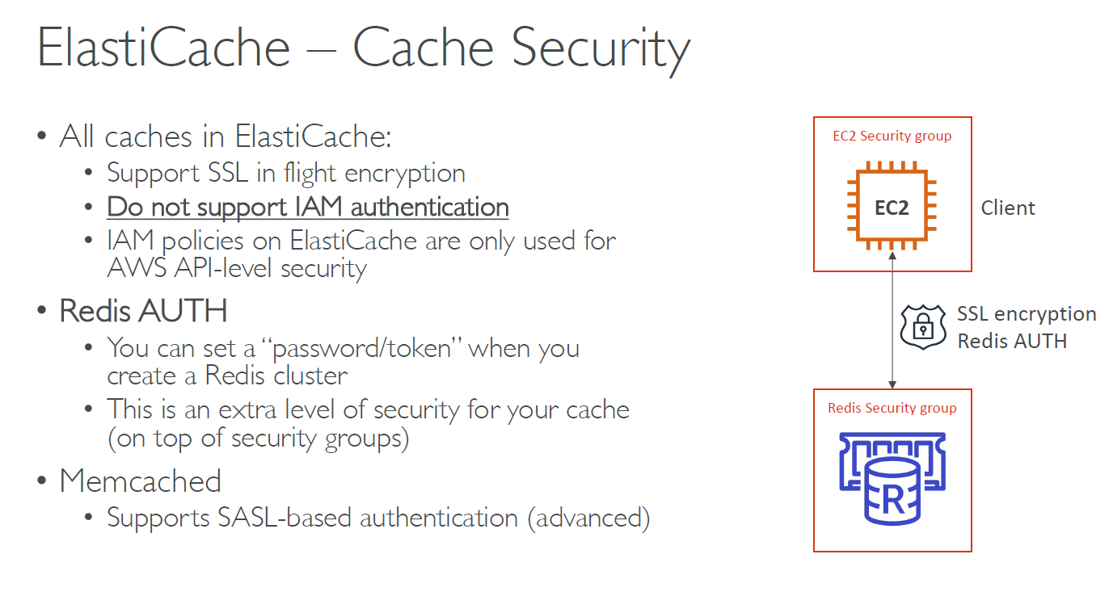

**Patterns for ElastiCache**

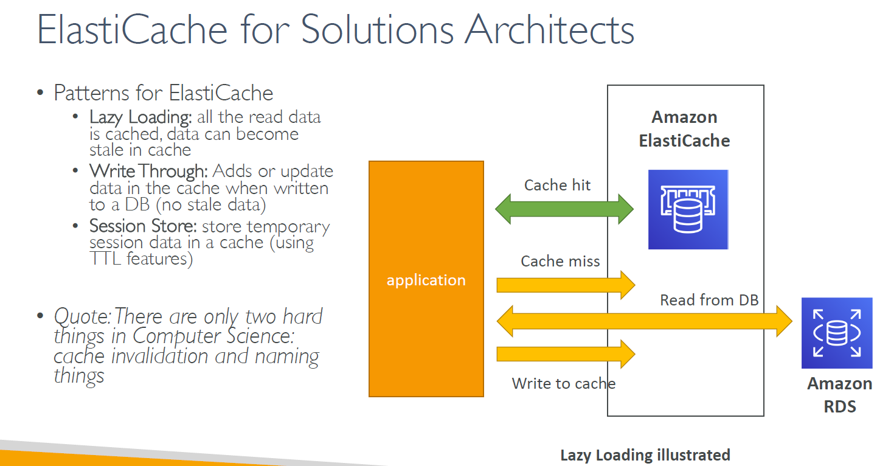

# AWS Route 53

Route 53 is a managed DNS (domain Naming system)

In AWS the most common records are –

• A: hostname to IPv4

• AAAA: hostname to IPv6

• CNAME: hostname to hostname

• Alias: hostname to AWS resource.

Route53 has some advanced features like –

Load balancing

Health checks

Routing policy etc

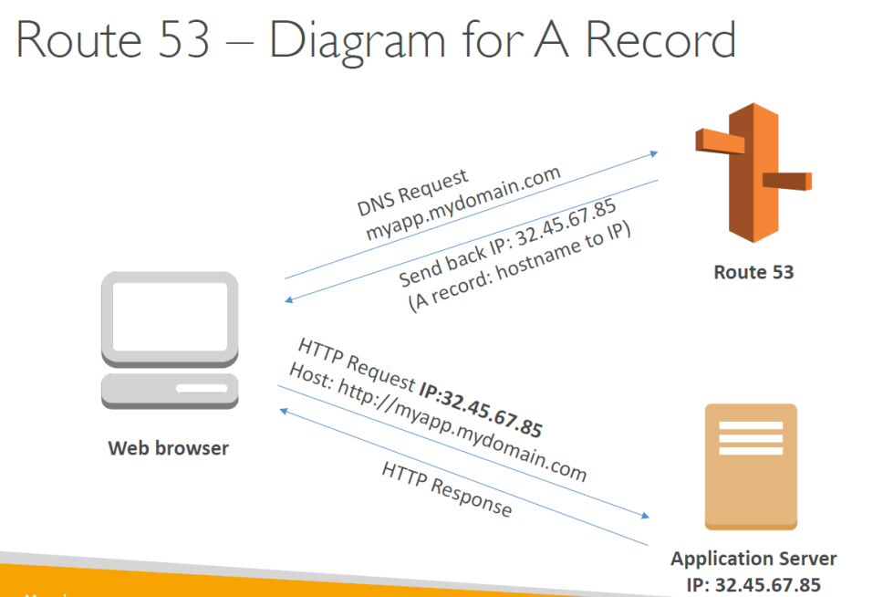

**Route53 hands on**

Search route53 🡪 hosted zone (it has no region, so no need to select any region)

Click on “registered domain” 🡪 choose a domain name

After the purchase is done you can check it on “Hosted zone”

Click on “create record set” 🡪 enter name, enter type – A (IPv4 address) 🡪 enter value 🡪 enter IP address 🡪 click on create

The above step means that once you hit the registered domain you would be redirected to the above entered IP address.

You can check by typing nslookup <domainName> Command in windows or dig <hostname> command in Linux

**Route S3 EC2 Setup**

1. Launch an EC2 in 3 different region(Ireland, us-east-1a,ap-northeast-1) using below User data script

#!bin/bash

yum update –y

yum install –y httpd

systemctl start httpd.service

systemctl enable httpd.service

EC2_AVAIL_ZONE = $(curl –s <http://169.254.169.254/latest/meta-data/palcement/availability-zone>)

echo “<h1> Hello world from $(hostname –f) in AZ EC2_AVAIL_ZONE </h1>” > /var/www/html/index/html

1. Create a load balancer for one of the instance –

Create an application load balancer, add name, select all availability zone, load balancer protocol – http port 80.

Create a new security group that allows all incoming traffic at port 80 (inbound rules – http port 80 0.0.0.0/0)

Configure routing 🡪 Enter target group as “Instance”, protocol http 80

Register target 🡪 click on the EC2 instance you had created in step 1.

Click on create. Hit the domain name and it redirects to your EC2 instance.

**DNS Record TTL**

It is the time to live specified so that till that time application can bypass DNS (route53) to directly hit the IP address in short the IP address is cached for TTL time(gathered after the first request)

## Route 53 CNAME vs Alias

**CNAME** – points a hostname to another hostname

However it works for only NON ROOT DOMAIN record (i.e. something.xx.mydomain.com, wont work for only mydomain.com)

**ALIAS** – points a hostname to a AWS resource

Example – something.xx.mydomain.com 🡪 bdb-12-3.us-east-1a.elb.amazonaws.com

Works for both NON ROOT DOMAIN as well as ROOT DOMAIN record

Free of charge

Has option to do Native health check of the AWS resource

Note – you can use CNAME for an AWS resource as well however it s chargeable whereas if you use ALIAS instead of CNAME it is free.

## Routing Policy

This option is present as “Routing policy” while creating record set –

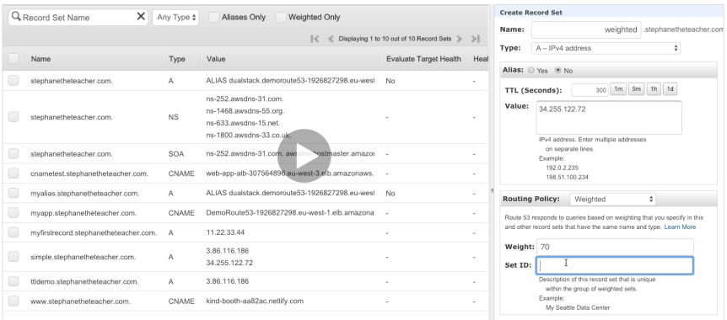

**Simple –**

You can’t attach health checks to simple routing policy

You can add multiple values and client would choose which one to redirect to.

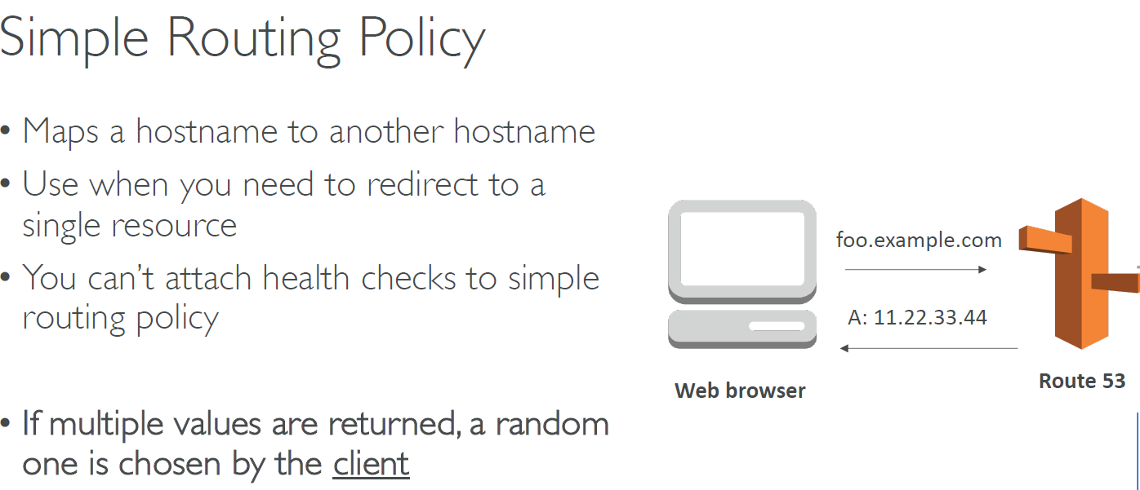

**Weighted –**

Control the % of the requests that go to the specific endpoint

Create more than one record set with different %

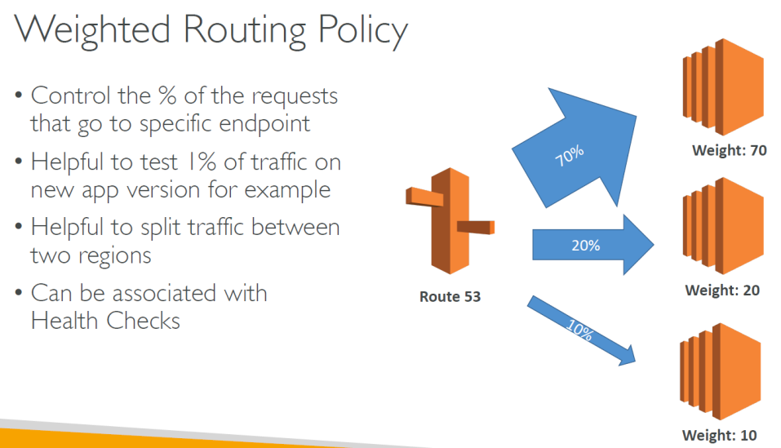

**Latency**

Redirects to the server that the least latency to the client

Latency is evaluated in terms of user to designated AWS region

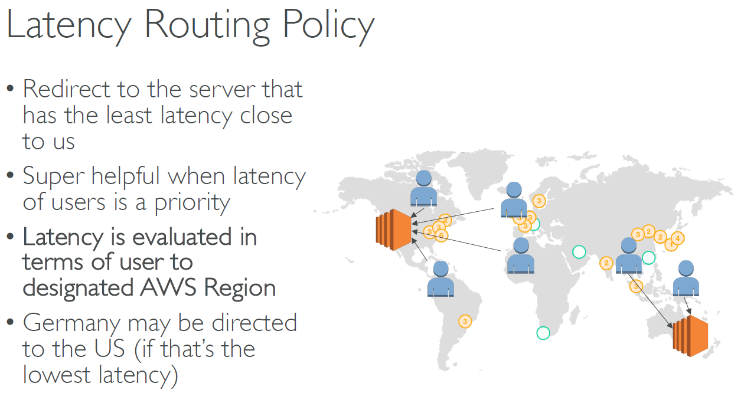

## Route53 Health Checks

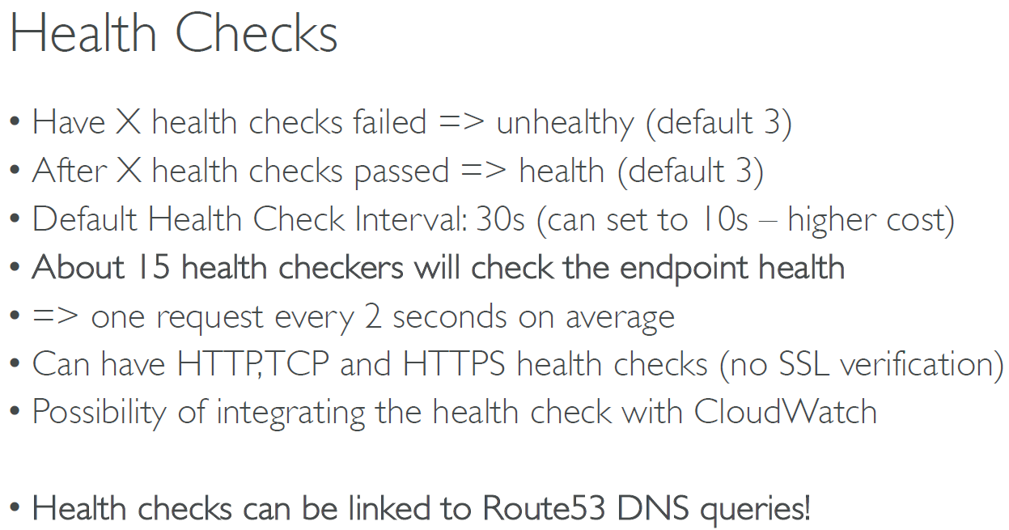

**How to configure health checks?**

Route53 dashboard 🡪 health checks 🡪 create health checks

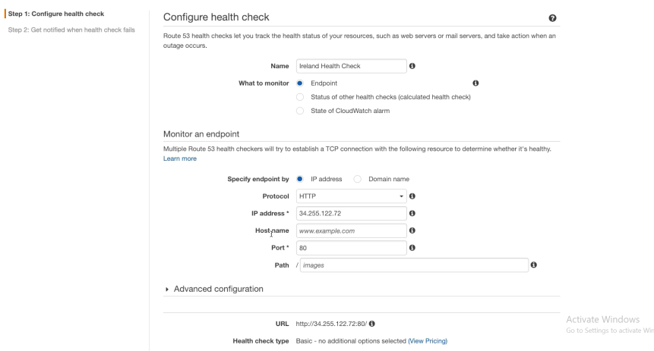

## Advanced Routing Policy

**Failover routing policy**

Health check is mandatory

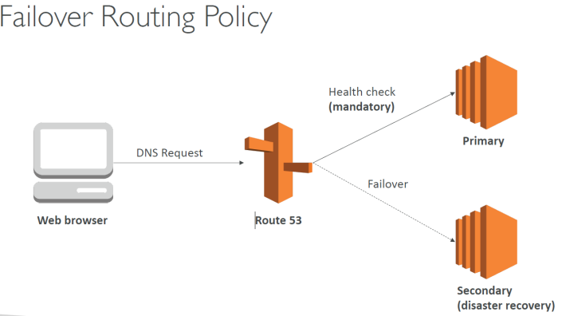

**How to create?**

Primary

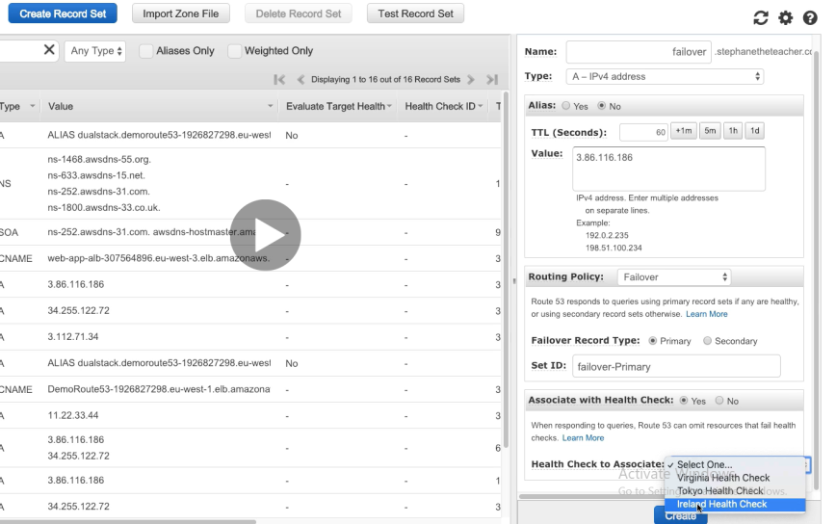

**Secondary**

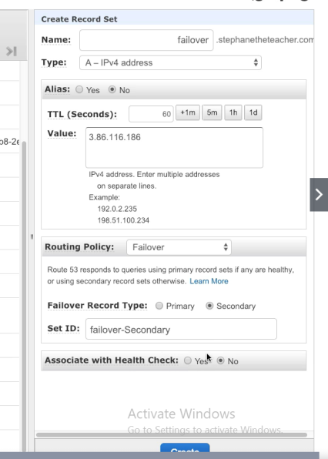

**Geo location routing policy**

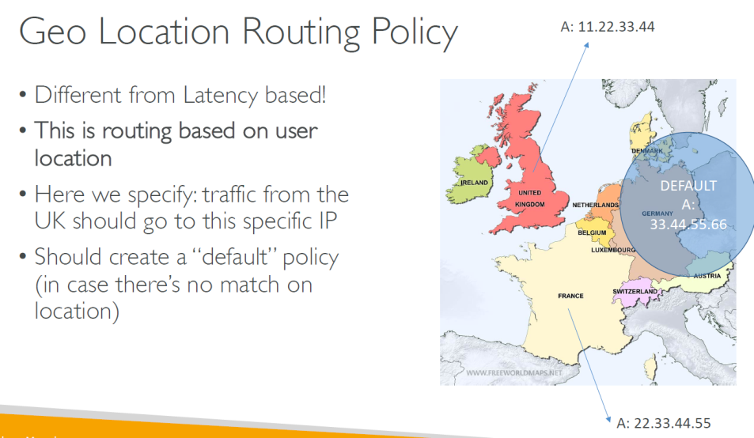

**How to create it?**

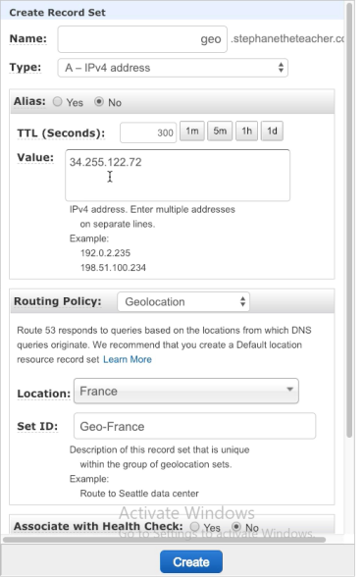

**Multi Value Routing policy**

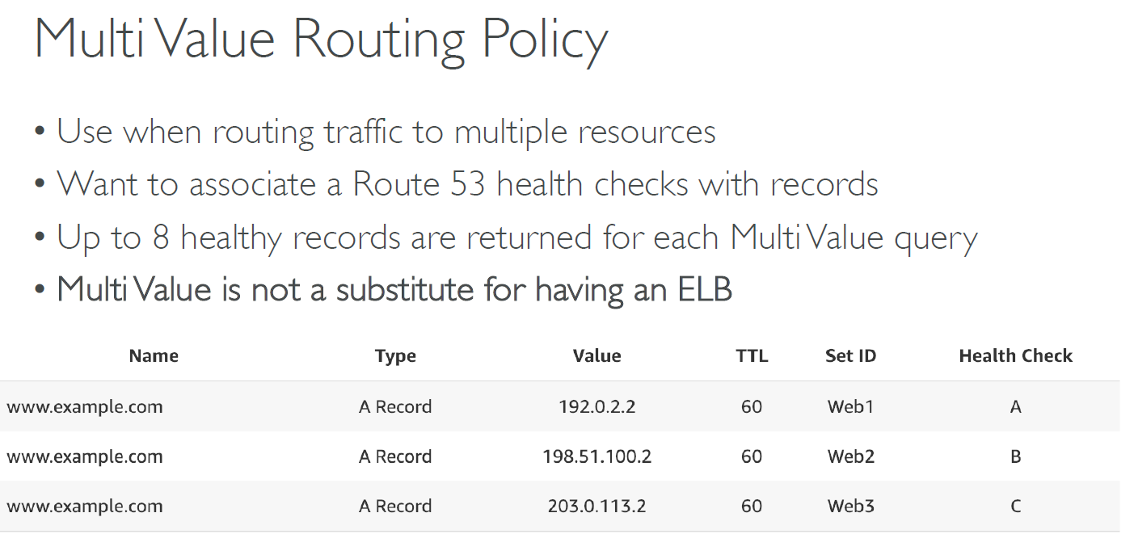

## 3rd party domain and Route 53

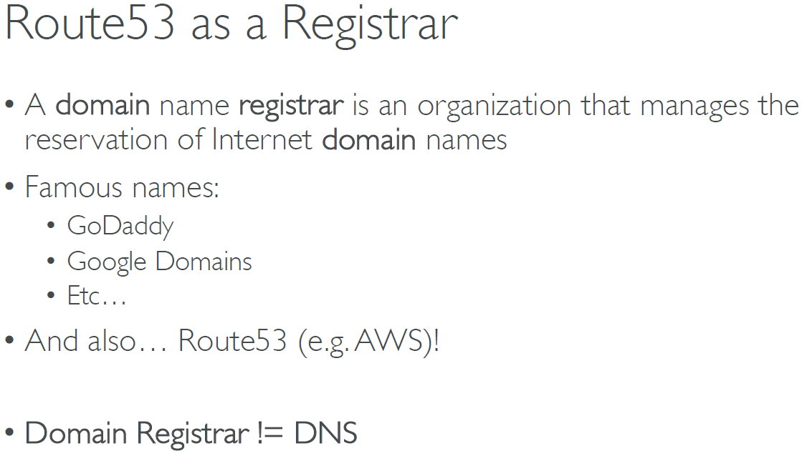

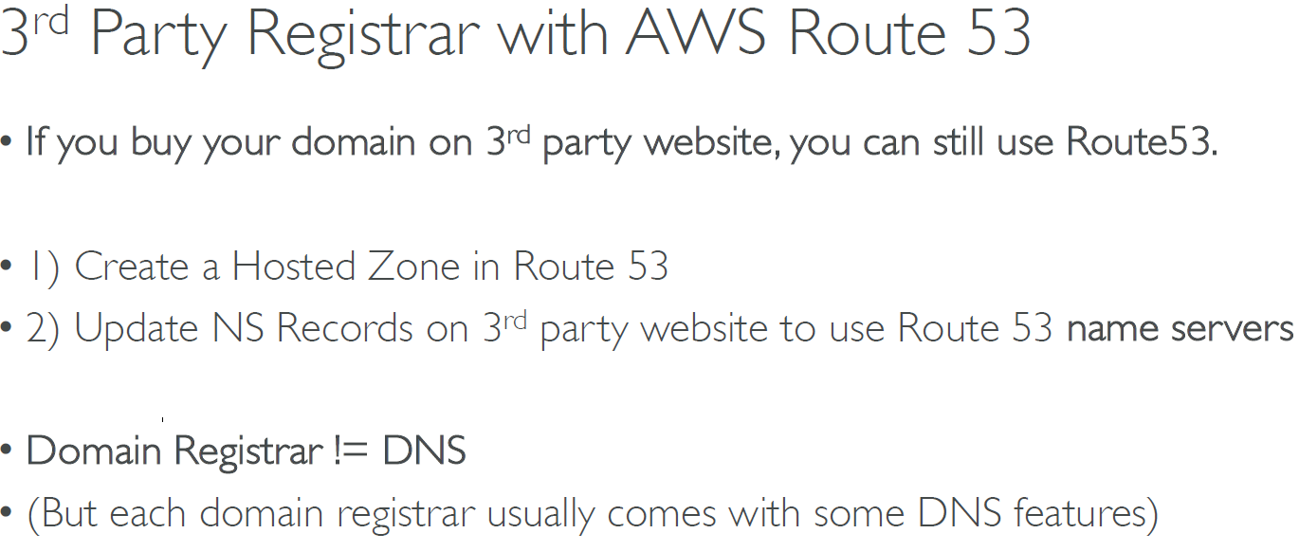

# Classic Solution Architecture

## WhatTimeItIs.com Stateless App

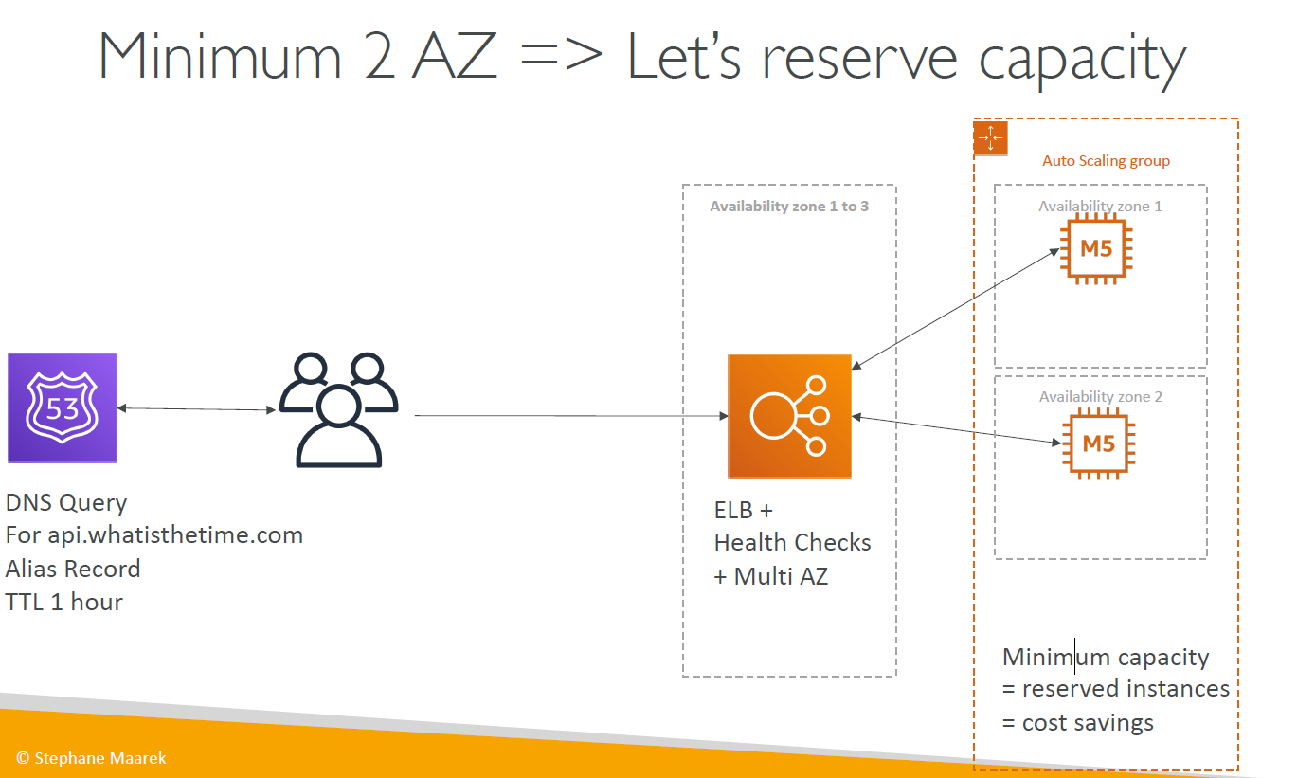

## MyClothes.com Stateful Web App

We need to scale, maintain horizontal scalability and keep our web application as stateless as possible

Users should not lose their shopping cart

Users should have personal details like address, name etc

Step 1 –

Introducing stickiness solves the problem where the shopping cart is saved on one instance and every request from the same customer goes to the same instance.

However if one instance goes down, it would lose the concerned shopping cart it holds in memory

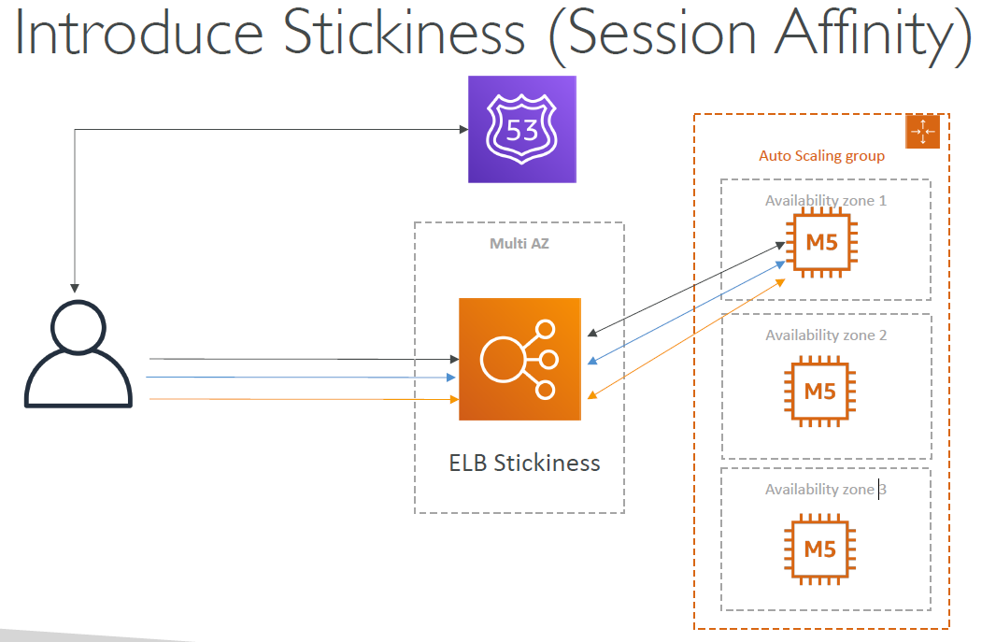

Step 2 – Introduce cookies

Problems – Makes http heavier

Security risk .Cookies must be validated. Cookies must be less than 4 KB

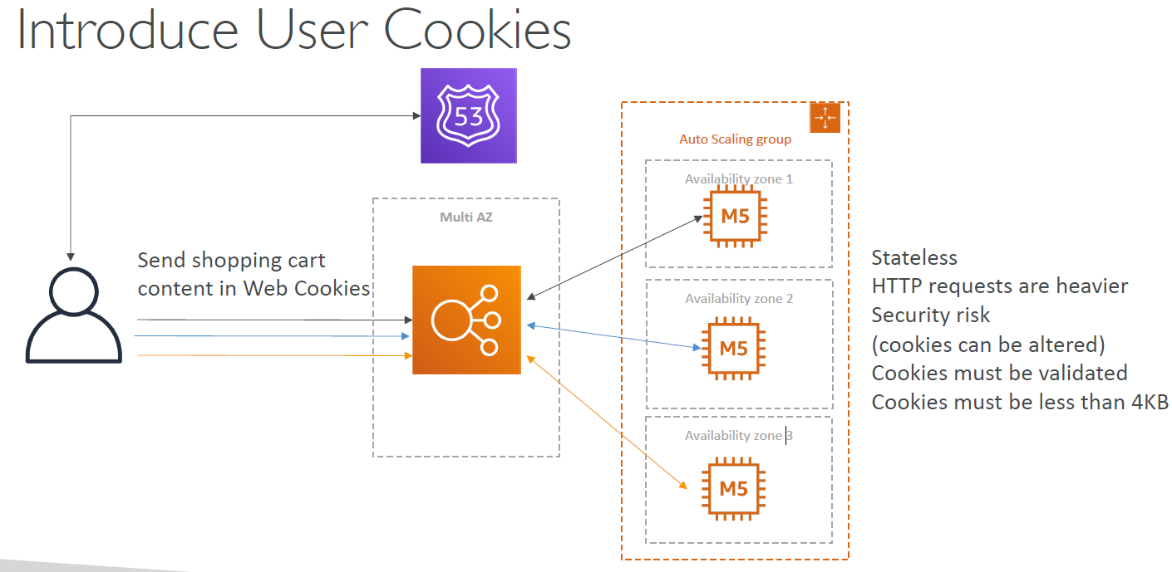

Step 3 – Introduce ElastiCache

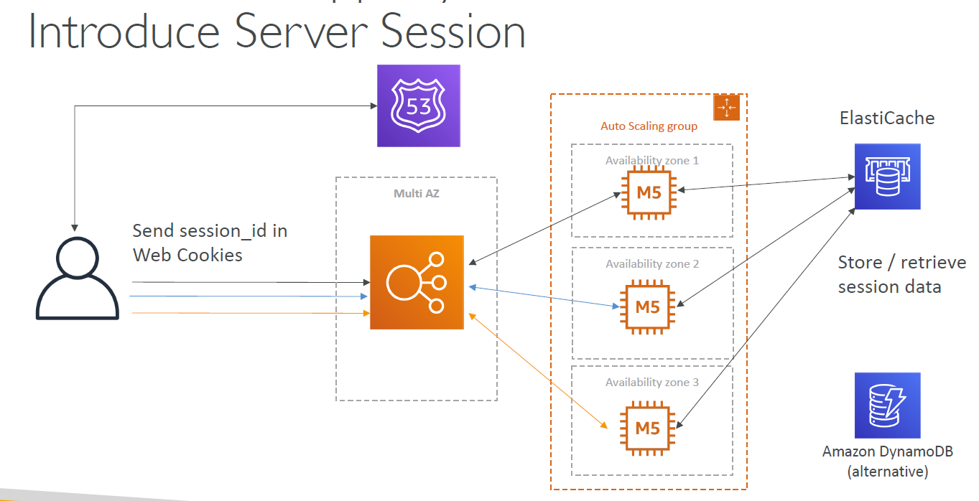

*

**Step 3 – Storing data in database**

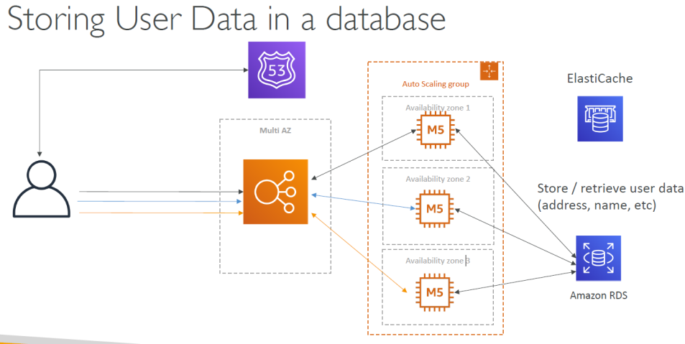

**Step 4 – Scaling reads using Read replicas**

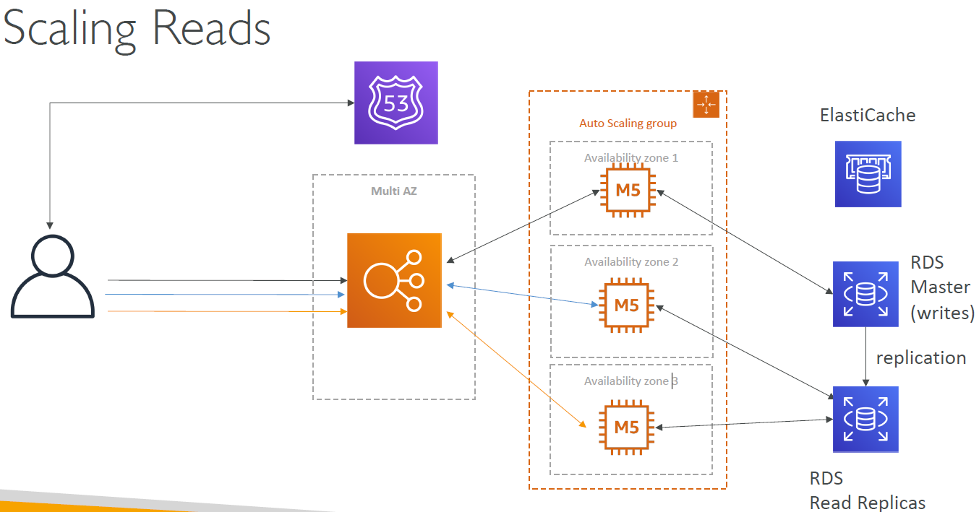

**OR (scaling reads using write through cache)**

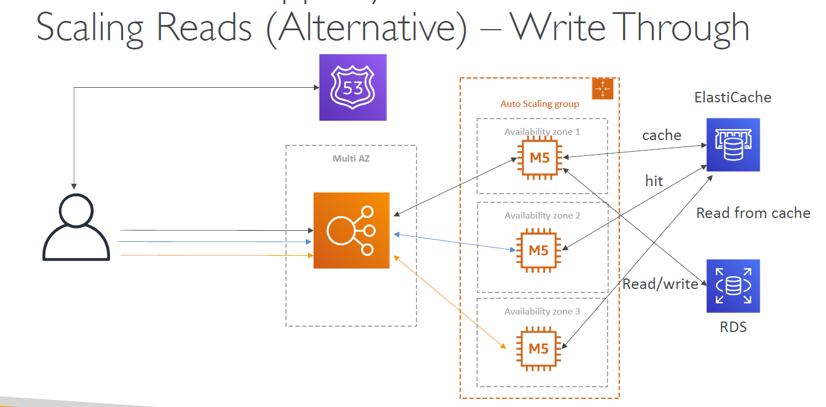

**Step 5 – Make application survive disaster**

Route 53 is already highly available and Multi AZ

ELB and all EC2 instances are made multi AZ

Make ElastiCache and RDS also multi AZ

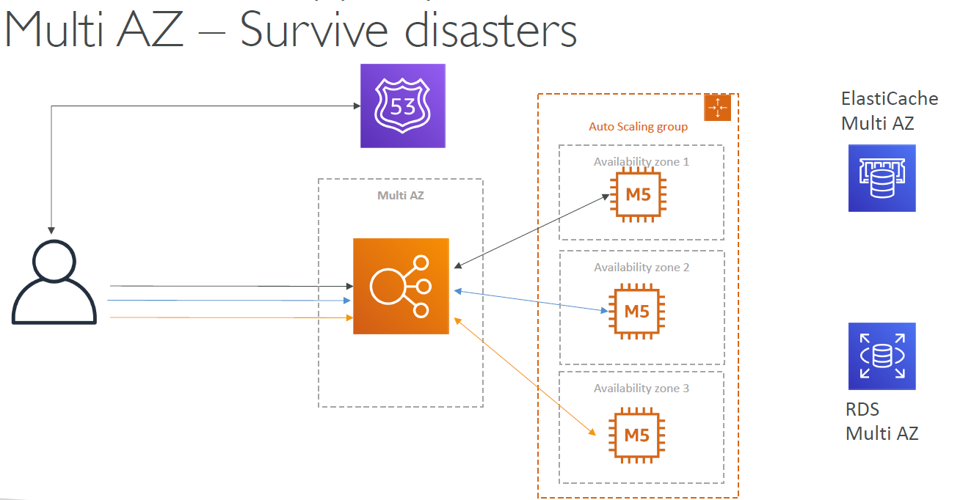

**Step 6 – Making the application secure using Security groups**

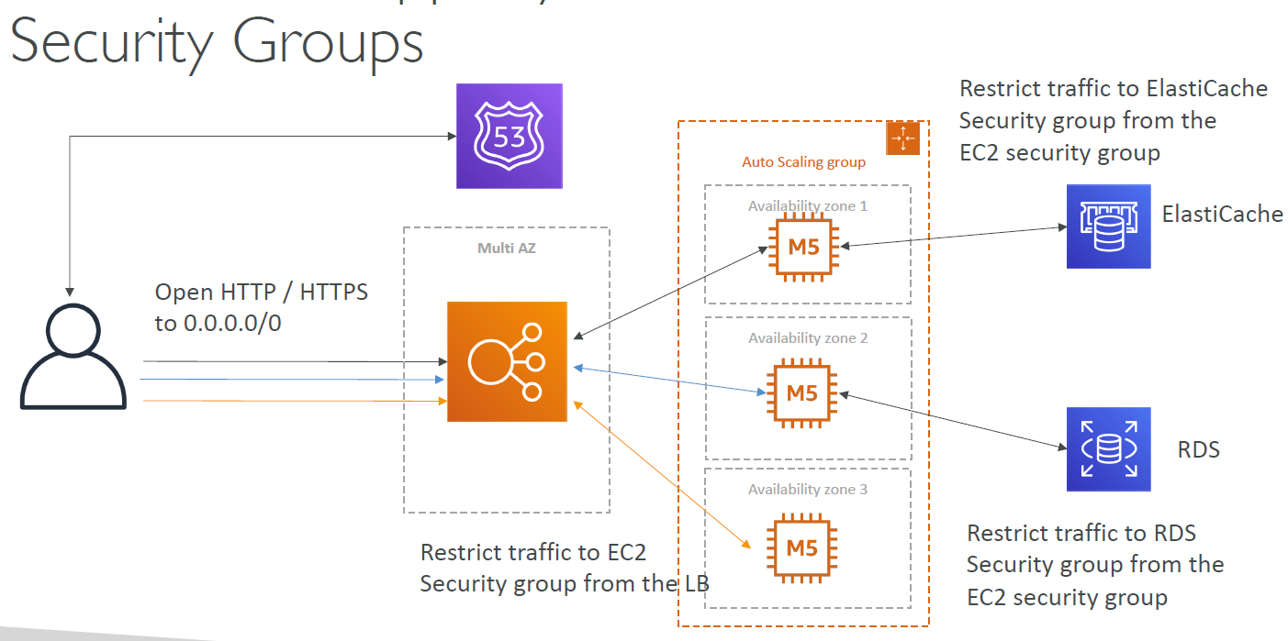

## MyWordPress.com – Stateful App

We want that the website to access and correctly display pictures uploads

Our user data and the blog content must be stored in MySQL database.

**Step 1 – Either use RDS or Aurora (personal choice of the author)**

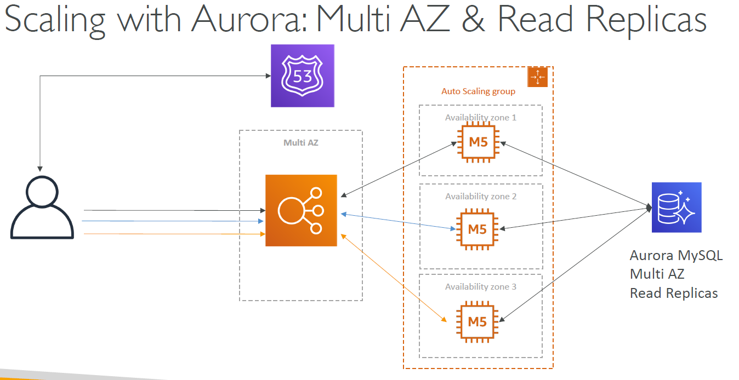

**Step 2 – Storing images**

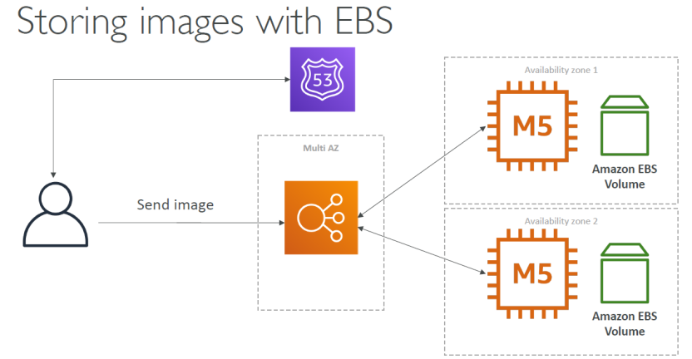

**Step 3 storing images with NFS**

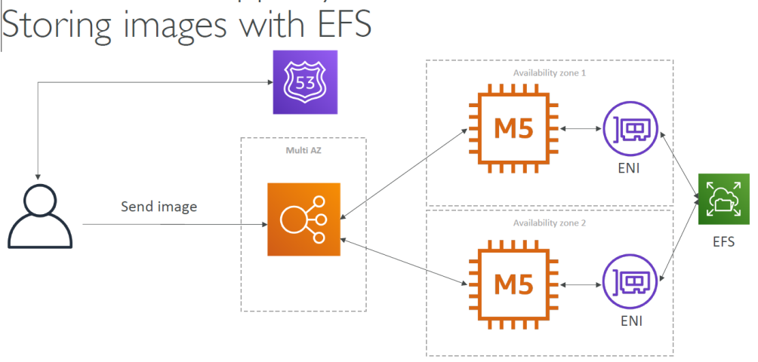

## Instantiating Applications quickly

EC2 instances –

Use a golden AMI – Install your applications, OS dependencies etc. beforehand and launch your EC2 instances form the Golden AMI

Bootstrap user data -- For dynamic configuration, use user data scripts

Hybrid – Mix of golden AMI and user data

RDS databases –

Restore from a snapshot: the database will have schemas and data ready

EBS volumes –

Restore from a snapshot: the disk will already be formatted and have data !

## AWS ElasticBeanstalk overview

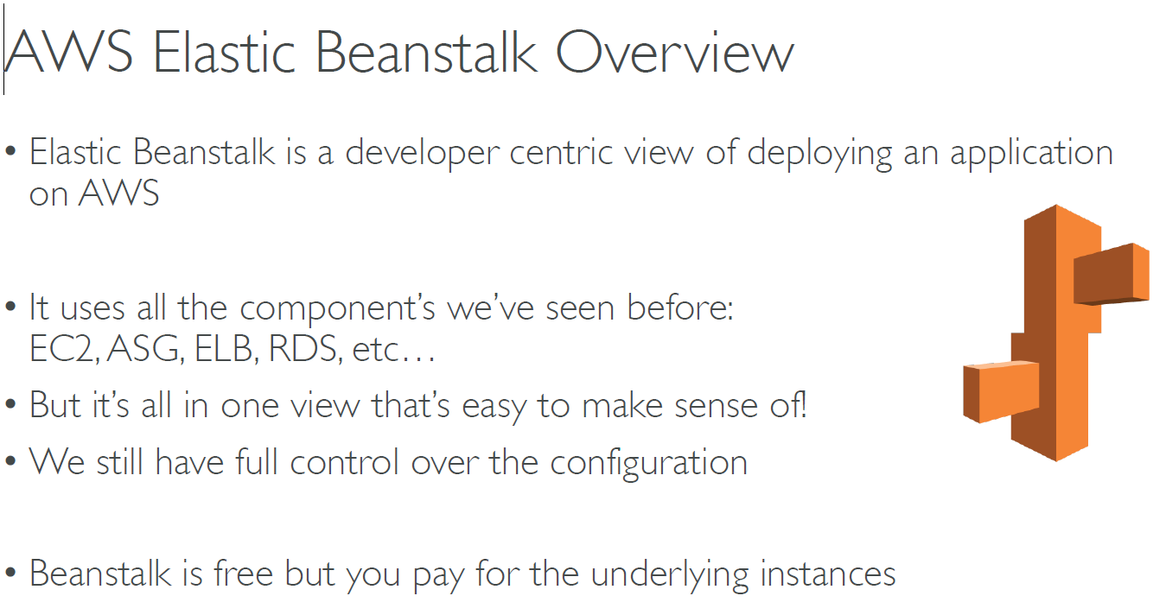

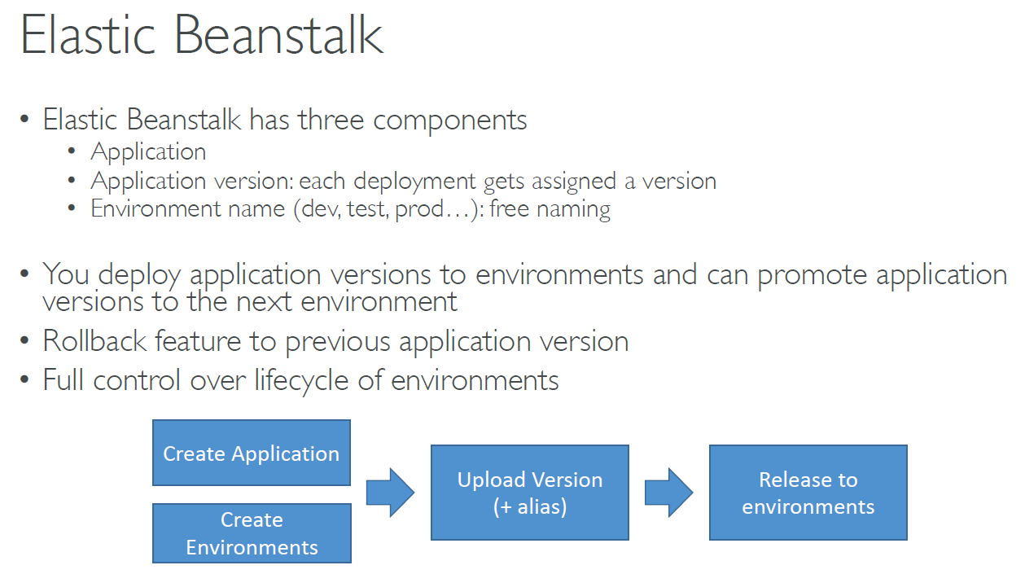

**BeanStalk hands on**

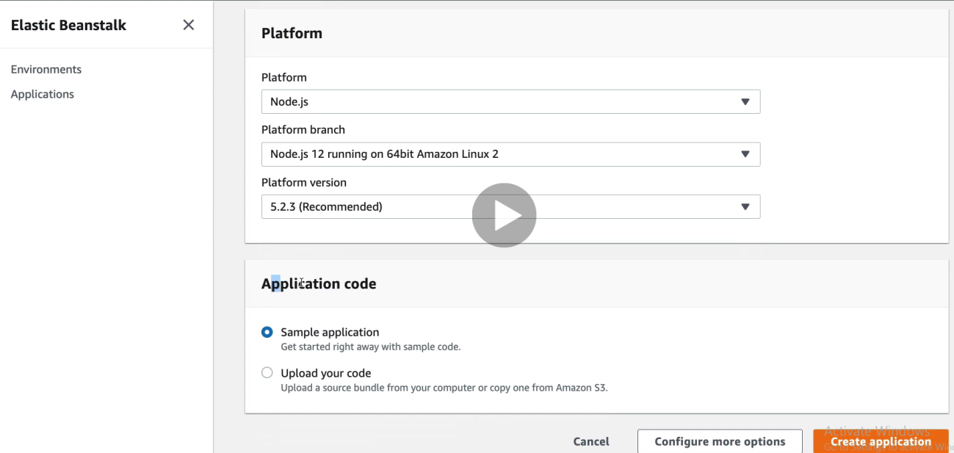

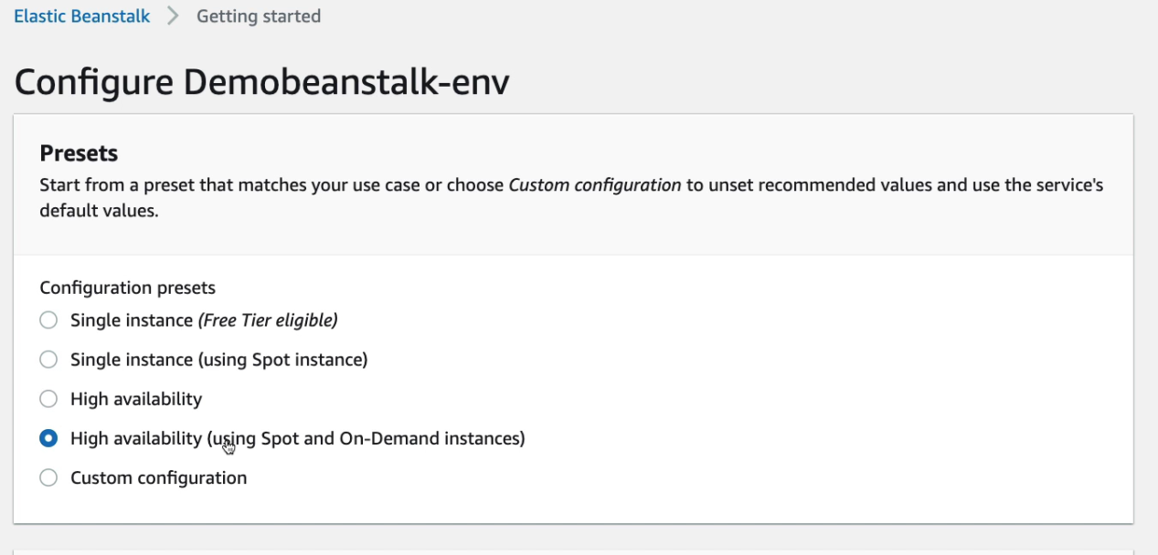

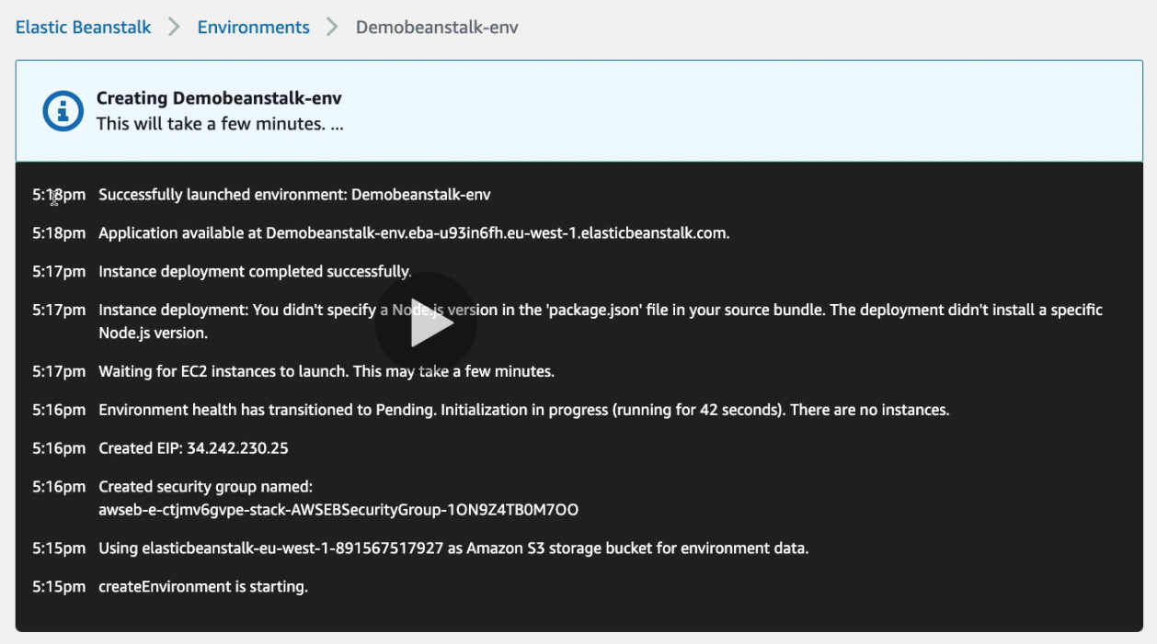

# Serverless Overviews from a Solution Architecture perspective

**Serverless**

The developers don’t have to manage servers anymore

They just deploy code … functions

Intially .. Serverless == Faas (Function as a service)

Serverless doesn’t mean there are no servers. It means you just don’t manger / provision/ see them

**Why AWS Lambda**

**EC2**

Virtual Servers in the cloud

Limited by RAM and CPU

Continuously running

Scaling means intervention to add / remove servers

**Lambda**

Virtual functions - no servers to manage!

Limited by time - short executions

Run on demand

Scaling is automated!

**Benefits of Lambda**

Pay per request and compute time

Free tier of 1,00,000 AWS lambda request and 400,000 GBs of compute time

Integrates with whole AWS suite of services, many programming languages , AWS cloud watch (nodejs , Pythod, Java,C# Ruby ,Rust)

**Docker is not for AWS Lambda !**

Cloud watch Events bridge -- > cron job

First 1,000,000 request are free

Pay per duration (very cheap to run Lambda)

**Lambda Limits**

AWS Lambda Limits to know - per region

Execution:

Memory allocation - 128MB - 3008 MB (64 MB increments)

Maximum execution time 900 seconds (15 minutes)

Disk capacity in the function container: 512 MB

Concurrency executions: 1000

Deployment:

Lambda function deployment size (compressed .zip): 50 MB

Size of uncompressed deployment: 250 MB

Can use /tmp directory to load other files at startup

Size of env variables: 4 KB

**Lambda hands on**

Search Lambda , change the url add “begin” as shown in below mail .Hit Run button below

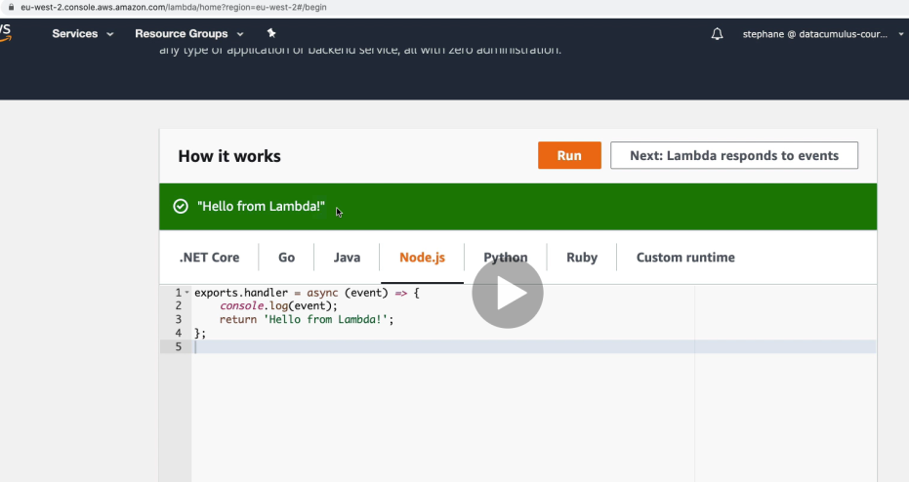

Click on “Lambda responds to events”

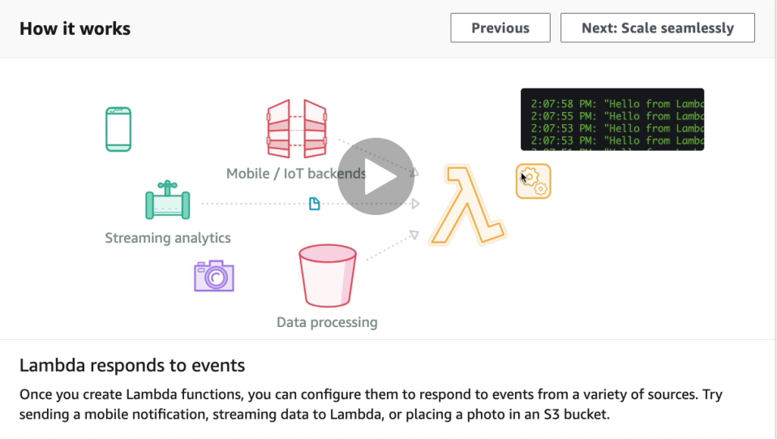

Click on “Next: Scale seamlessly”

First 1 million requests are free and hence it doesn’t cost you. Check below

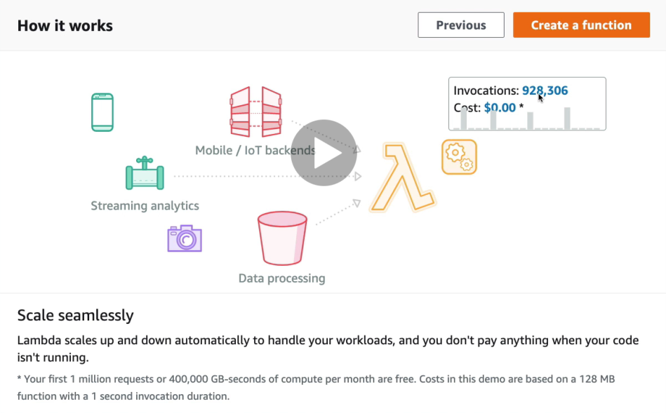

Click on “create function”

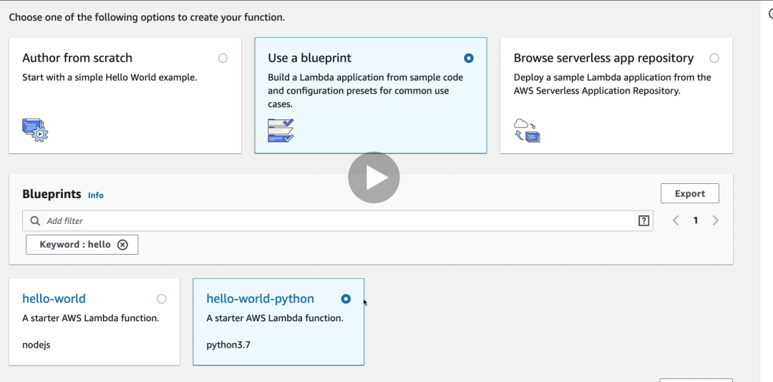

Click on “next”

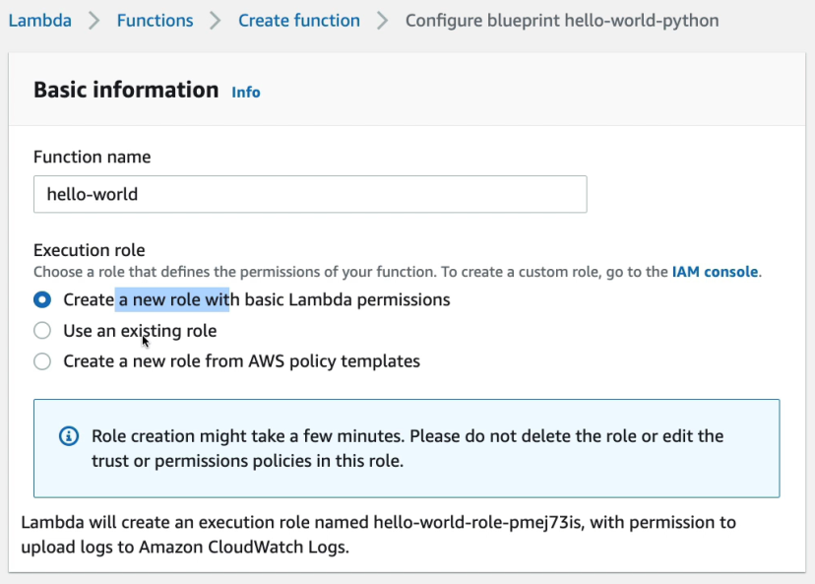

You have option of “Lambda function code”

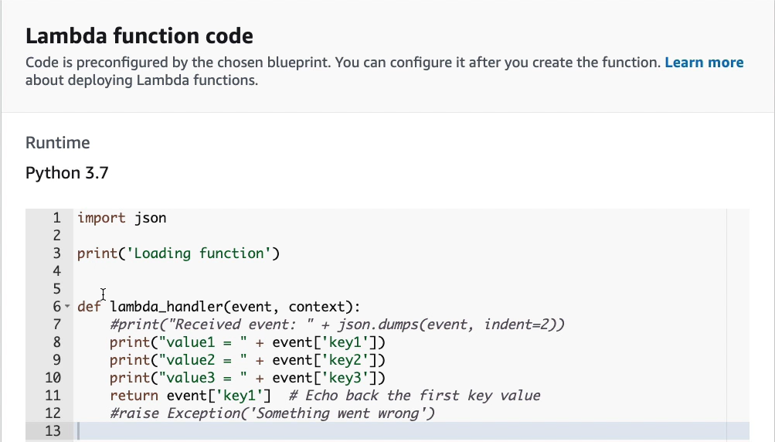

Click on “create function”

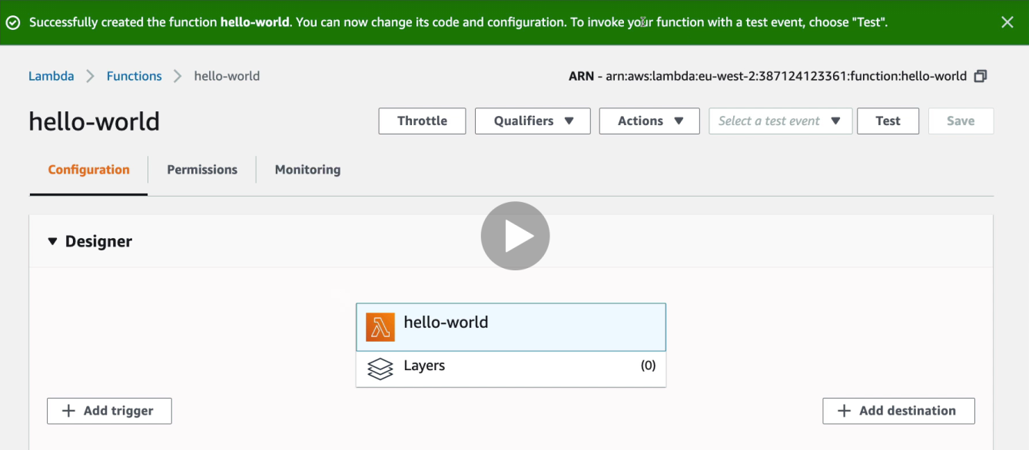

## Lambda@Edge

• You have deployed a CDN using CloudFront

• What if you wanted to run a global AWS Lambda alongside?

• Or how to implement request filtering before reaching your application?

• For this, you can use Lambda@Edge: deploy Lambda functions alongside your CloudFront CDN

• Build more responsive applications

• You don’t manage servers, Lambda is deployed globally

• Customize the CDN content

• Pay only for what you use

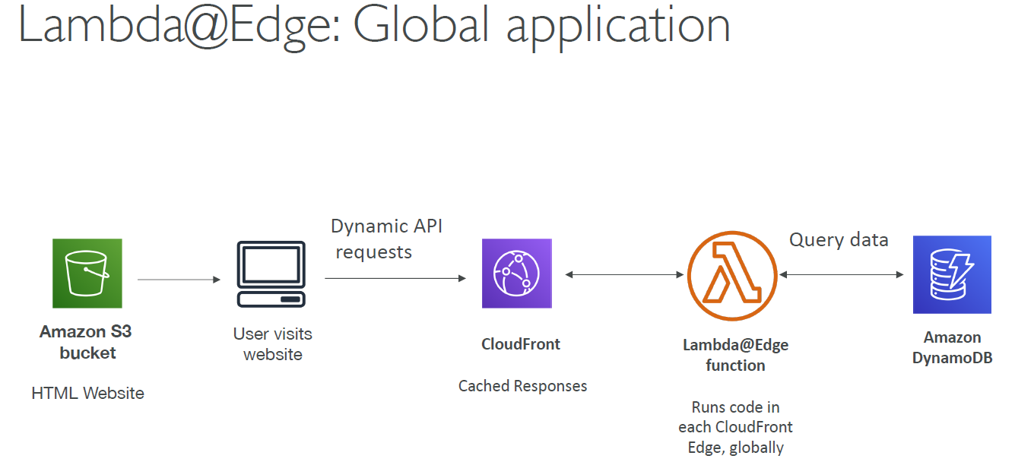

**Lambda@Edge : Use case**

* Website security and privacy
* Dynamic Web Application at the edge
* Search Engine Optimization (SEO)
* Intelligently Route Across Origins and Data centers
* Bot mitigation at the Edge
* Real time image transformation
* User Authentication and Authorization
* User Prioritization
* User tracking and Analytics

## DynamoDB

* It is a fully managed, NoSql, highly available with replication across 3 AZ.
* Scales to massive workloads, distributed database
* Low cost, fast, consistent in performance, integrated with IAM for security, administration and authorization.
* Enables event driven programming with DynamoDB streams.

**DynamoDB for Lambda**

* **Table must have provisioned read and write capacity units.**
* **Read Capacity Units (RCU): throughput for reads .**
* **Write capacity Units(WCU) : throughput for writes**
* **This means Read is less expensive than write**
* **Throughput can be exceeded temporarily using "burst credit"**
* **If burst credit are empty ,you'll get a "ProvisionedThroughputException"**

**DAX - DynamoDBAccelator –**

* Seamless cache
* Writes go through DAX to dynamo DB
* Solves the hot key problem (too many reads)
* 5 mins TTL for cache by default
* upto 10 nodes in cluster ,Multi AZ
* Secure through encryption (KMS, VPC etc.)

**DynamoDB Streams**

* Changes in DynamoDB can end up in a Dynamo Stream
* This can be used to react to changes in real time, Analytics, Insert into Elastic search, create views etc.

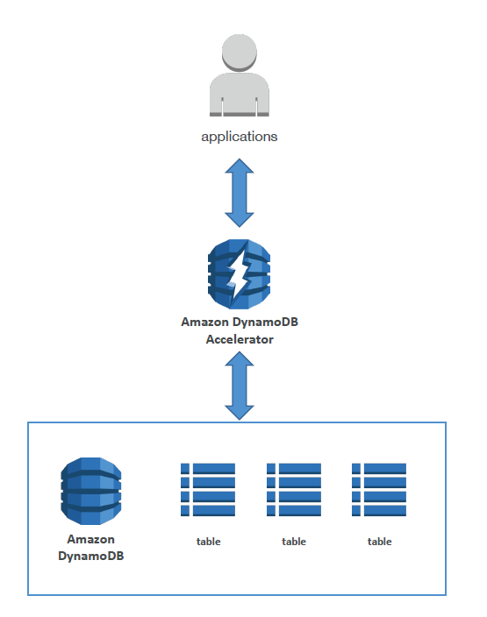 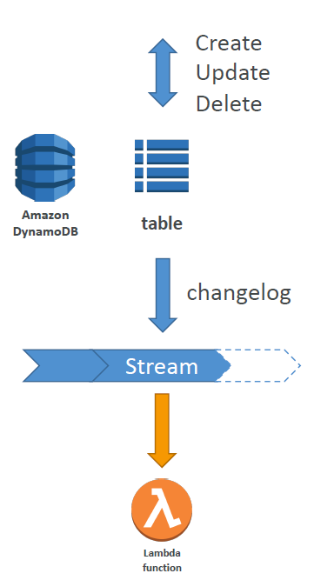

DynamoDB Accelerator diagram DynamoDB Streams

**DynamoDB - New Features**

**Transactions (new from Nov 2018)**

• All or nothing type of operations

• Coordinated Insert, Update & Delete across multiple tables

• Include up to 10 unique items or up to 4 MB of data

**On Demand (new from Nov 2018)**

• No capacity planning needed (WCU / RCU) – scales automatically

•2.5x more expensive than provisioned capacity (use with care)

• Helpful when spikes are un-predictable or the application is very low throughput

**DynamoDB Lambda Advanced features - Part 2**

**Backup and restore feature available**

**Global Tables**

* active active replication ,many regions
* Must enable DynamoDB streams
* Amazon DMS can be used to migrate to DynamoDB (from Mongo, Oracle, MySQL, S2 etc ..)

**You can launch a local DynamoDB**on your computer for development purpose

**Capacity Planning**

* provisioned WCU and RCU
* On demand capacity get unlimited WCU and RCU

## Lambda API Gateway

**Lambda API Gateway**

* Provides us http endpoint through which you can invoke Lambda
* No infrastructure to manage
* Supports for Websocket protocol
* Handles API versioning
* Handles security (Authentication and Authorization)
* Creates API keys, handle request throttling
* Swagger/Open API import to quickly define APIs
* Transform and validate requests and responses.
* Generate SDK and API specifications
* Cache API responses

**Integration with**

* invoke Lambda function
* HTTP endpoints in the backend
* AWS services - SQS etc

**API Gateway - Endpoint types**

* **Edge** - Optimized (default) - For global clients. API gateway still lives in only once region
* **Regional** - For clients within the same region
* **Private** - Can be only accessed from your VPC using and interface VPC endpoint .

## Lambda API Security –

Three ways to provide security via Lambda API Security –

1. IAM Permissions
2. Lambda Authorizers
3. Cognito User Pools

**IAM Permissions**

Great for users / roles already present in AWS account

Handles authentication + authorization

Leverages Sig v4

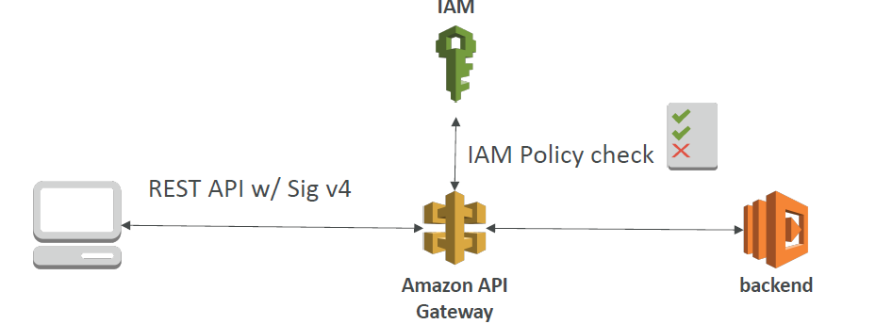

**Custom Authorizer:**

Great for 3rd party tokens

Very flexible in terms of what IAM policy is returned

Handles authentication + authorization

Pay per lambda invocation

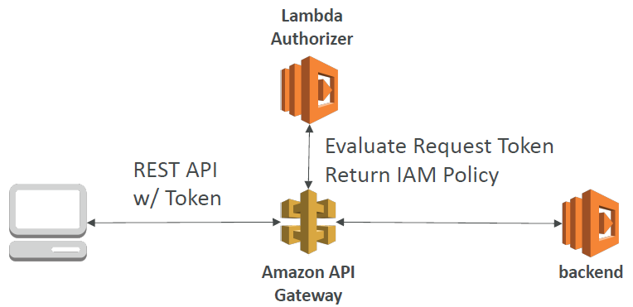

**Cognito User Pool:**

You manage your own user pool (can be backed by Facebook, Google login etc)

No need to write any custom code

Must implement authorization in the backend

Cognito only helps with authentication, and not authorization

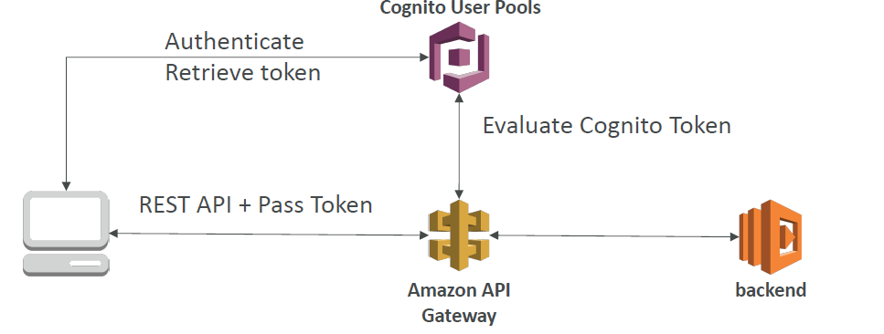

**Lambda AWS Cognito User Pools (CUP)**

Create a serverless database of user for your mobile apps

Simple login : Username (or email) / password combination

Possibility to verify emails /phone numbers and add MFA

An enable Federated Identities (Facebook, Google, SAML ..)

Sends back a JSON Web tokens (JWT)

Can be integrated with API Gateway for authentication

**AWS Cognito - Federated Identity Pools**

**Goal :**

Provide direct access to AWS Resources from the client side.

**How:**

Log in to federated identity provider - or remain anonymous.

Get temporary AWS credentials back from the Federated Identity Pool

These credentials come with a pre-defined IAM policy stating their permissions.

**Example:**

provide (temporary ) access to write to S3 bucket using Facebook Login

**Lambda AWS Cognito**

We want to give our users an identity so that they can interact with our applications.

**Cognito User Pools:**

Sign in functionality for app users

Integrated with API Gateway

**Cognito Identity Pools (Federated Identity)**

Provide AWS credentials to users so they can access AWS resources directly

Integrate with Cognito User Pools as an identity provider

**Cognito Sync: out of syllabus**

Synchronized data from device to Cognito

May be deprecated and replaced by App Sync

## API Gateway hands on

Search API Gateway

3 types –

HTTP API -- Lambda, HTTP backend

Web socket – Lambda, HTTP, AWS services for more real time application like chat board etc.

REST API – Lambda, HTTP, AWS services

REST API (for private VPN)

Select Rest API and click on Build

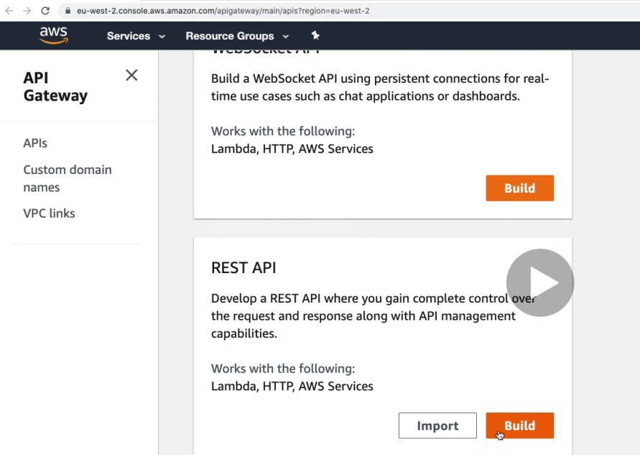

Click on “Create API” below --

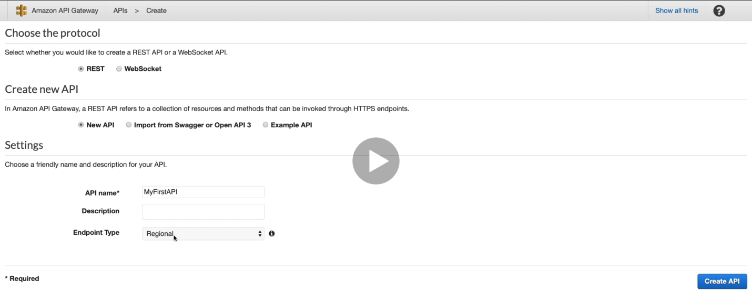

Create a new method under “/” and use “Lambda Function” as integration Type

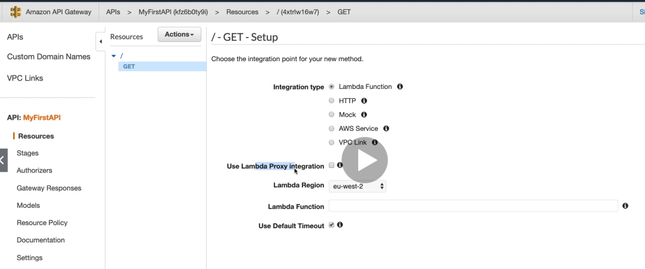

Create a lambda function using “author from scratch” option and python as language

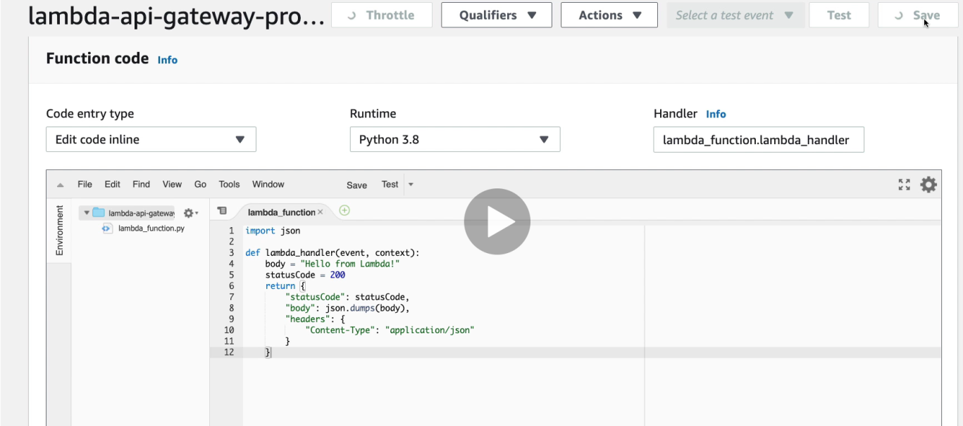

Use the above lambda function below and click on save

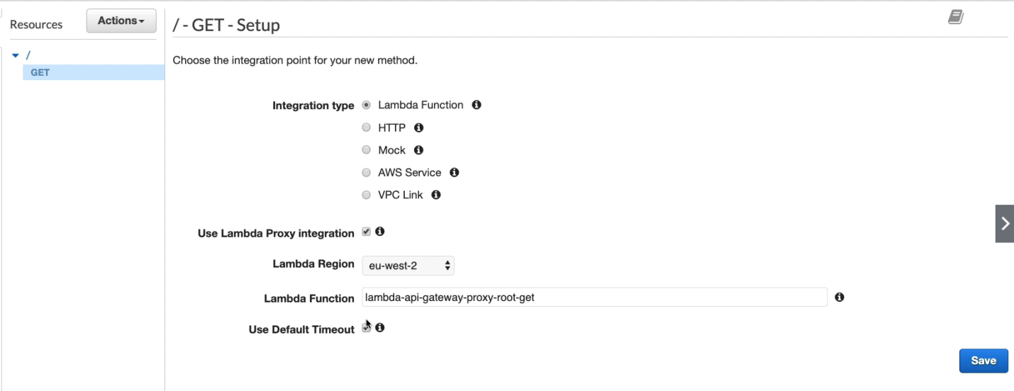

Final step

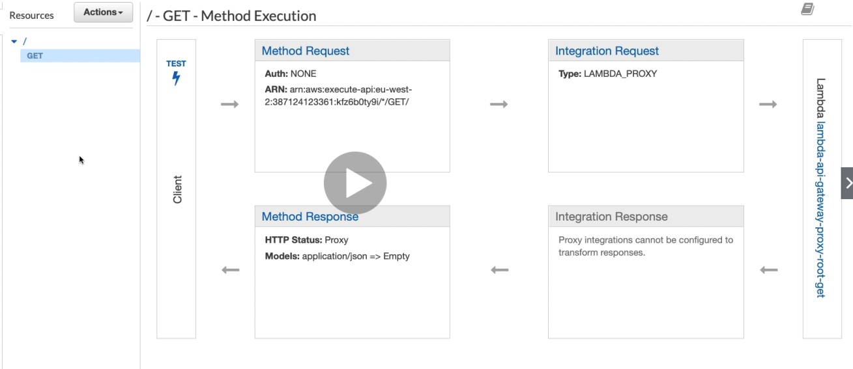

Click on Test and test it

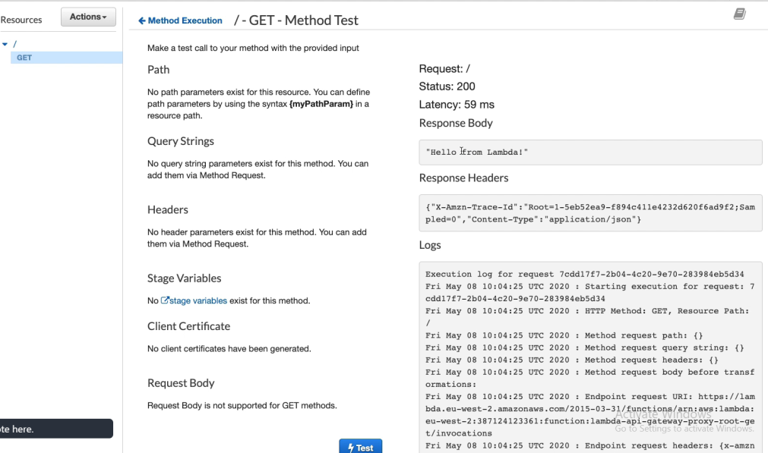

Click on “actions” 🡪 “Deploy API” to deploy the above API and then select deployment stage and hit “Deploy”

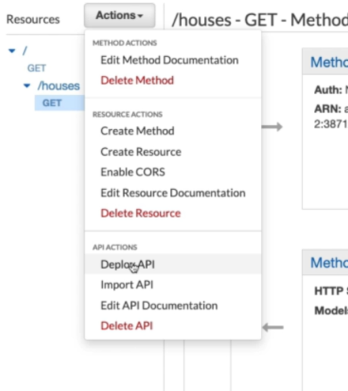 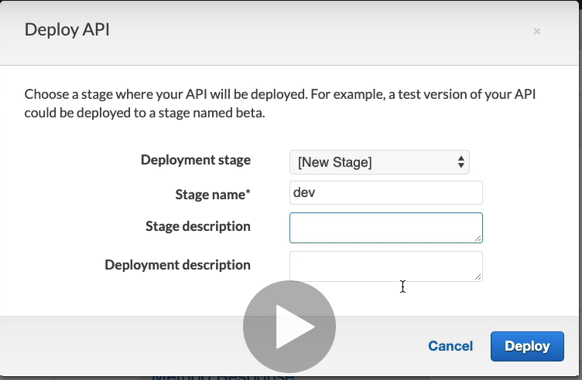

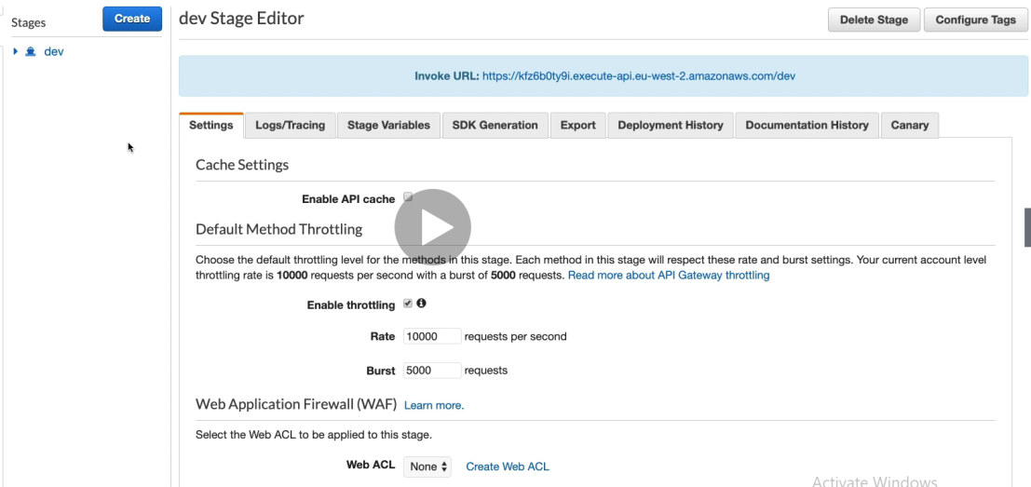

## AWS Serverless Application Model

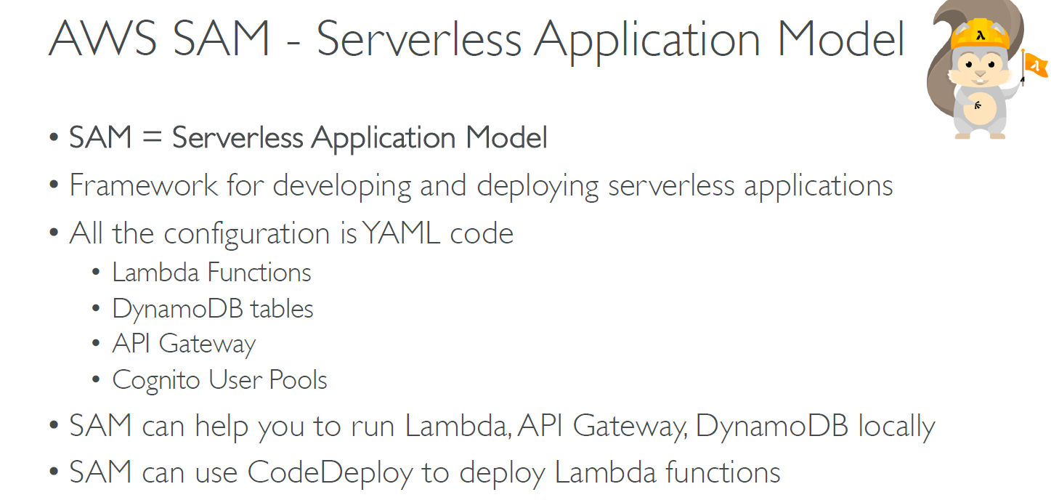

# Databases in AWS

**Database Types**

**RDBMS**: RDS, Aurora - great for joins, tabular format data

**NoSQL DB**: DynamoDB (~JSON), ElastiCache (key/value pairs), Neptune (graphs) - no joins, no SQL

**Object Store**: S3 /Glacier

**Data Warehouse**(for SQL Analytics/BI): Redshift(OLAP),Athena

**Search**: ElasticSearch(JSON) - free text , unstructured searches

**Graphs**: Neptune - displays relationships between data

**Choosing the Right Database:-**

* Read-heavy , write-heavy or balanced workload
* Throughput needs? (will it fluctuate )
* How much data to be stored and for how long and how much it would grow?
* Data durability? Source of truth for the data?
* Latency requirements? Concurrent users?
* Data model? How will you query the data? Joins? Structured? Semi Structured?
* Strong schema? More flexibilty? Search? RBDMS/NoSQL?
* License costs

## RDS

In RDS we tell Amazon what type of EC2 instance type we want, EBS volume and size etc. However we are not allowed to do an SSH in it

* Managed PostgreSQL/ Mysql/ Oracle/ SQL server
* Must provision an EC2 instance and EBS Volume type and size
* support for Read replicas and MultiAZ
* Security through IAM, Security groups ,KMS ,SSL
* Backup/ Snapshot / Pint in time restore
* Managed and sch maintenance
* Monitoring through cloudWatch

**RDS for solution architects**

* Operation - **small downtime**  during maintenance, failover or scaling in read replicas (requires manual intervention)
* Security - AWS responsible for it
* Reliability - Multi AZ feature ,failover in case of failures
* Performance - Depends on EC2 it is hosted on. **Doesn’t auto scale (requires manual intervention)**
* Cost- Pay per hour based on provisioned EC2 and EBS

## Aurora

Data is held in 6 replicas, across 3 AZ

* **Auto healing** capability
* Multi AZ ,auto scaling Read replicas
* Read replicas can be global
* **Auto scaling** of storage from 10GB to 64 GB
* Same security as RDS
* Aurora Serverless available

**Use case** - same as RDS, but with less maintenance/ more flexibility / more performance however more costly .AWS is pushing more for Aurora than RDS

**Aurora for Solutions Architect**

* Operations - less operations ,auto scaling storage
* Security - same as RDS
* Reliability - Multi AZ, highly available (more than RDS)
* Performance - 5x performance than RDS (15 read replicas ,for RDS only 5 )
* Cost - higher than RDS but lower than Oracle

## ElastiCache

Managed Redis / Memcached (similar offering as RDS, but for caches)

* In memory key value stored
* Support for clustering and Multi AZ, Read replicas
* Security provided ,monitoring through cloudWatch, managed and scheduled maintenance

**Use case** - Frequent reads, less writes.

**From Solutions Architect**

* Operation : same as RDS
* Security : same as RDS
* Reliability : Clustering ,multi AZ
* Performance - high performance than RDS, Aurora, used as cache
* Cost - hourly basis

## DynamoDB

* AWS proprietary technology, managed NOSQL database
* **Serverless, provisioned capacity, auto scaling, on demand capacity**
* **Dynamo also provides caching technology**, however it is slightly less performant than Elastic cache but well with acceptable limits
* Highly Available, Multi AZ by default, **read and writes are decoupled**.
* Reads can be eventually consistent or strong consistent
* Monitoring, Security is provided like RDS etc
* You can only query on primary key, sort key or indexes

**Use case** - Serverless appln deployments, has transactions capability, provides distributed serverless cache, nosql language

**As solution architect**

Operations: no operations needed

Security: fully secure

Reliability: Multi AZ, Backups

Performance: single digit milliseconds performance, DAX for caching reads

Cost: Pay per exact usage

## S3 as Database

* S3 is a key / value store for objects
* It is great for big objects, but latency is high for small objects.
* Serverless, scales infinitely, max object size 5TB
* Features - Versioning , Encryption, Cross Region, Security

**Use case** - Static files, key value store for big files, website hosting

**S3 as Solution architect**

* Operation - no need
* Security : Available IAM ,Bucket policies, encryption
* Reliability - Very reliable, multi AZ
* Performance - scales to thousands of reads/writes per second
* Cost - pay per  storage usage

## Athena DB

* SQL layer over S3
* pay per query
* Output results back to S3

**Use case** - one time SQL queries, serverless queries on S3, log analytics

**Athena for solution architect**

* Operation : no need
* Security : IAM + S3 security
* Reliability : highly available ,managed service
* Performance : depends on data size
* Cost : pay per query

## Redshift DB Overview

* Redshift is based on PostgreSQL but not used for OLTP
* It's OLAP (online analytical processing)
* Columnar storage of data (instead of row based)
* Highly distributed ,highly available
* Pay based on instances the queries
* Data is loaded from S3,DynamoDB,DMS,other DBs
* From 1 node to 128 node ,each node can have 160 GB
* Backup & Restore ,Security provided
* Snapshot provided
* Redshift Spectrum - Query data that is already in S3 without loading it

**Redshift for Solutions Architect**

* Operations - similar to RDS
* Security - same as RDS
* Reliability : highly available ,auto healing features
* Performances - 10X
* Cost : pay per node provisioned

**Remember: Redshift = Analytics / BI / Data Warehouse**

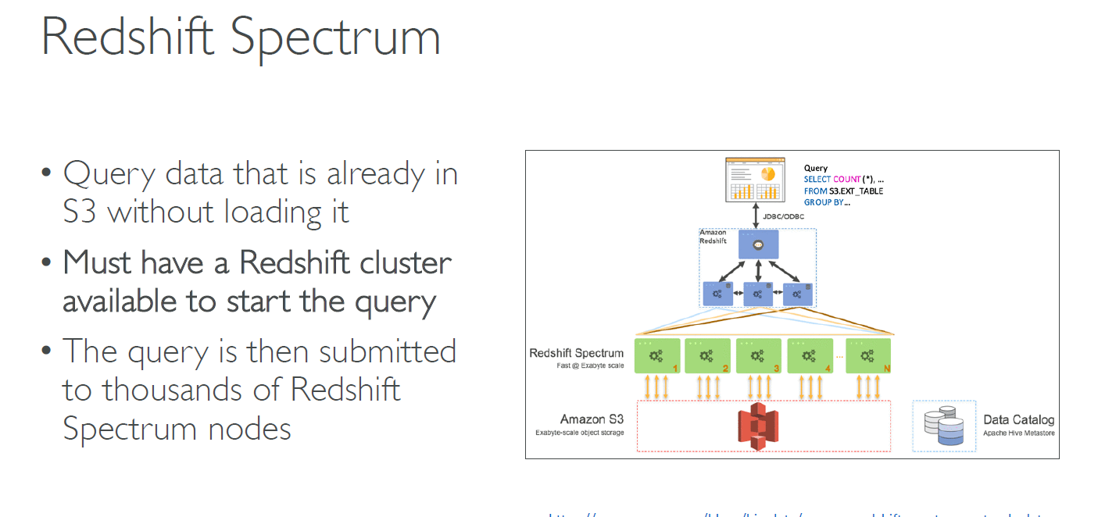

## Neptune DB

* Full managed graph database (e.g. Wikipedia, socialNetworking )
* Highly available across 3 AZ
* Point in time recovery ,continuous backup to S3
* Support for KMS encryption

**Neptune for solution architect**

* Operation - similar to RDS
* Security : similar to RDS
* Reliability :  MultiAZ ,clustering
* Performance : best suited for graphs
* Cost : pay per node provisioned (similar to RDS)

**ElasticSearch**

* In dynamo DB ,you search by only primary key or indexes ,however Elastic Search allows you to search by any field
* ElasticSearch has some usage for Big Data applications
* You can provision a cluster of instances
* Build in integrations - IoT, cloudWatch logs , Amazon Kinesis
* Security similar to RDS

**ElasticSearch as Solution Architect**

* Operation : similar to RDS
* Security : Coginto IAM VPC KMS SSL
* Reliability : Multi AZ, clustering
* Cost : pay per node provisioned
* Performance : based on ElasticSearch project

**Remember: ElasticSearch = search / Indexing**

## Amazon S3

Amazon S3

* limitless storage
* it allows to store objects(files) in "buckets"(directories)
* Buckets are defined at regional level
* Naming convention -
* no uppercase ,no underscore,3063 characters long

**Objects**

* All objects have key which is the file path
* e.g. s3://my-bucket/my_file.txt
* Object value are the content of the body that contains size of max 5GB
* It also has - Metadata, Tags, version id

**Amazon S3 -Versioning -**

* You can version the files in S3 and it is enabled at the bucket level.
* Same key overwrite will increment the "version"
* Versioning helps unintended deletes and easy roll back
* Any file that is not versioned with have version "null"

**Enable versioning**

* Go to "properties" -->"Edit bucket versioning" --> "enabled "
* After this every file would have version.
* If you add the same file again, we would have two files with different version.
* If we delete any version files , it is soft delete with type = "Delete Marker"
* You can rollback by permanently deleting the  "Delete Marker" file

**Encryption in S3**

4 methods to encrypt objects - (SSE - Server side encryption)

* SSE-S3 - encryption using keys handled by AWS S3 encryption
* SSE-KMS - leverages AWS Key Mgmt services to manage encrypt keys
* SSE-C - when you want to manage your own encryption keys .
* Client side encryption

**SSE-S3-**

AWS-256 encryption type, must set header -"x-maz-server-side-encryption" : "AES256"

**SSE-KMS-**

* encryption using keys managed by KMS
* KMS advantages: user control + audit trail
* header : "x-amz-server-side-encryption":"aws:kms"

**SSE-C**

* encryption using keys managed by you/customer
* Amazon S3 does not store the encryption keys.
* You send both the encryption key and the data
* HTTPS is must

**Client side encryption**

* Client must encrypt and decrypt the data by themselves before sending / retrieving from S3
* Customer fully manages the keys and encryption cycle

**S3 Security**

**User based** - IAM policies - which API class should be allowed for a specific user from IAM console

**Resource Based** -

* Bucket Policies - allows cross account
* Object Access Control List (ACL) - finer grain
* Bucket Access Control List (ACL) - less common

**S3 Bucket polices -**

JSON based policies -

* Resources - buckets and objects
* Actions-Set of API  Allow or Deny
* Effect - Allow /Deny
* Principal - The account or user to apply the policy
* Usage - to grant public access to bucket
* Force objects to be encrypted at upload

**Block Public Access-**

Remember there is a way to block public access to S3 granted through ACLs

**S3 Security - Other**

Networking

Logging and Auditing

User Security - MFA delete and Pre-signed URL

**S3 Websites -**

S3 can host static websites and have them accessible on the www.

If you get 403 (forbidden) error, make sure the bucket policy allows public read

To enable it, upload html files and then click on "Static Website hosting" --> enable

**CORS - Explained**

**CORS - means Cross Origin Resource Sharing**

* You hit one URL and that URL tells you to hit another URL .This is CORS. What browsers do is hit another URL and ask if it allows cross origin (called preflight request) .If it allows then it continues the operation.
* The requests won’t be fulfilled unless the other origin allows the requests ,using CORS headers (ex. Access-Control-Allow-Origin)

**S3 CORS Case**

* Your web browser hits S3 bucket which hosts a static website(index.html)
* This index.html then asks web browser to internally call another S3 website hosted on another S3 bucket.
* If the other bucket has enabled CORS then it allows the above operation

**S3 Consistency model -**

GET after DELETE and PUTS of existing objects is eventual consistent

However, GET after PUT/POST is consistent

# Advanced Amazon S3 & Athena

S3 MFA – Delete

**Multi-Factor authentication** forces user to generate a code on a device (usually a mobile phone or hardware) before doing important operations on S3

To use MFA-Delete, enable Versioning on the S3 bucket

• You will need MFA to

• Permanently delete an object version

• suspend versioning on the bucket

• You won’t need MFA for

• enabling versioning

• listing deleted versions

• Only the bucket owner (root account) can enable/disable MFA-Delete

• MFA-Delete currently can only be enabled using the CLI

S3 MFA delete is done only via CLI and is complex.

The below MFA delete option cannot be enabled from UI has to be done by CLI

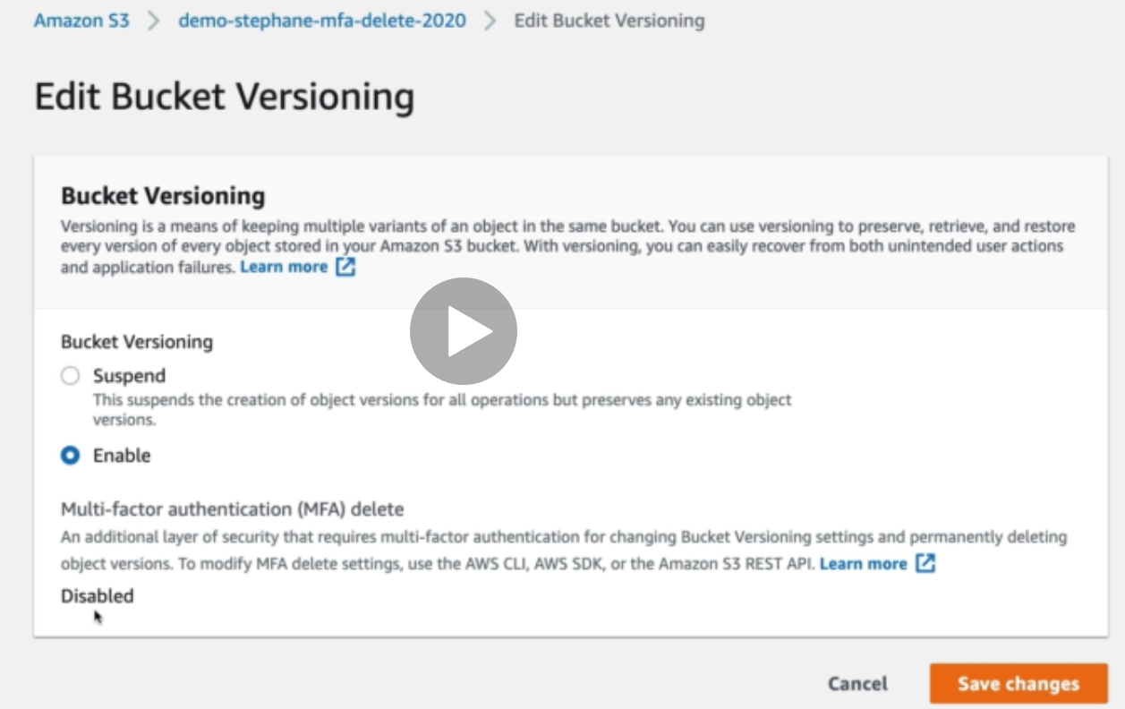

CLI command to enable

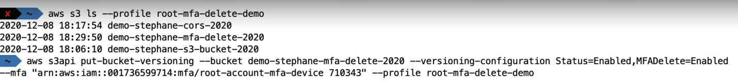

With this now you cannot delete the object in S3 bucket. If you wish to delete, you need to disable the MFA again.



## S3 Access Logs

For audit purpose, you may want to log details of all the accesses to the S3 bucket.

This is done by ensuring any request made to S3, form any account, authorized or denied, are logged into another S3 bucket.

That data can be analyzed by using tools like Athena.

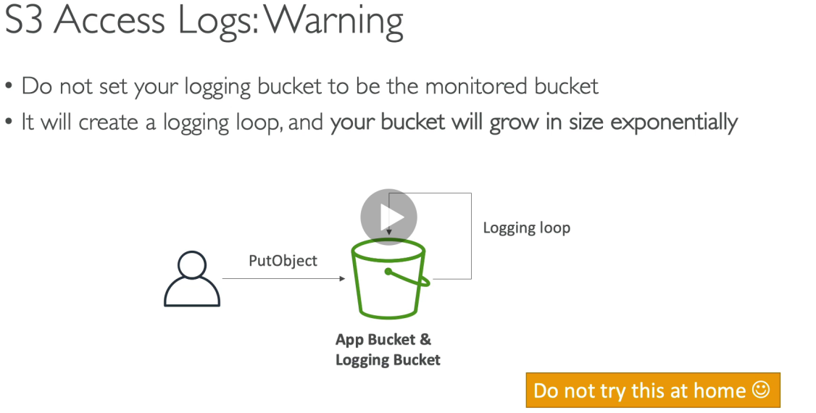

**Hands on S3 Access logs**

* Create two buckets (one on which you need to enable access logs(demo-stephane-s3-bucket-2020) and other where the access logs need to be stored(demo-s3-access-logs-stephane-2020) for which you need to enable Access logs

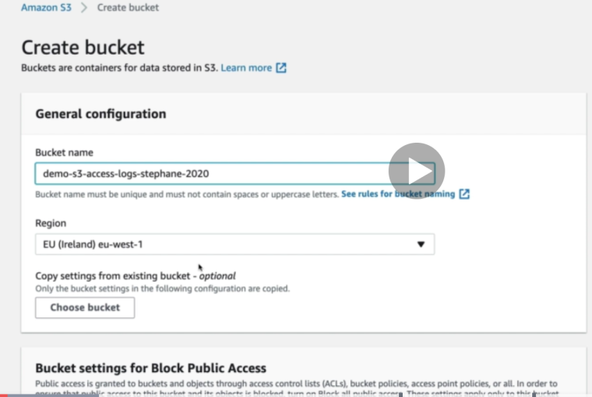

Go to properties and enable “Server access logging”

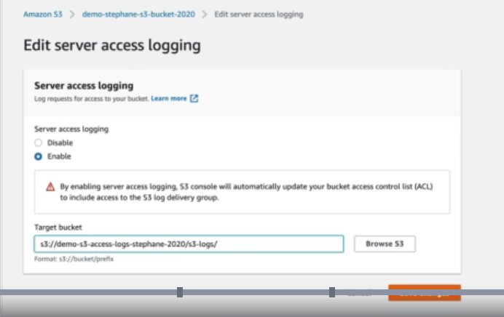

Logs generated in the S3 bucket

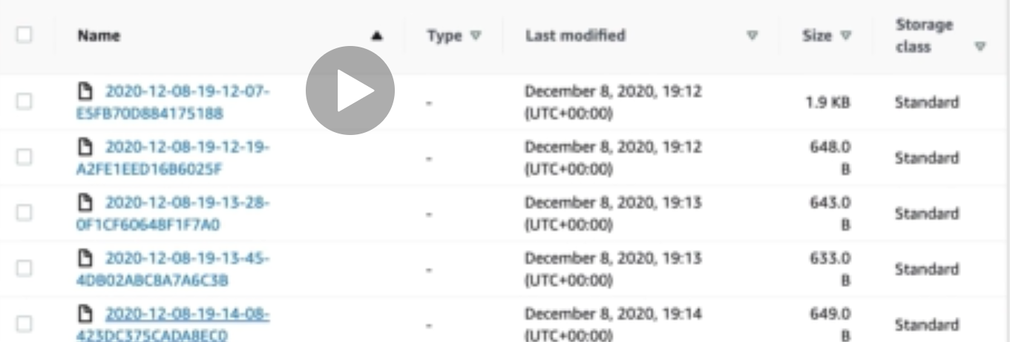

## S3 Replication

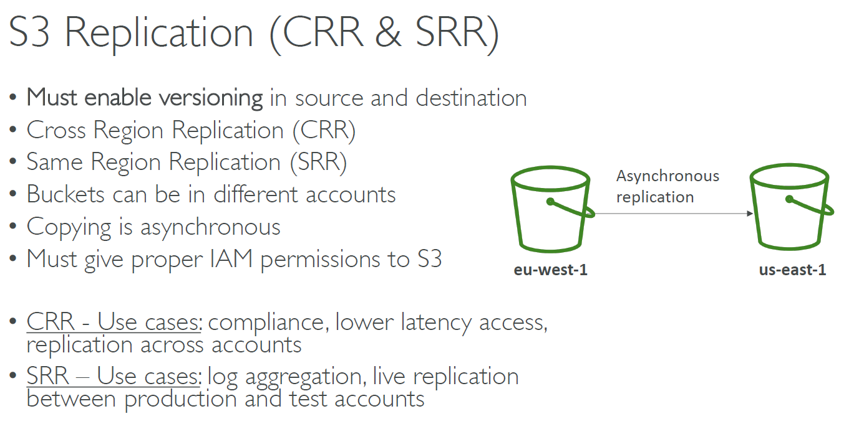

**S3 Replication – Notes**

• After activating, only new objects are replicated (not retroactive)

• For DELETE operations:

• If you delete without a version ID, it adds a delete marker, not replicated

• If you delete with a version ID, it deletes in the source, not replicated

• There is no “chaining” of replication

• If bucket 1 has replication into bucket 2, which has replication into bucket 3

• Then objects created in bucket 1 are not replicated to bucket 3

**S3 replication hands on**

* Create two buckets with version enabled
* GO to original budget ,click management, click “replication rules”

Replication rules have “destination” option where you can choose the replicated bucket name and keep other options the way it is and click “save”

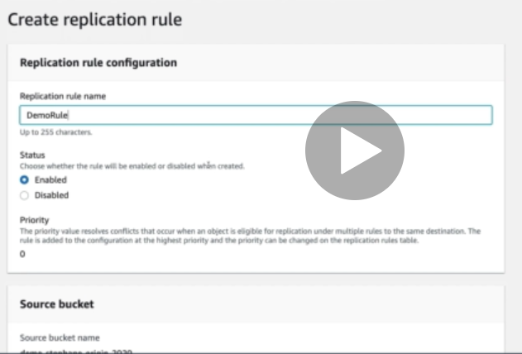

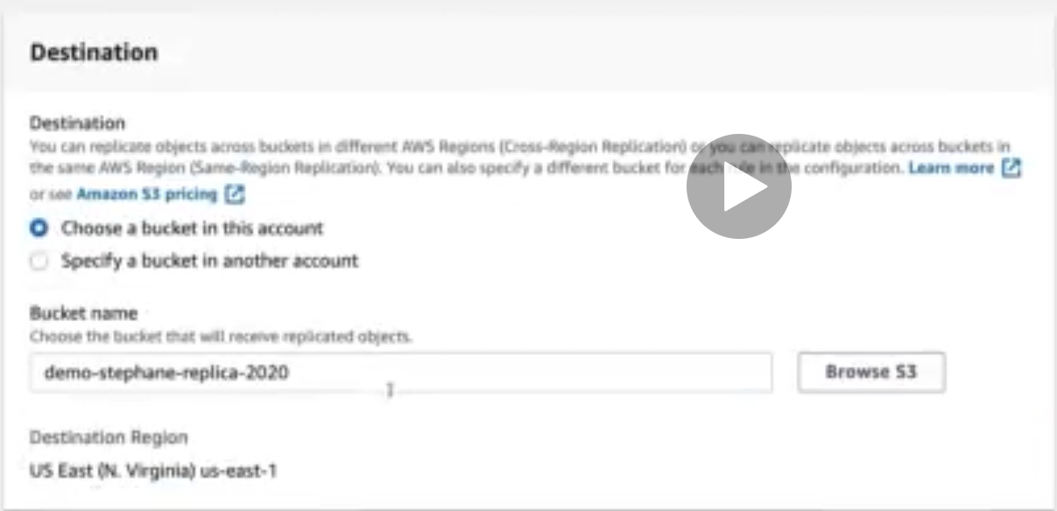

**S3 pre-signed URLs**

• Can generate pre-signed URLs using SDK or CLI

• For downloads (easy, can use the CLI)

• For uploads (harder, must use the SDK)

• Valid for a default of 3600 seconds, can change timeout with --expires-in

[TIME_BY_SECONDS] argument

• Users given a pre-signed URL inherit the permissions of the person who generated the URL for GET / PUT

Examples:

• Allow only logged-in users to download a premium video on your S3 bucket

• Allow an ever changing list of users to download files by generating URLs dynamically

• Allow temporarily a user to upload a file to a precise location in our bucket

## S3 Storage Classes

**•** Amazon S3 Standard - General Purpose

• Amazon S3 Standard-Infrequent Access (IA)

• Amazon S3 One Zone-Infrequent Access

• Amazon S3 Intelligent Tiering

• Amazon Glacier

• Amazon Glacier Deep Archive

• Amazon S3 Reduced Redundancy Storage (deprecated - omitted)

**S3 Standard – General Purpose**

• High durability (99.999999999%) of objects across multiple AZ

• If you store 10,000,000 objects with Amazon S3, you can on average expect to incur a loss of a single object once every 10,000 years

• 99.99% Availability over a given year

• Sustain 2 concurrent facility failures

• Use Cases: Big Data analytics, mobile & gaming applications, content distribution …

**S3 Standard – Infrequent Access (IA)**

• Suitable for data that is less frequently accessed, but requires rapid access when needed

• High durability (99.999999999%) of objects across multiple AZs

• 99.9% Availability

• Low cost compared to Amazon S3 Standard

• Sustain 2 concurrent facility failures

• Use Cases: As a data store for disaster recovery, backups…

**S3 One Zone - Infrequent Access (IA)**

• Same as IA but data is stored in a single AZ

• High durability (99.999999999%) of objects in a single AZ; data lost when AZ is destroyed

• 99.5% Availability

• Low latency and high throughput performance

• Supports SSL for data at transit and encryption at rest

• Low cost compared to IA (by 20%)

• Use Cases: Storing secondary backup copies of on-premise data, or storing data you can recreate

**S3 Intelligent Tiering**

• Same low latency and high throughput performance of S3 Standard

• Small monthly monitoring and auto-tiering fee

• Automatically moves objects between two access tiers based on changing access patterns i.e. it moves your S3 objects from S3 standard to IA based on access patterns

• Designed for durability of 99.999999999% of objects across multiple Availability Zones

• Resilient against events that impact an entire Availability Zone

• Designed for 99.9% availability over a given year

**Amazon Glacier**

• Low cost object storage meant for archiving / backup

• Data is retained for the longer term (10s of years)

• Alternative to on-premise magnetic tape storage

• Average annual durability is 99.999999999%

• Cost per storage per month ($0.004 / GB) + retrieval cost

• Each item in Glacier is called “Archive” (up to 40TB)

• Archives are stored in “Vaults”

**Amazon Glacier & Glacier Deep Archive**

Amazon Glacier – 3 retrieval options (response time after asking for an object):

• Expedited (1 to 5 minutes)

• Standard (3 to 5 hours)

• Bulk (5 to 12 hours)

• Minimum storage duration of 90 days

Amazon Glacier Deep Archive – for long term storage – cheaper:

• Standard (12 hours)

• Bulk (48 hours)

• Minimum storage duration of 180 days

Exam question – Which one to use between Glacier deep archive and Glacier – Based on min storage duration and retrieve file duration

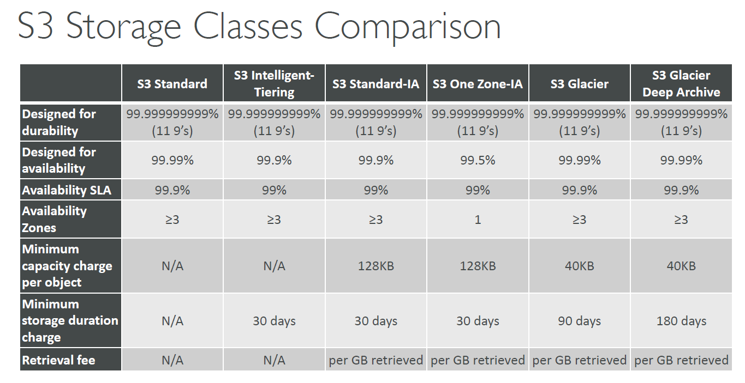

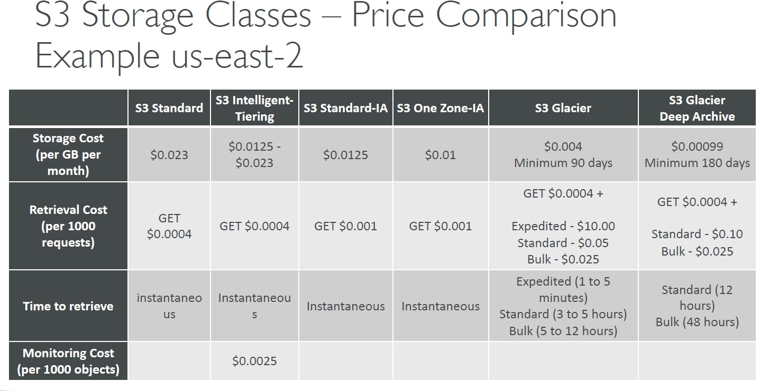

**S3 storage classes + Glacier + hands on**

Create a bucket

While uploading a file, can click on “Additional upload options” to define the storage class for the file

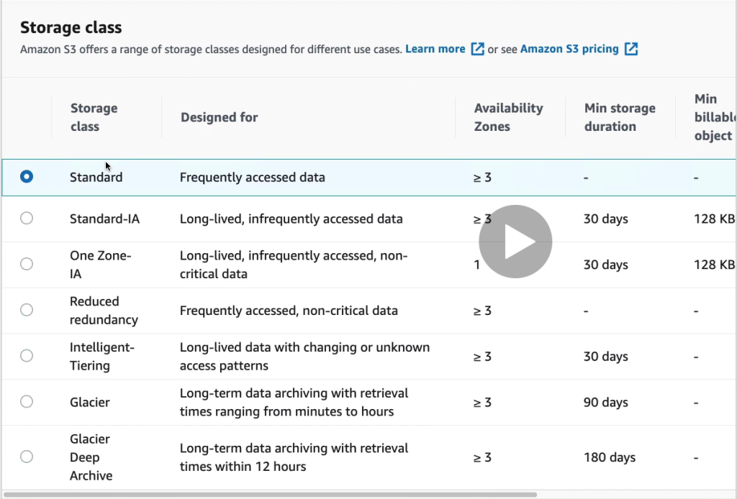

Storage class assigned to every file stored in S3 (refer below image)

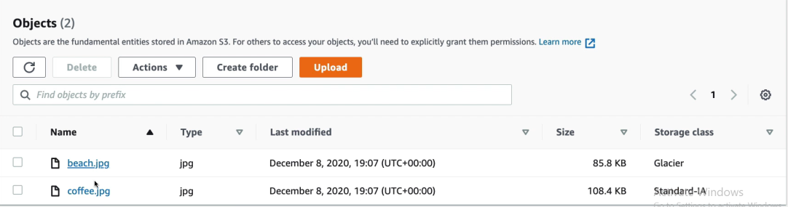

If you try to access file with “Glacier” as storage type, then in that case you have to “initiate Restore” first (refer below image)

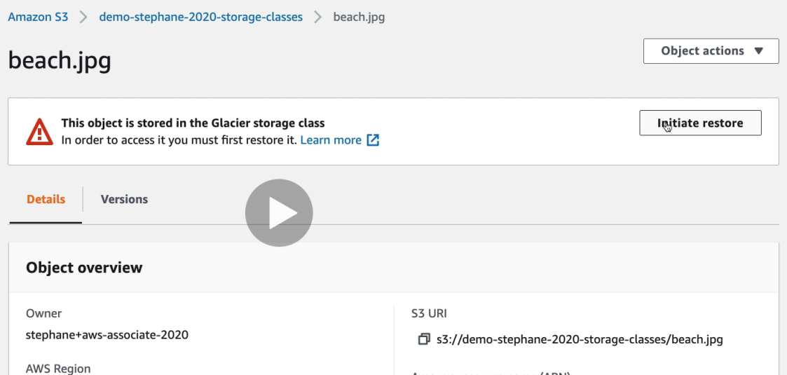

After clicking on “initiate restore”

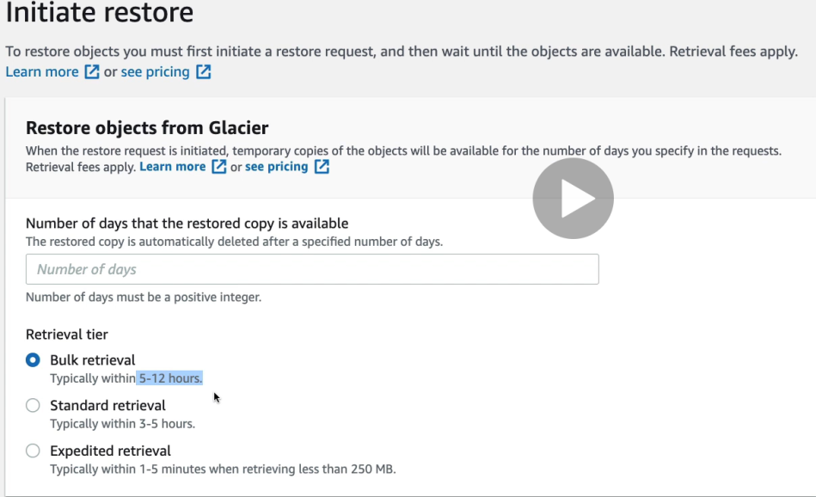

Note – you can also update the storage class of a file

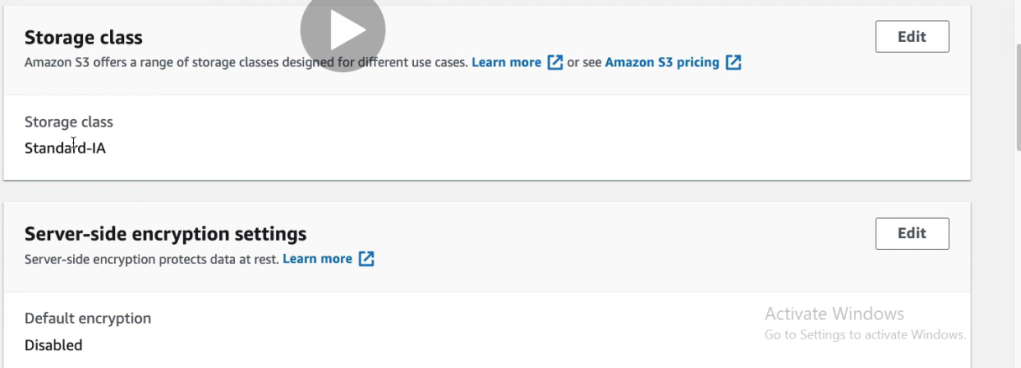

**S3 – Moving between storage classes**

You can customize the movement of object from one storage class to other using lifecycle configuration

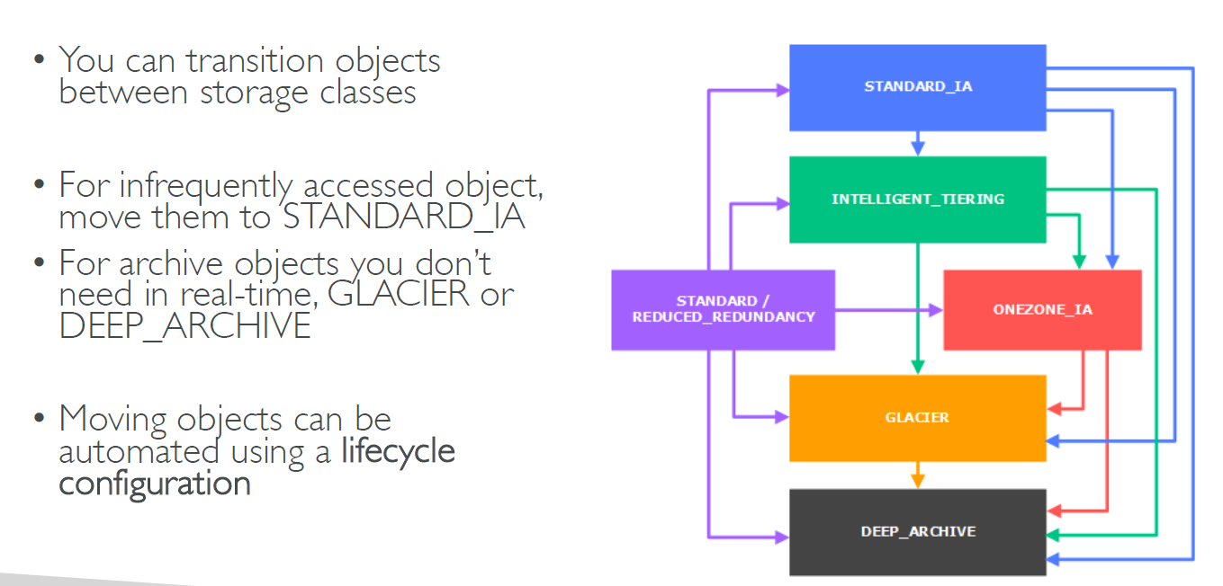

**S3 Lifecycle Rules**

Transition actions: It defines when objects are transitioned to another storage class.

• Move objects to Standard IA class 60 days after creation

• Move to Glacier for archiving after 6 months

Expiration actions: configure objects to expire (delete) after some time

• Access log files can be set to delete after a 365 days

• Can be used to delete old versions of files (if versioning is enabled)

• Can be used to delete incomplete multi-part uploads

• Rules can be created for a certain prefix (ex - s3://mybucket/mp3/*)

• Rules can be created for certain objects tags (ex - Department: Finance)

**S3 Lifecycle Rules – Scenario 1**

Your application on EC2 creates images thumbnails after profile photos are uploaded to Amazon S3. These thumbnails can be easily recreated, and only need to be kept for 45 days. The source images should be able to be immediately retrieved for these 45 days, and afterwards, the user can wait up to 6 hours. How would you design this?

• S3 source images can be on STANDARD, with a lifecycle configuration to transition them to GLACIER after 45 days.

• S3 thumbnails can be on ONEZONE_IA, with a lifecycle configuration to expire them (delete them) after 45 days.

**S3 Lifecycle Rules – Scenario 2**

A rule in your company states that you should be able to recover your deleted S3 objects immediately for 15 days, although this may happen rarely. After this time, and for up to 365 days, deleted objects should be recoverable within 48 hours.

• You need to enable S3 versioning in order to have object versions, so that “deleted objects” are in fact hidden by a “delete marker” and can be recovered

• You can transition these “noncurrent versions” of the object to S3_IA

• You can transition afterwards these “noncurrent versions” to DEEP_ARCHIVE

**S3 Lifecycle hands on**

Create a bucket 🡪 in “Management” section click on “Lifecycle rules”

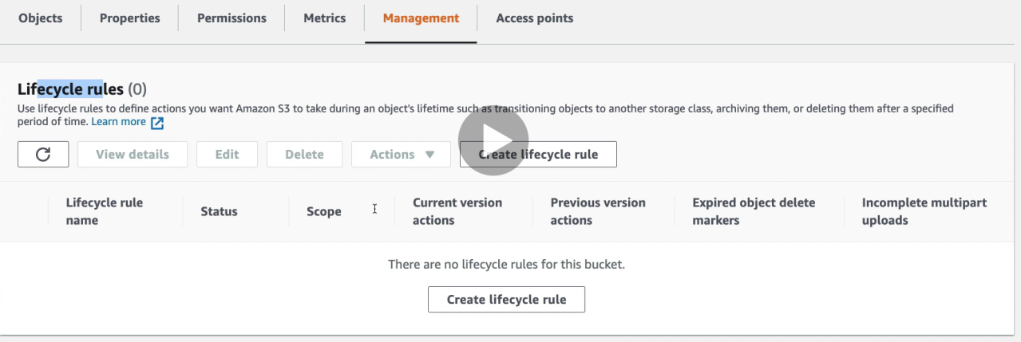

Click on “Create lifecycle rule”

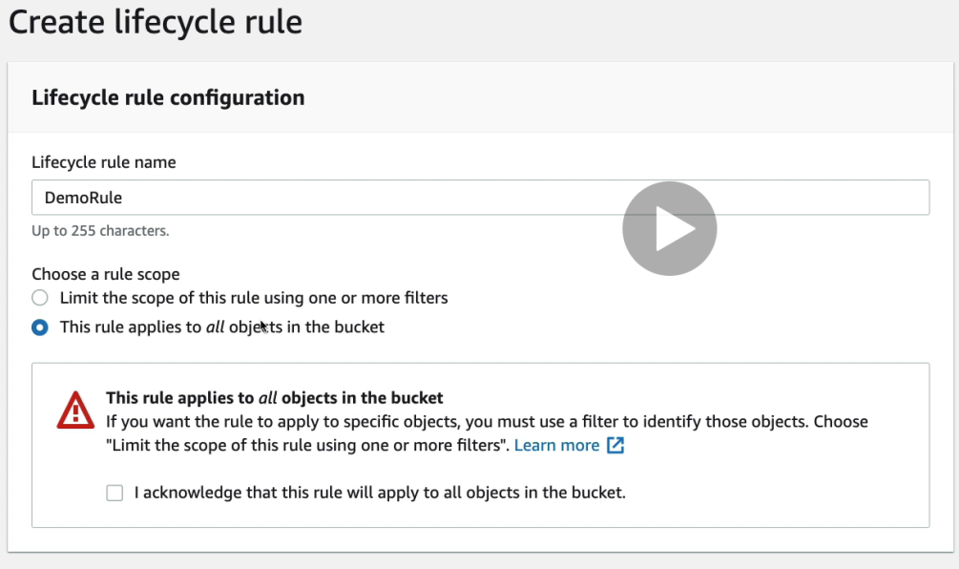

In Lifecycle rules actions we have below options –

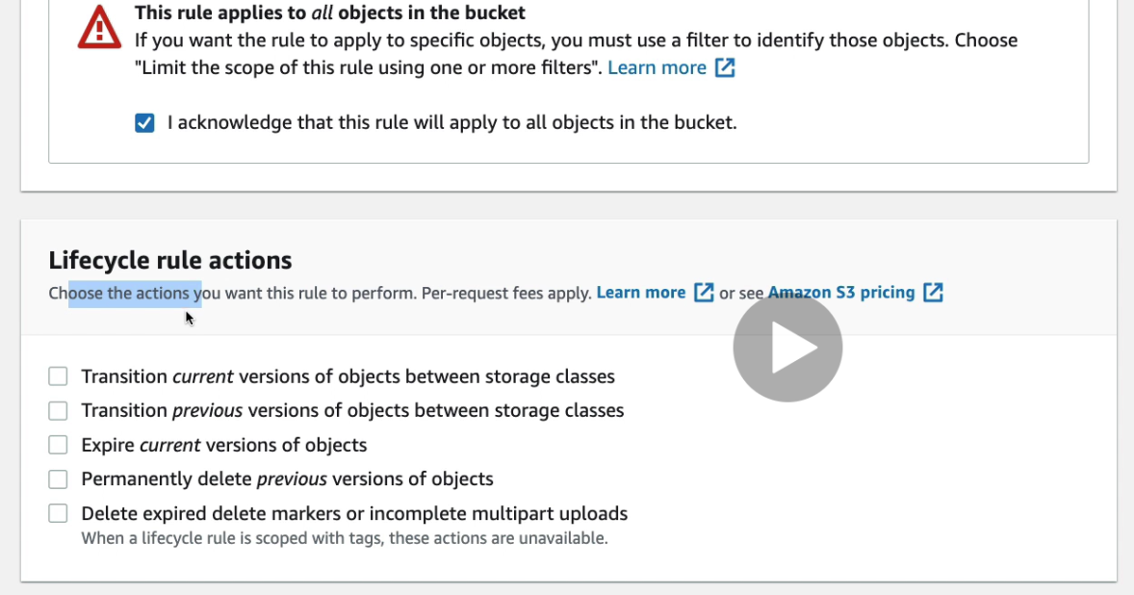

Select first option and provide below rules –

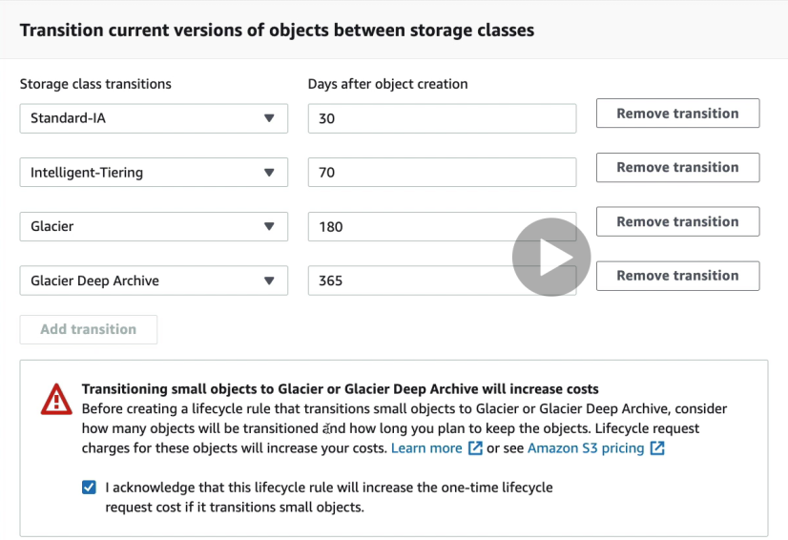

Also I can enable “expire current versions of objects” & then second option as well in below pic

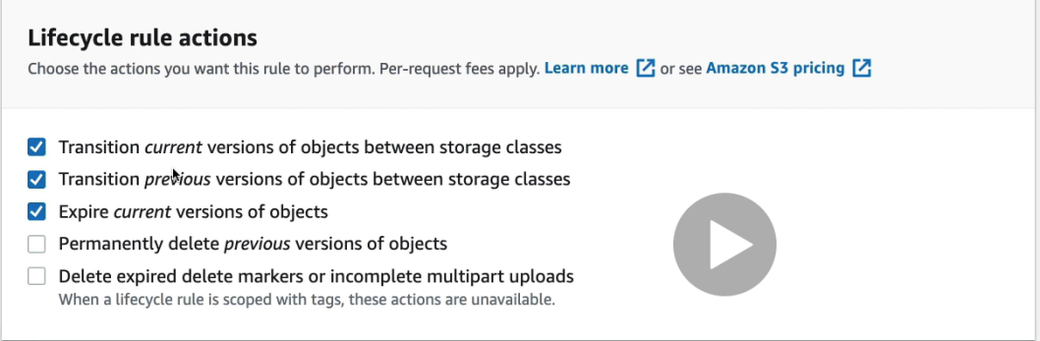

Expire configuration

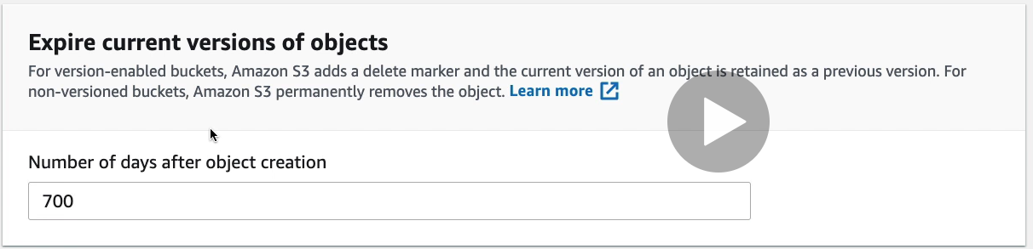

Transition previous object configuration

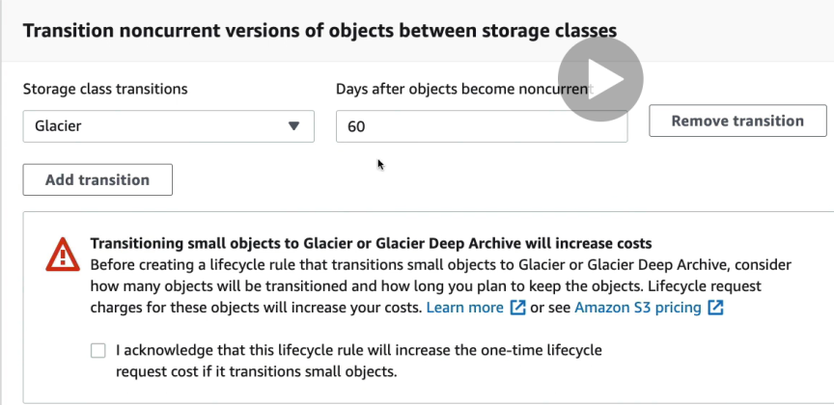

**S3 – Baseline Performance**

• Amazon S3 automatically scales to high request rates, latency 100-200 ms

• Your application can achieve at least 3,500 PUT/COPY/POST/DELETE and 5,500 GET/HEAD requests per second per prefix in a bucket.

• There are no limits to the number of prefixes in a bucket.

• Example (object path => prefix):

• bucket/folder1/sub1/file => /folder1/sub1/

• bucket/folder1/sub2/file => /folder1/sub2/

• bucket/1/file => /1/

• bucket/2/file => /2/

• If you spread reads across all four prefixes evenly, you can achieve 22,000 requests per second for GET and HEAD

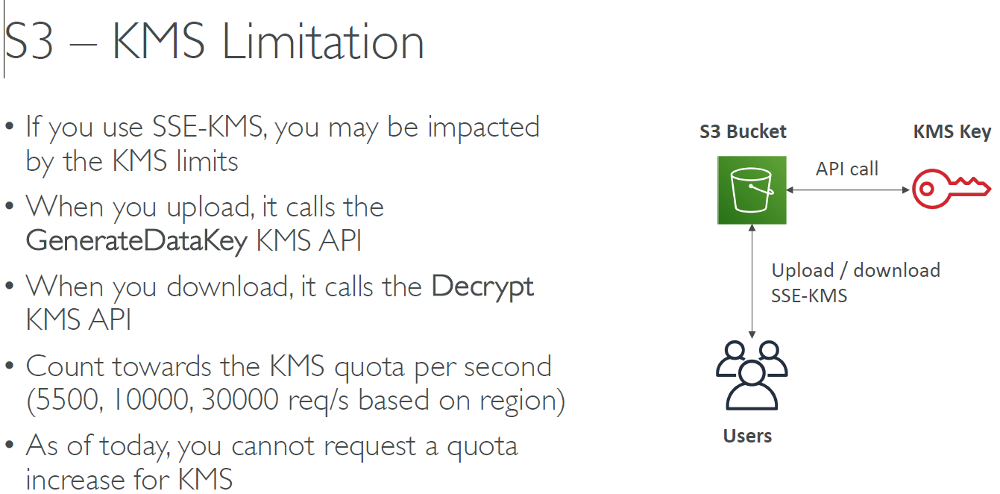

S3 performance for uploading files (you can do multi part upload)

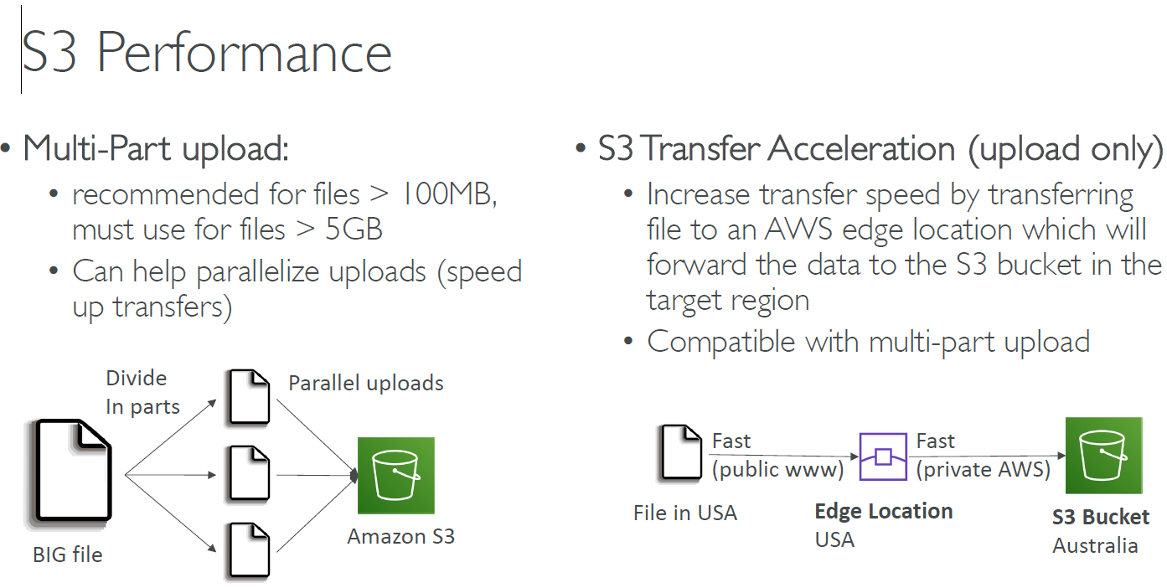

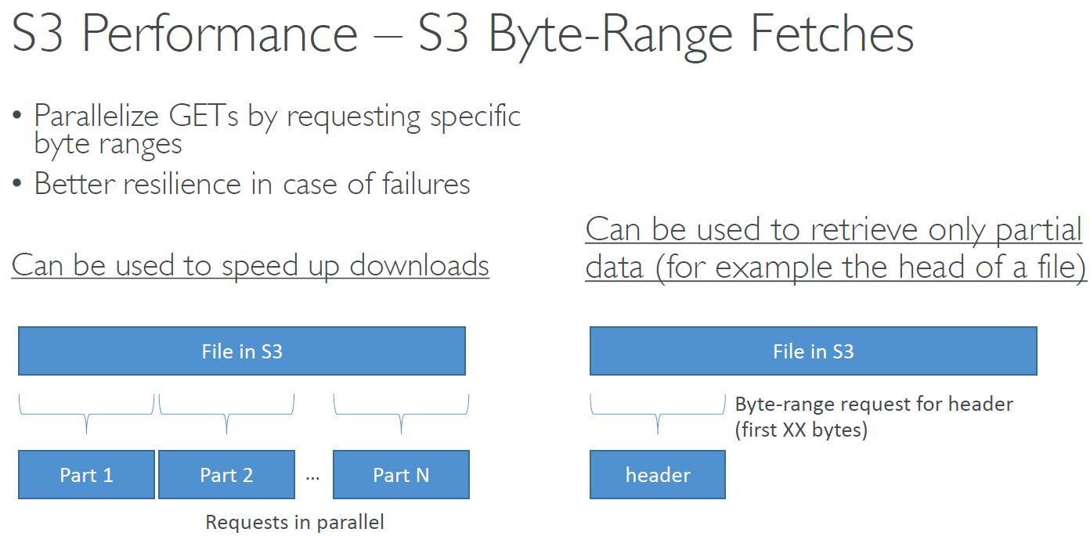

You can do a select query on files stored in S3 and get only relevant data instead of pulling the whole file

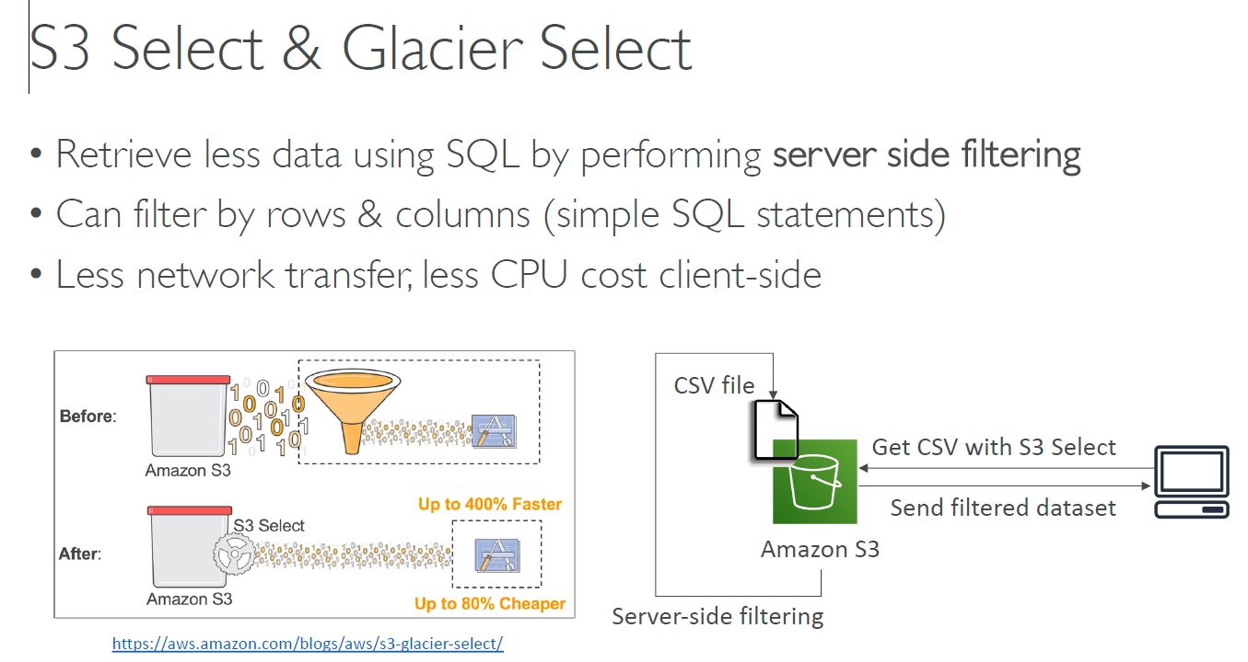

**S3 Event Notification**

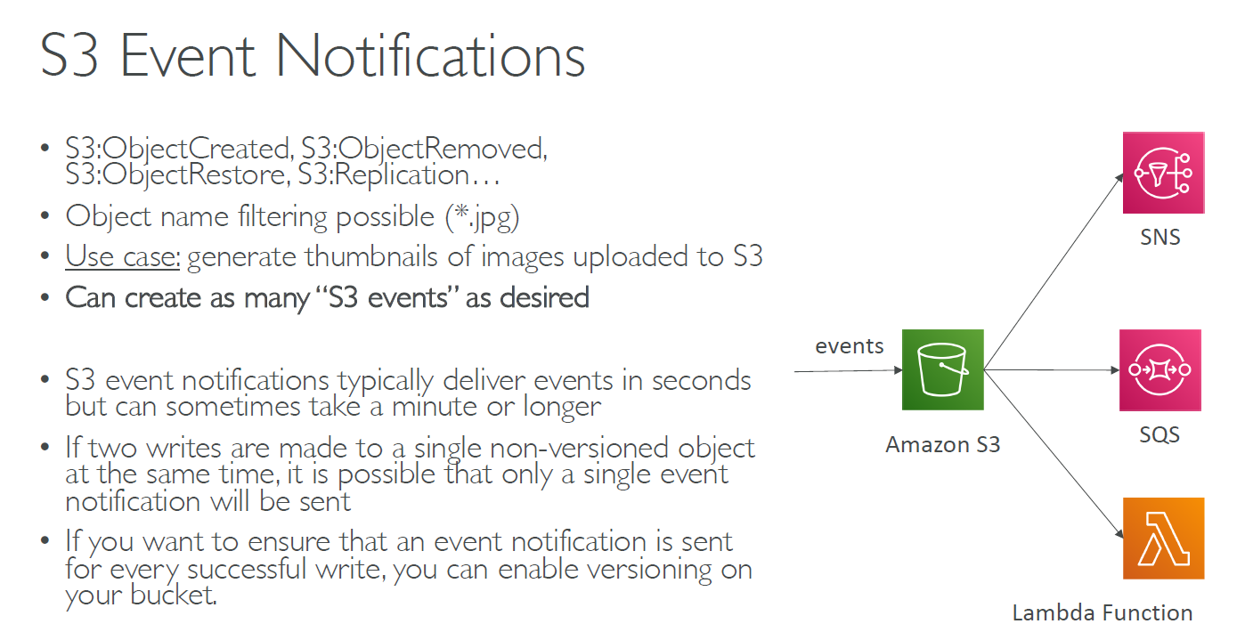

**S3 event notifications hands on**

Create a bucket 🡪 click on properties 🡪 click on event notifications

Click on “create event notification”

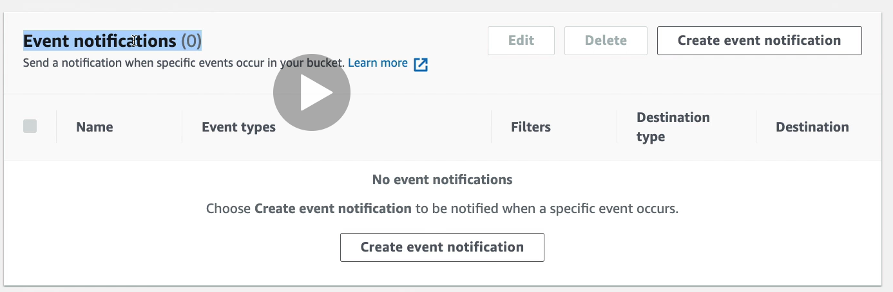

Choose event “Event types”

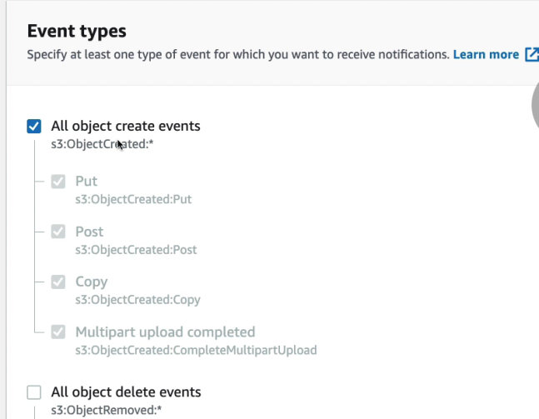

Click on destination from Lambda function, SNS topic or SQS queue

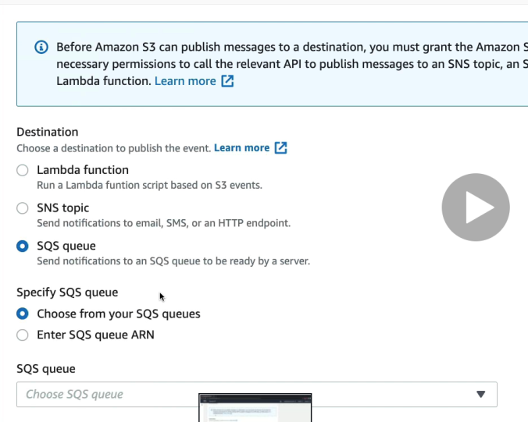

Click on SQS queue above and then create a new SQS queue and enter the name in SQS queue test block

Ensure your newly created SQS queue has access policy such that the S3 queue can send event to this newly created queue

Use policy generation and ensure you allow everyone “*” to send message to the queue

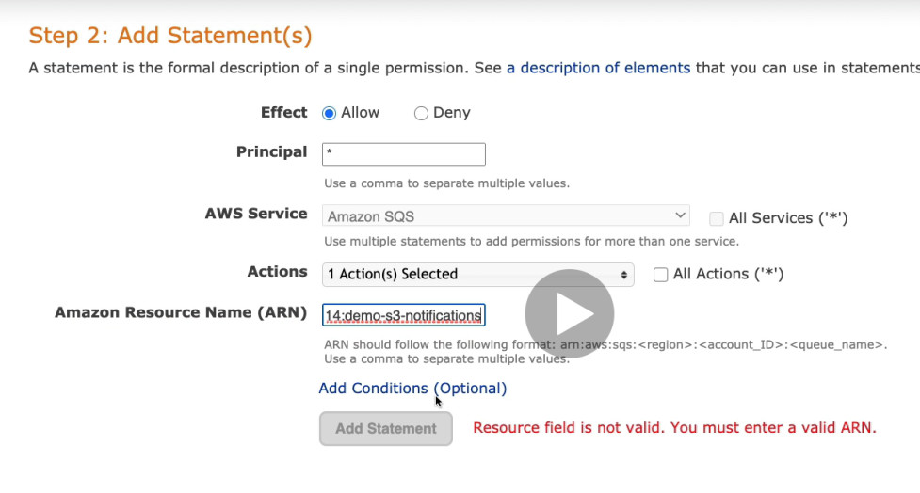

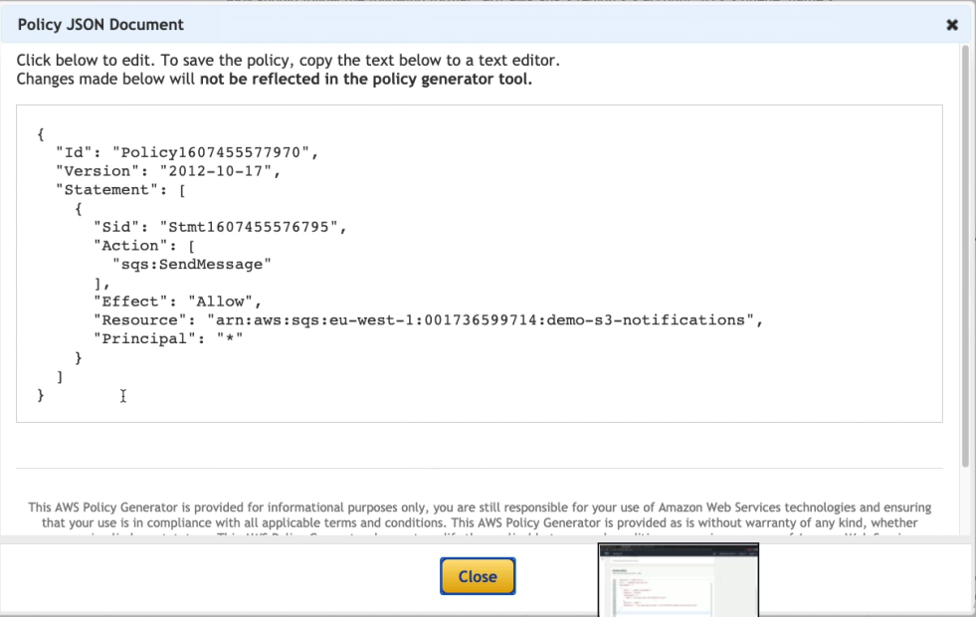

Click on save changes in the S3 properties after entering the queue name –

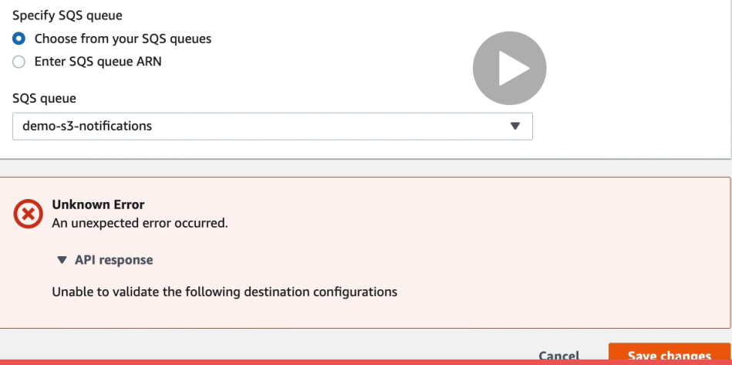

## Athena overview for S3

Whenever you want to perform analytics directly against S3 files use Athena

• Uses SQL language to query the files

• Has a JDBC / ODBC driver

• Charged per query and amount of data scanned

• Supports CSV, JSON, ORC, Avro, and Parquet (built on Presto)

• Use cases: Business intelligence / analytics / reporting, analyze & query VPC Flow Logs, ELB Logs, CloudTrail trails, etc...

• Exam Tip: Analyze data directly on S3 => use Athena

**Athena Hands on**

Search Athena and click on “get started” shown in below pic

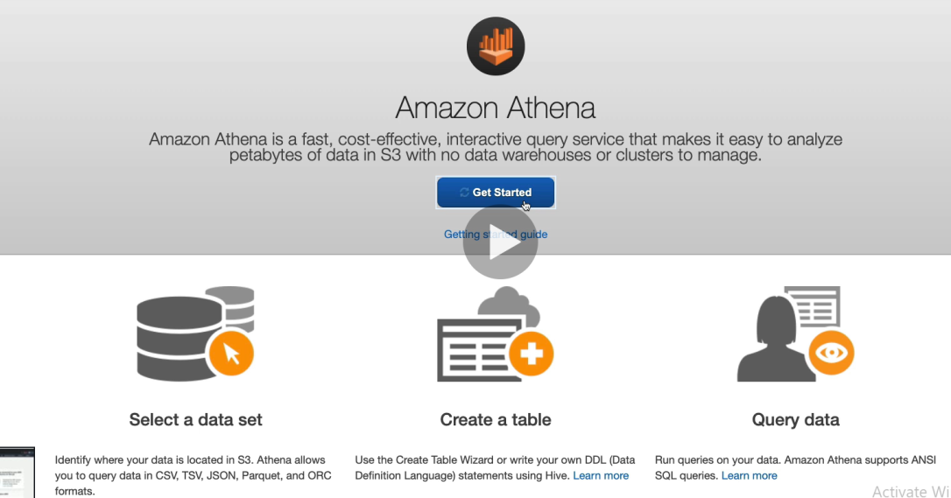

Set the query result location in Athena like below –

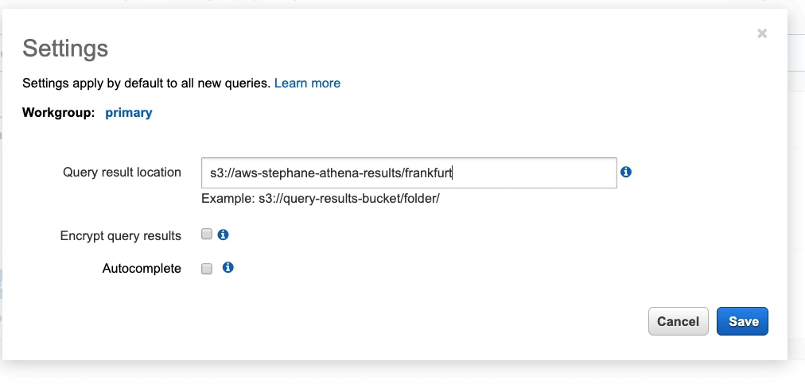

Then create database

Use Athena-s3-access-logs.sql file from the code

Then run the below query –

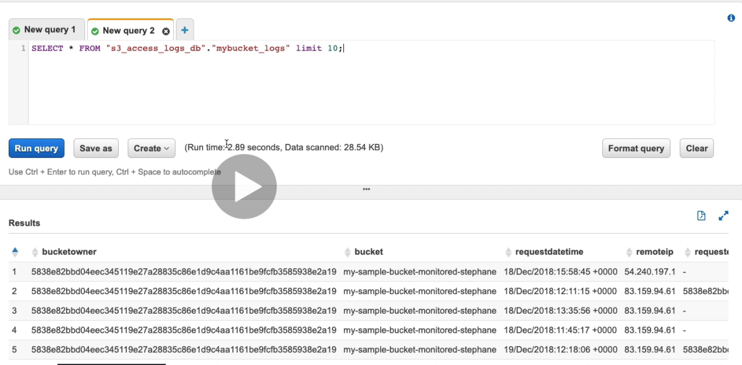

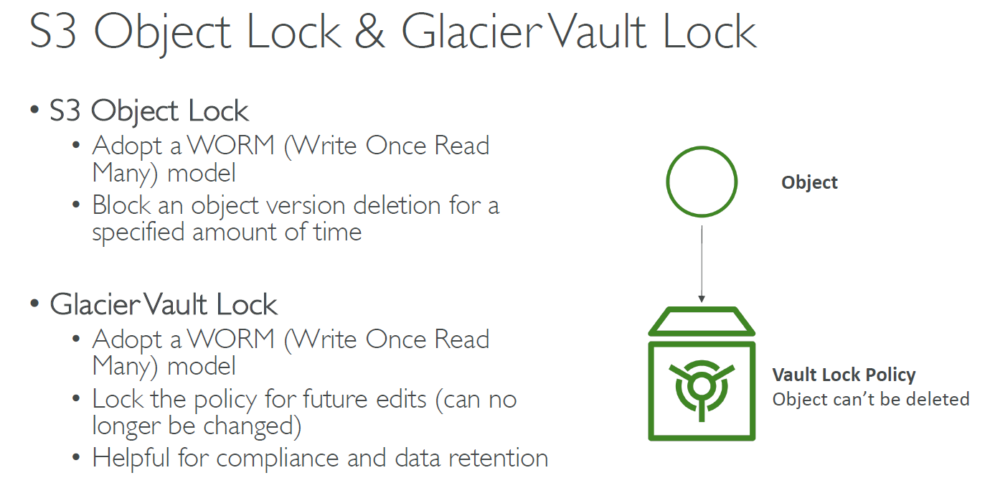

# AWS CloudFront

* CloudFront is Content Delivery Network (CDN)
* Improves read performance by caching the content at the edge location
* 216 points of presence globally.
* Can expose external HTTPS and can talk to internal HTTP backend
* DDoS protection, integration with shield, AWS web application firewall

**CloudFront – Origins**

• S3 bucket

• For distributing files and caching them at the edge

• Enhanced security with CloudFront Origin Access Identity (OAI)

• CloudFront can be used as ingress (to upload files to S3)

• Custom Origin (HTTP)

• Application Load Balancer

• EC2 instance

• S3 website (must first enable the bucket as a static S3 website)

• Any HTTP backend you want

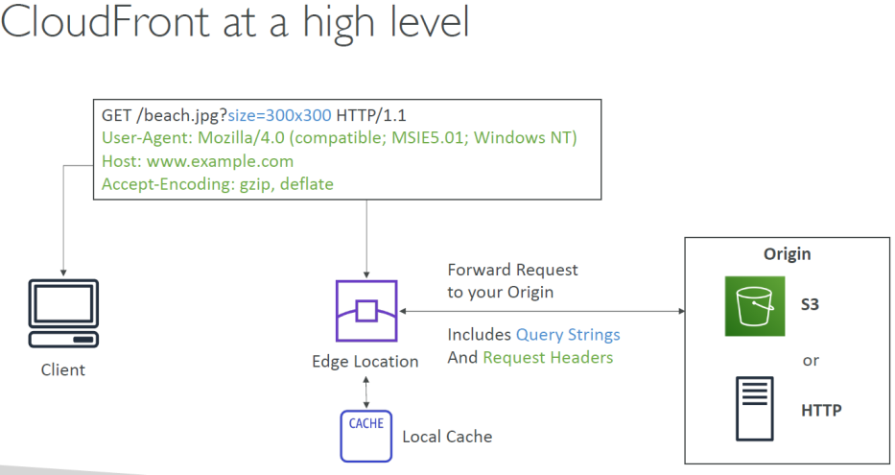

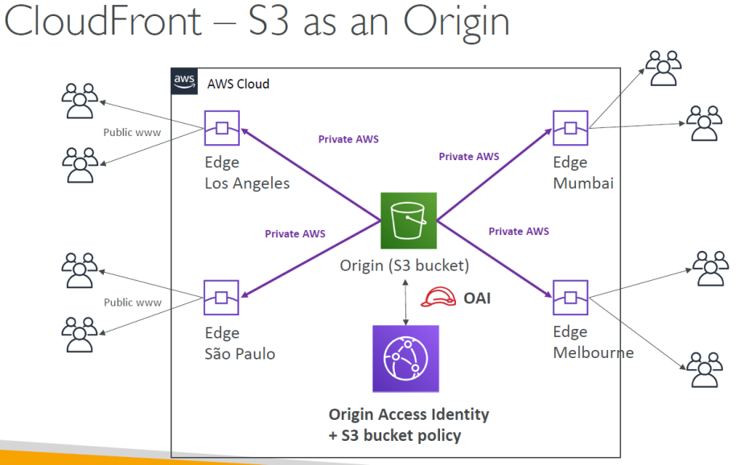

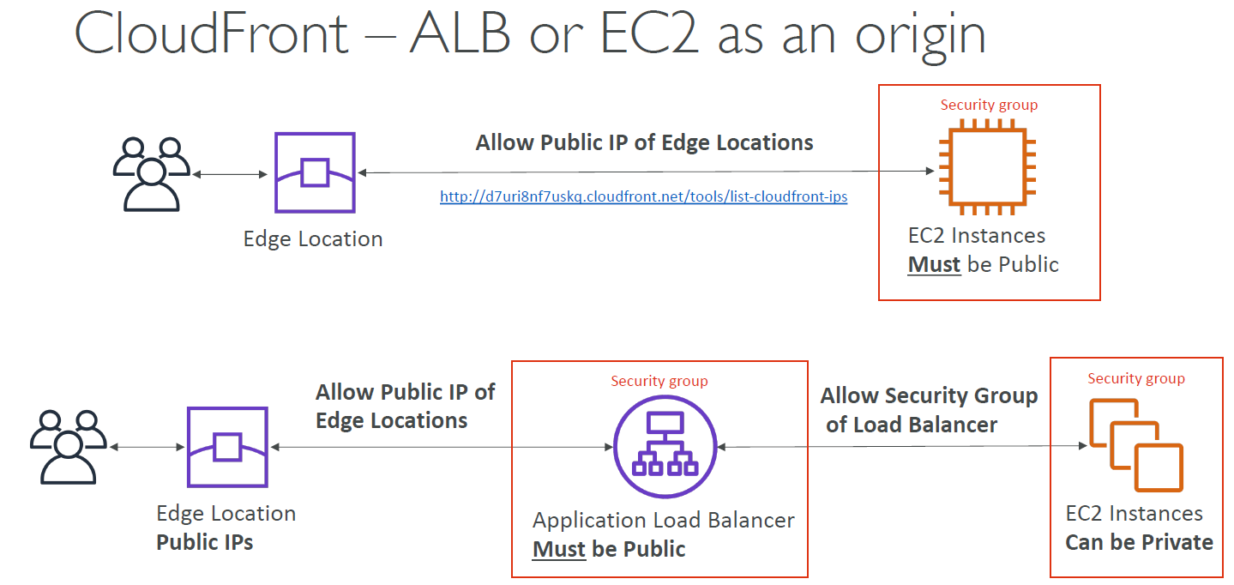

**CloudFront Geo Restriction**

• You can restrict who can access your distribution

• Whitelist: Allow your users to access your content only if they're in one of the countries on a list of approved countries.

• Blacklist: Prevent your users from accessing your content if they're in one of the countries on a blacklist of banned countries.

• The “country” is determined using a 3rd party Geo-IP database

• Use case: Copyright Laws to control access to content

**CloudFront vs S3 Cross Region Replication**

**CloudFront:**

• Global Edge network

• Files are cached for a TTL (maybe a day)

• Great for static content that must be available everywhere

**S3 Cross Region Replication:**

• Must be setup for each region you want replication to happen

• Files are updated in near real-time

• Read only

• Great for dynamic content that needs to be available at low-latency in few regions

## CloudFront S3 hands on

• We’ll create an S3 bucket and some jpg files in it

• We’ll create a CloudFront distribution

• We’ll create an Origin Access Identity

• We’ll limit the S3 bucket to be accessed only using this identity

**How to create CloudFront?**

1 Search for CloudFront in AWS search bar 🡪 click on “create Distribution” 🡪click on “get started” for web option

2 Enter the S3 bucket name in the “Origin Domain Name” column like below and then click on “create Distribution”

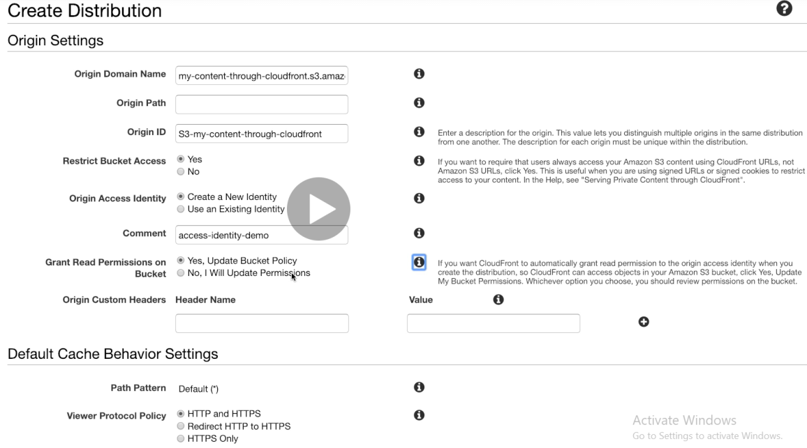

Successful creation of CloudFront-

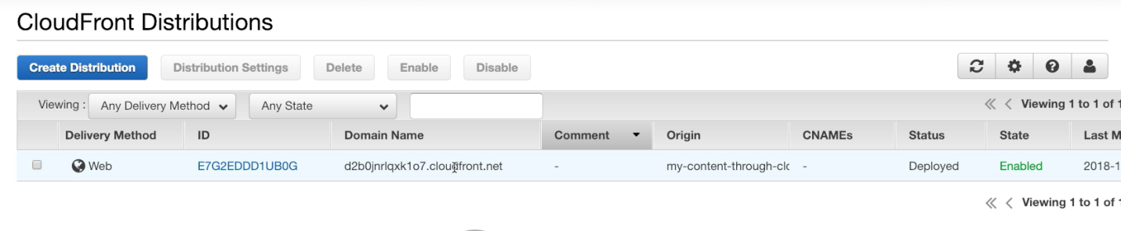

We also have an origin Access Identity created along with above CloudFront –

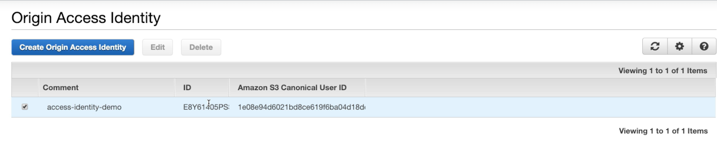

Automatically our S3 bucket policy gets updated to ensure that ensure only CloudFront can access the S3 bucket’s contents

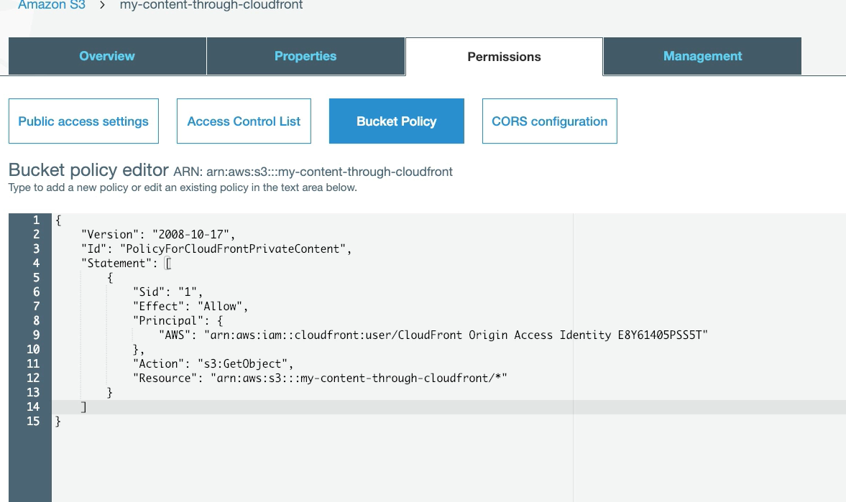

## CloudFront Signed URL / Signed Cookies

• You want to distribute paid shared content to premium users over the world

• We can use CloudFront Signed URL / Cookie. We attach a policy with:

• Includes URL expiration

• Includes IP ranges to access the data from

• Trusted signers (which AWS accounts can create signed URLs)

• How long should the URL be valid for?

• Shared content (movie, music): make it short (a few minutes)

• Private content (private to the user): you can make it last for years

• Signed URL = access to individual files (one signed URL per file)

• Signed Cookies = access to multiple files (one signed cookie for many files

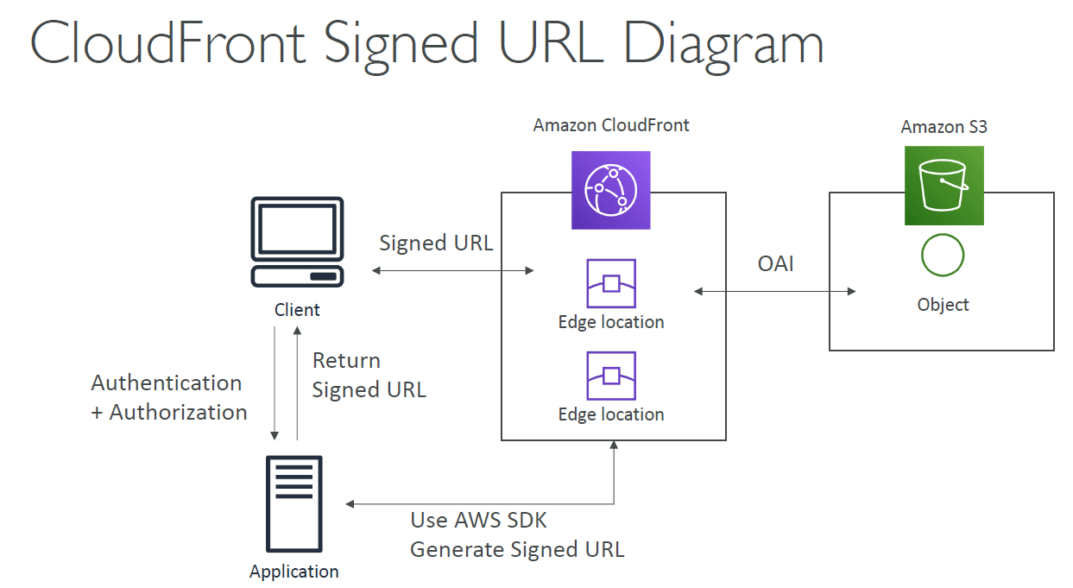

CloudFront Signed URL vs S3 Pre-Signed URL

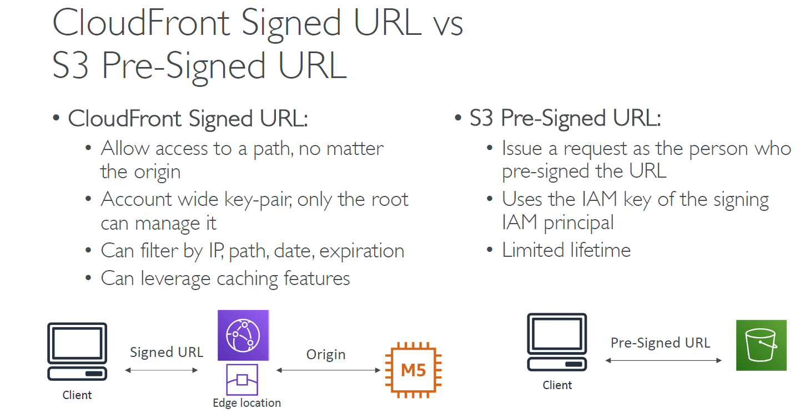

## AWS Global Accelerator

Using global accelerator you skip the hops from source to destination using a concept of any cast IP

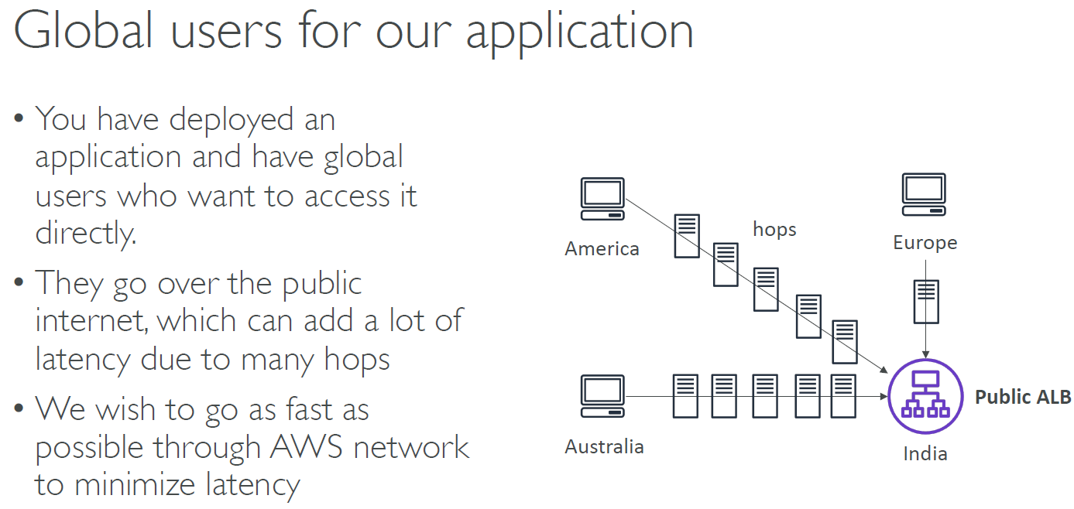

Anycast IP means a set of servers have same IP address and the closet server gets resolved to the client

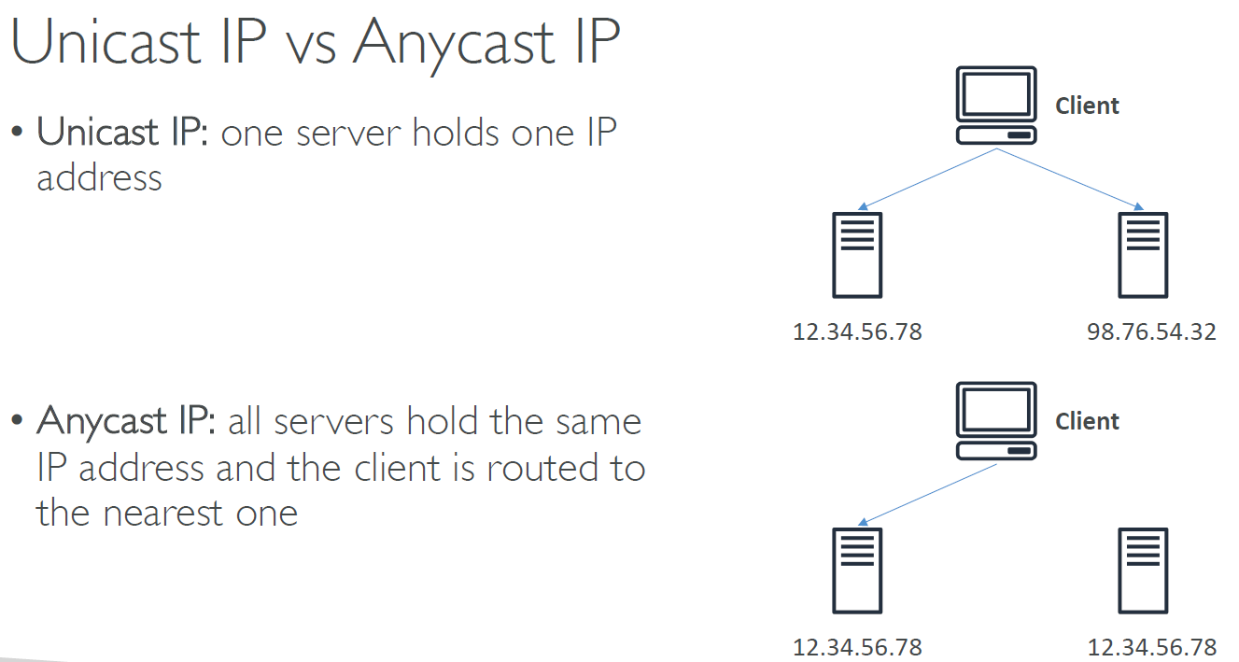

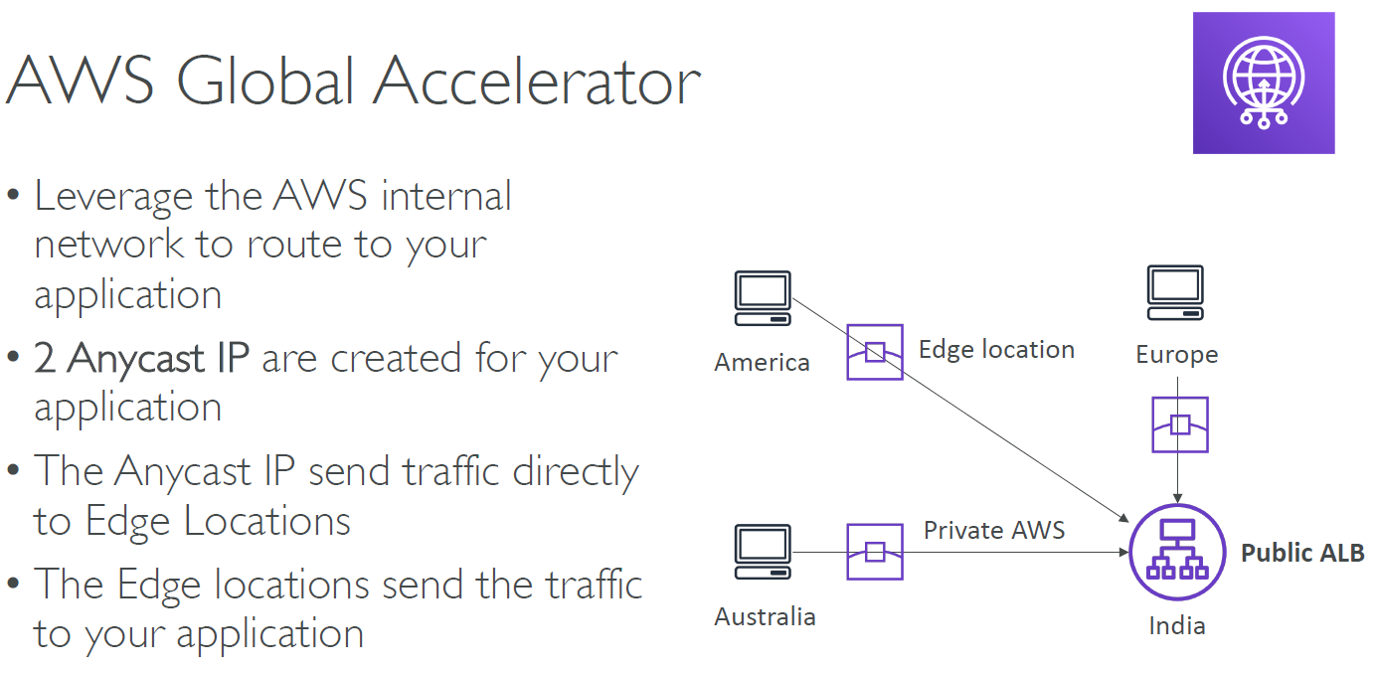

**AWS Global Accelerator**

• Works with Elastic IP, EC2 instances, ALB, NLB, public or private

• Consistent Performance

• Intelligent routing to lowest latency and fast regional failover

• No issue with client cache (because the IP doesn’t change)

• Internal AWS network

**Health Checks**

• Global Accelerator performs a health check of your applications

• Helps make your application global (failover less than 1 minute for unhealthy)

• Great for disaster recovery (thanks to the health checks)

**Security**

• Only 2 external IP need to be white-listed

• DDoS protection thanks to AWS Shield

**AWS Global Accelerator vs CloudFront**

• They both use the AWS global network and its edge locations around the world

• Both services integrate with AWS Shield for DDoS protection.

**CloudFront**

• Improves performance for both cacheable content (such as images and videos)

• Dynamic content (such as API acceleration and dynamic site delivery)

• Content is served at the edge

**Global Accelerator**

• Improves performance for a wide range of applications over TCP or UDP

• Proxying packets at the edge to applications running in one or more AWS Regions.

• Good fit for non-HTTP use cases, such as gaming (UDP), IoT (MQTT), or Voice over IP

• Good for HTTP use cases that require static IP addresses

• Good for HTTP use cases that required deterministic, fast regional failover

**AWS Global Accelerator Hands on**

Create 2 new EC2 instance in different region.

Search for AWS Global Accelerator 🡪 “Create a new Accelerator” 🡪 Enter name “MyFirstAccelerator”🡪 Click “Next” 🡪Add listeners

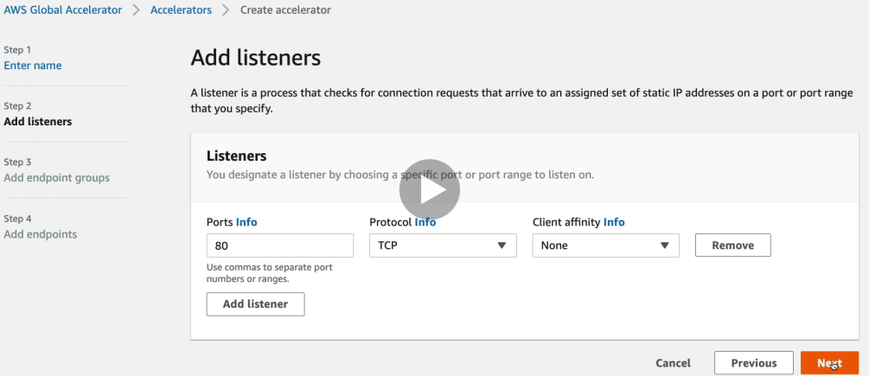

Add endpoint groups

Add both endpoints (of the two EC2 instances). This would make a group consisting of two endpoints.

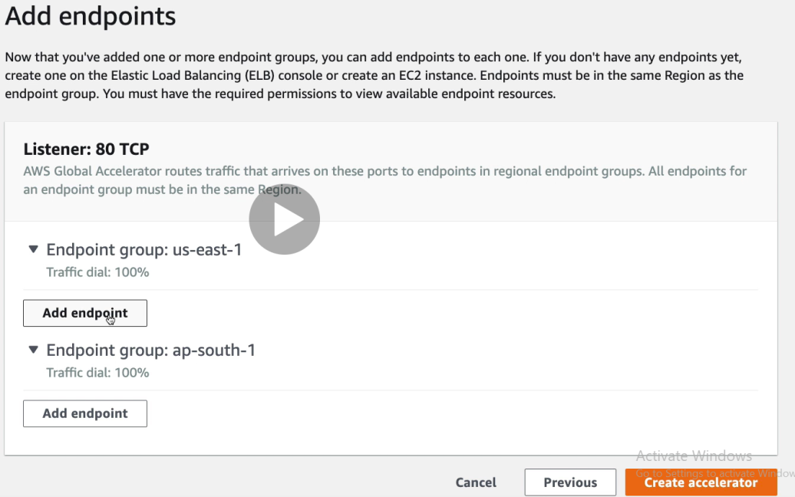

Add Endpoint against each region like below –

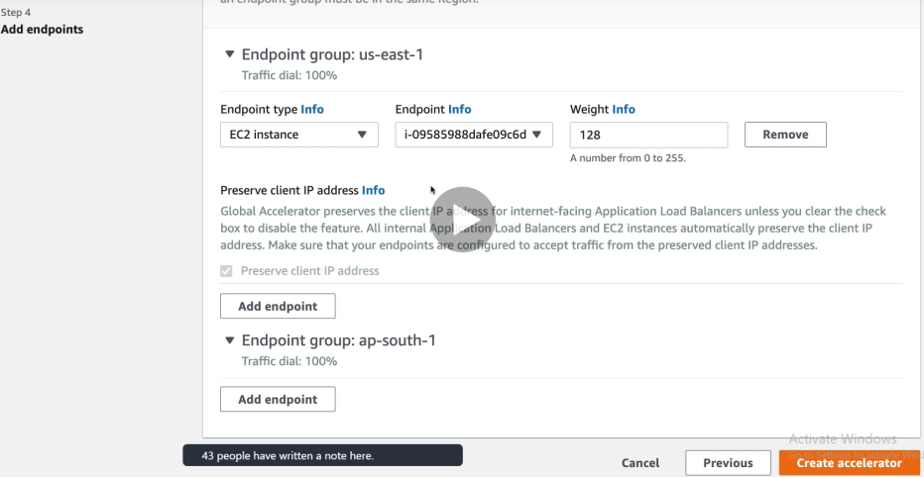

Click on “Create Accelerator” with two static IP addresses and one DNS name. Hit the DNS and it would give the output from the nearest EC2 instance

